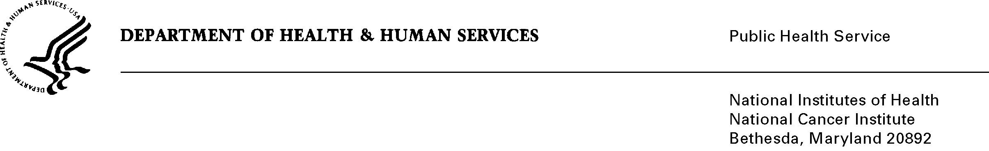
Date: Tuesday June 28, 2011

TO: Office of Management and Budget (OMB)

Through: Mary Forbes, Reports Clearance Officer, HHS
Seleda Perryman, Program Clearance Officer, OPERA, NIH
Vivian Horovitch-Kelley, PRA OMB Project Clearance Liaison, OMAA, NCI

FROM: Abdul R. Shaikh, PhD, MHSc, HCIRB, DCCPS, NCI
National Cancer Institute (NCI)/NIH

SUBJECT: Using Public Data for Cancer Prevention and Control: From Innovation to Impact (NCI)

This is a request for OMB to complete this as an emergency processing of this a new submission titled “Using Public Data for Cancer Prevention and Control: From Innovation to Impact (NCI)” for 6 months. OMB approved this submission for emergency processing on June 27, 2011.

This initiative utilizes the new prize authority in the America COMPETES Act to address the President’s call for agencies to increase their use of prizes and challenges to spur innovation and solve difficult problems. The NCI’s Division of Cancer Control and Population Sciences (DCCPS), in consultation with the HHS Office of the Secretary and collaborating with the HHS Office of the National Coordinator for Health Information Technology, is asking contestants to develop software applications (apps) that utilize the wide array of health-related data made available by NCI and other Federal agencies. Contestants will submit innovative solutions to cancer prevention and control challenges faced by consumers, clinicians, or researchers such as behavior risk reduction for prevention/survivorship (e.g., nutrition, physical activity, smoking cessation), early detection and screening, informed decision-making, and adherence to treatment regimens. It is estimated that up to 20 contestants will submit apps to the challenge for phase one and an additional four contestants will submit a revised app as finalists. The estimated burden per respondent will be 200-300 hours which amounts to an annualized total of 4,400 hours.

The first phase of the challenge is linked to a special conference session at the September 25th Health 2.0 conference, where finalists will engage with leaders in government and technology. Launching on July 1st will provide the minimum estimated time (6 weeks) necessary for adequate promotion and development of apps by contestants for submission by August 15th, before judging, notification of finalists, and travel arrangements will be addressed.

The apps submitted to the challenge should accelerate problem-solving by generating novel solutions to difficult problems addressing DCCPS priority areas on the continuum of cancer prevention and control: http://cancercontrol.cancer.gov/od/index.html.

