The Study of the Use of Nursing Home Antibiograms

Brigham & Women’s Hospital
75 Francis Street
Boston, MA 02115

The Brigham and Women’s Hospital (BWH) is participating in a study related to antibiotic prescribing practices in long-term care settings. As you are likely aware, there is ongoing concern about antibiotic overprescribing and the inappropriate use of some antibiotics. The purpose of this project is to improve antibiotic prescribing practices in nursing homes as well as hospital emergency departments when nursing home residents are transferred there.

Because you treat patients at BWH for whom you write prescriptions, your thoughts on the matter are especially important. We are writing to ask you to participate in a voluntary survey related to antibiotic use and prescribing practices.

Abt Associates, a research and consulting firm, has been contracted by the Agency for Healthcare Quality and Research to conduct this study. We are surveying other providers and nurses at three area nursing homes and providers at BWH. We expect that the resulting information will lend itself to the development of a successful program for antibiotic use. Responses will be summarized and reported across all BWH providers who participated in the survey (i.e., three at pre-implementation; approximately 50 at post-implementation). The BWH may be named in reports to AHRQ and may be named in publications or presentations that may result from this work.

We hope that you will be interested in participating in this study. A member of our research staff will call you sometime over the next week to obtain your email address so that we can send you the survey electronically, or obtain your mailing address if you prefer a paper and pencil version of the survey. If at any time you have questions or would like additional information about the study, please contact the Project Director, Rosanna Bertrand, PhD at 617-349-2556. We respect your time and the care that you provide to older adults.

Thank you for your consideration.

Sincerely,

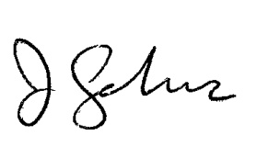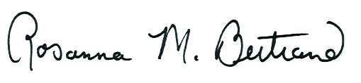

Rosanna Bertrand, PhD  Project Director  Abt Associates Inc. |  | Jeremiah Schuur, MD, MHS  Emergency Medicine  Brigham & Women's Hospital

