The Study of the Use of Nursing Home Antibiograms

The nursing home in which you work is participating in a study related to antibiotic prescribing practices in long-term care settings. As you are likely aware, there is ongoing concern about antibiotic overprescribing and the inappropriate use of some antibiotics. The purpose of this project is to improve antibiotic prescribing practices in nursing homes as well as hospital emergency departments when nursing home residents are transferred there.

Because you provide care for residents at a study participating nursing home, your thoughts on the matter are especially important. We are writing to ask you to participate in a voluntary interview related to antibiotic use and prescribing factors.

Abt Associates, a research and consulting firm, has been contracted by the Agency for Healthcare Quality and Research to conduct this study. We are surveying physicians, nurse practitioners, physician assistants, and nurses at three participating nursing homes, as well as physicians at the Brigham and Women’s Hospital. We expect that the resulting information will lend itself to the development of a successful program for antibiotic use.

We hope that you will be interested in participating in this survey. A copy of the survey and a statement of informed consent are included in this packet. If you agree to participate, please sign the statement of consent and complete the survey. Enclose them both in the stamped, addressed envelope that is also included in the packet. If at any time you have questions or would like additional information about the study, please contact the Project Director, Rosanna Bertrand, PhD at 617-349-2556. We respect your time and the care that you provide to older adults.

Thank you for your consideration.

Sincerely,

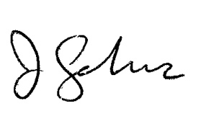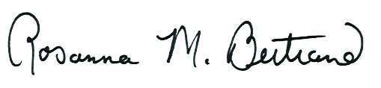

Rosanna Bertrand, PhD  Project Director  Abt Associates Inc. |  | Jeremiah Schuur, MD, MHS  Emergency Medicine  Brigham & Women's Hospital

