MySocialSecurity.gov Portal
(Access to iBEVE Application post ROME Authentication)

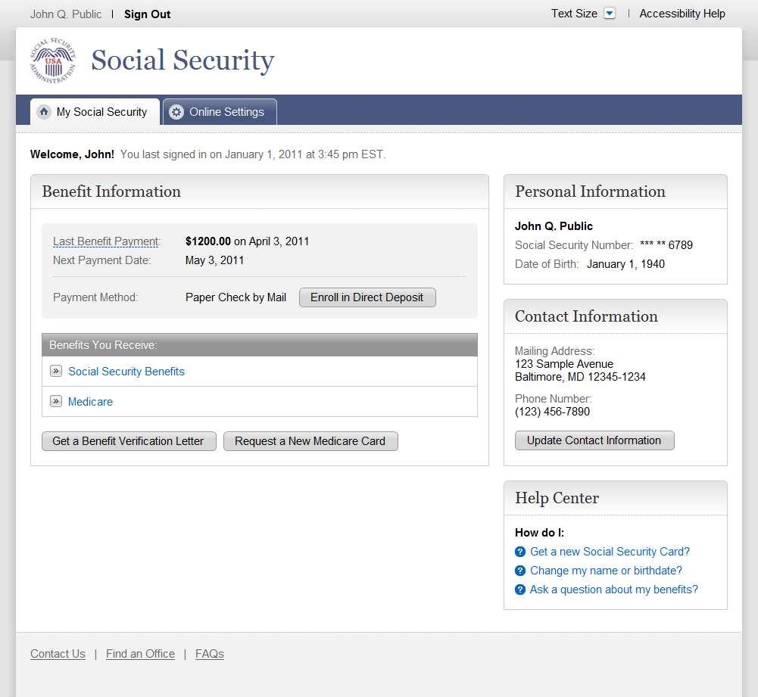

Benefit Verification - Customize Your Letter
(Screen 1 of iBEVE Application)

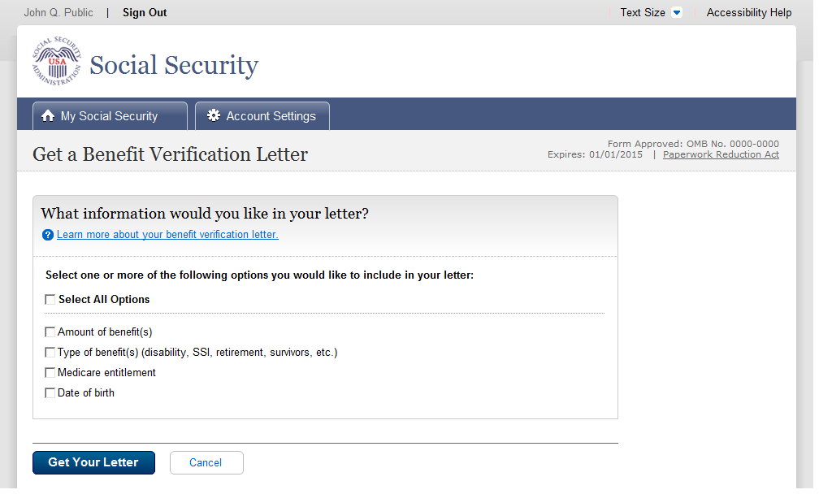
More Info

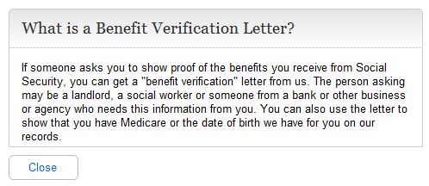
Benefit Verification - Your Letter
(Screen 2 of the iBEVE application)

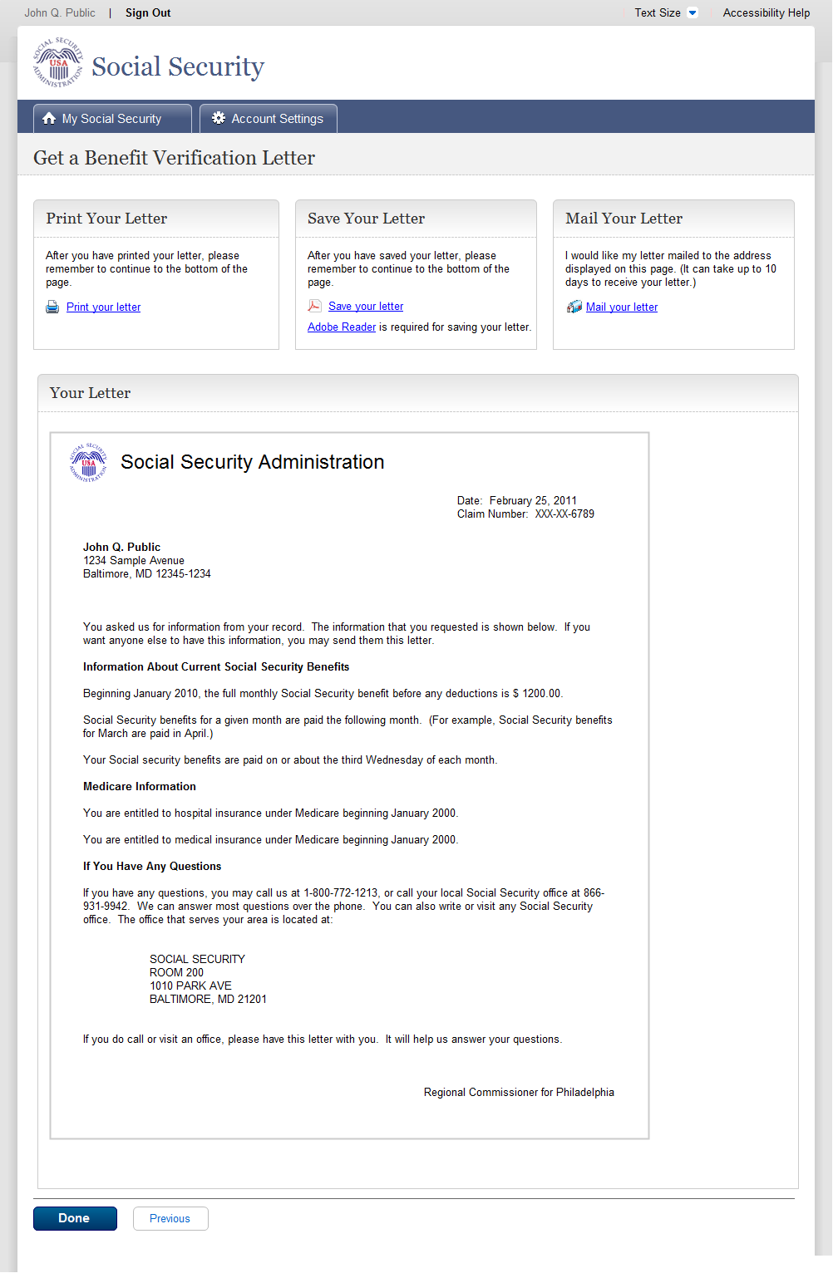
Print Letter (Print Dialog Box)

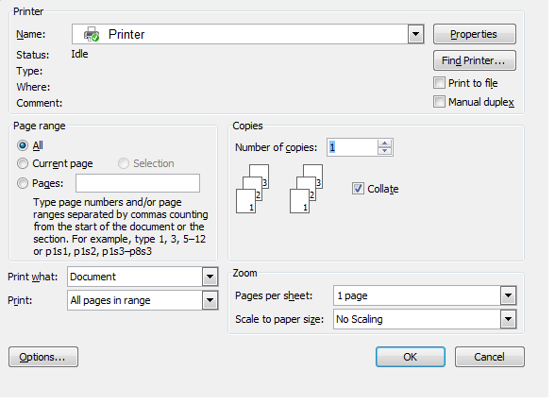
Save Letter (PDF)

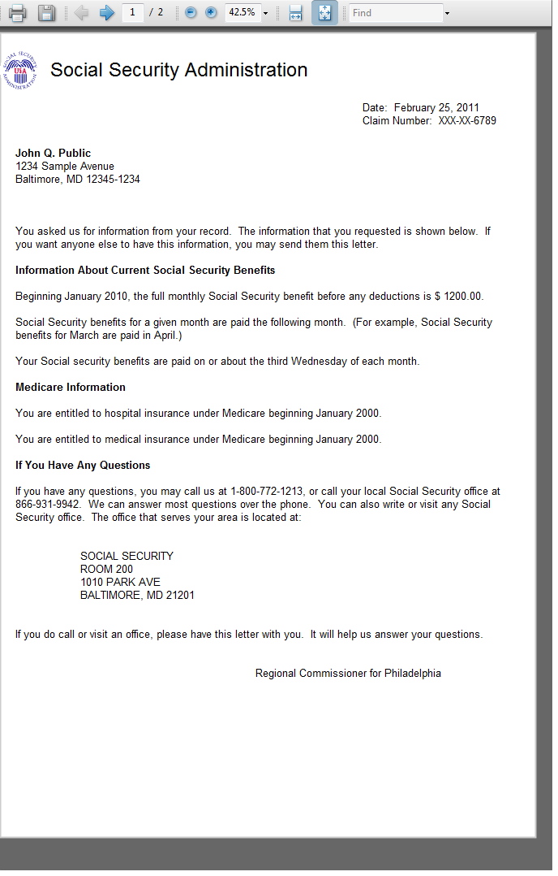
Benefit Verification - Mail Confirmation
(Screen 3 of iBEVE application)
