Comparative Effectiveness Research Inventory

Customer comment card:

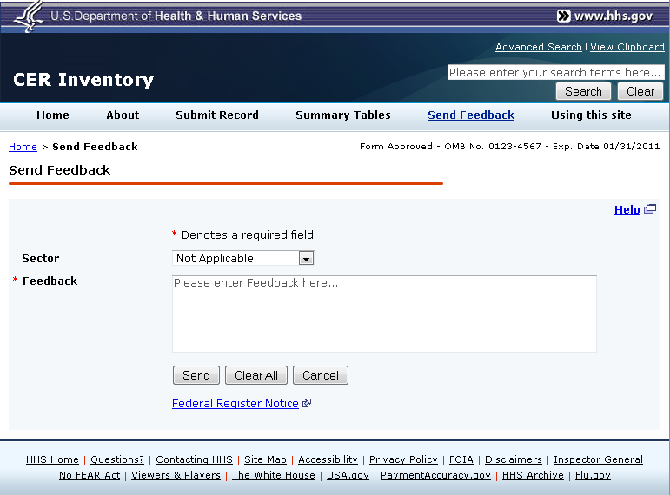

The form provides a drop down for users to note their “Sector”: Not Applicable; Government-research; Government-general; Academic; Other nonprofit; Other researcher; Other. Selection of a sector is not required in order to submit feedback.

The following footer will be included:

According to the Paperwork Reduction Act of 1995, no persons are required to respond to a collection of information unless it displays a valid OMB control number. The valid OMB control number for this information collection is 0990- . The time required to complete this information collection is estimated to average three (3) minutes per response, including the time to review instructions, search existing data resources, gather the data needed, and complete and review the information collection. If you have comments concerning the accuracy of the time estimate(s) or suggestions for improving this form, please write to: U.S. Department of Health & Human Services, OS/OCIO/PRA, 200 Independence Ave., S.W., Suite 336-E, Washington D.C. 20201, Attention: PRA Reports Clearance Officer