Voice-of-Customer Surveys

for HealthCare.gov

Page-Level Survey

Layout
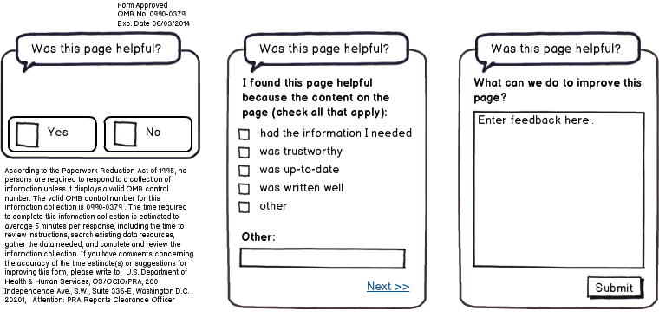

Questions
- Was this page helpful?
  - Yes
  - No
[IF Q1 RESPONSE is YES]
- I found this page helpful because the content on the page: (check all that apply)
  - Had the information I needed
  - Was trustworthy
  - Was up-to-date
  - Was written clearly
  - Other: ____________________________
- What can we do to improve this page?
[IF Q1 RESPONSE is NO]
- I did not find this page helpful because the content on the page: (check all that apply)
  - Had too little information
  - Had too much information
  - Was confusing
  - Was out-of-date
  - Other: ____________________________
- What can we do to improve this page?

