Voice-of-Customer Surveys

for StopBullying.gov

# Site-Level Survey for Visitor Feedback

## Introductory Text

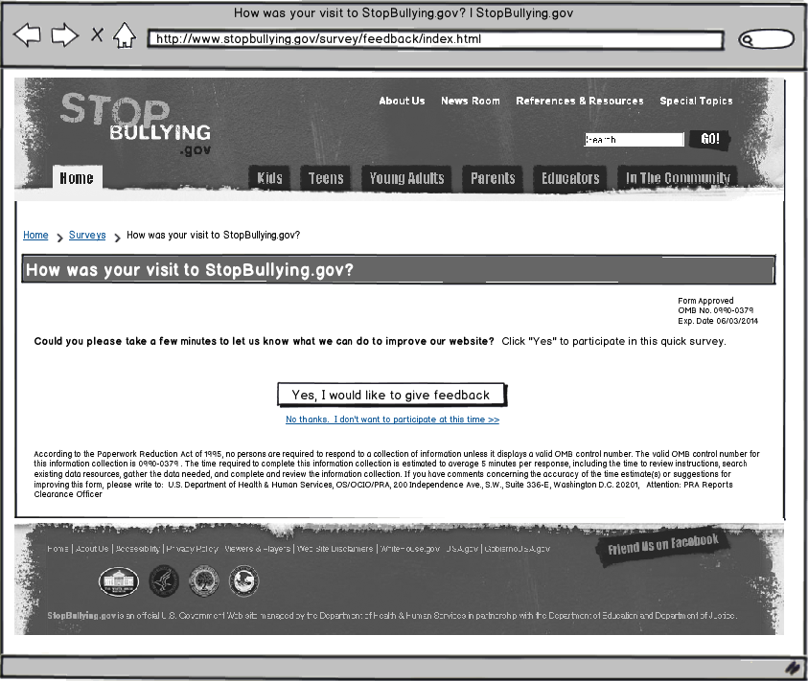

## Questions

1. What were you looking for on StopBullying.gov today?
   * Learn basic information about bullying (what it is, what the warning signs are)
   * Find out how I can prevent bullying
   * Learn how I can take action in my school/community
   * Find information on how to get help
   * Find research on bullying
   * Get news and updates about StopBullying.gov
   * I had nothing specific in mind when I came to the website today.
   * Other: ______________________
2. Were you able to find what you were looking for?
   * Yes
   * Partially
   * No

**[If Q2 response is YES]**

1. How long did it take to find the information?
   * Immediately
   * Few minutes
   * A long time
2. Did you find the information helpful?
   * Yes
   * Partially
   * No

**[If Q4 response is YES]**

1. What did you like best about the content?
2. Based on today’s visit, how would you rate the following?
   * Your experience during your visit
   * How the website looks
   * How you can get around the website
3. How can we improve StopBullying.gov?

**[If Q4 response is PARTIALLY or NO]**

1. What can we do to make the information more helpful?
2. Based on today’s visit, how would you rate the following:
   1. Your experience during your visit
   2. How the website looks
   3. How you can get around the website
3. What can we do to make StopBullying.gov better?

**[If Q2 response is PARTIALLY or NO]**

1. What information were you looking for and did not find on StopBullying.gov?
2. Based on today’s visit, how would you rate the following:
   1. Your experience during your visit
   2. How the website looks
   3. How you can get around the website
3. What can we do to make StopBullying.gov better?

## Thank You Text

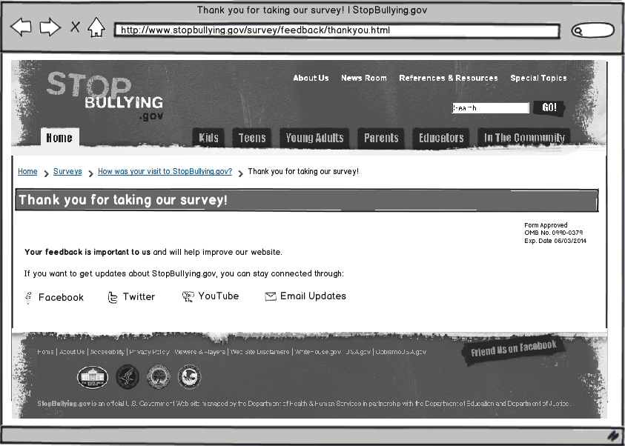

# Page-Level Survey

## Layout

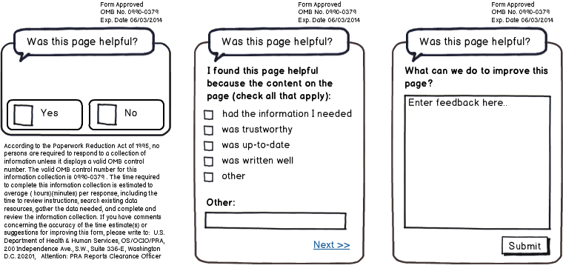

## Questions

1. Was this page helpful?
   * Yes
   * No

**[IF Q1 RESPONSE is YES]**

1. I found this page helpful because the content on the page: (check all that apply)
   * Had the information I needed
   * Was trustworthy
   * Was up-to-date
   * Was written well
   * Other: ____________________________
2. What can we do to improve this page?

**[IF Q1 RESPONSE is NO]**

1. I did not find this page helpful because the content on the page: (check all that apply)
   1. Had too little information
   2. Had too much information
   3. Was confusing
   4. Was out-of-date
   5. Was poorly written
   6. Other: ____________________________
2. What can we do to improve this page?