Voice-of-Customer Surveys

for HHS.gov

# Site-Level Survey for Visitor Feedback

## Introductory Text

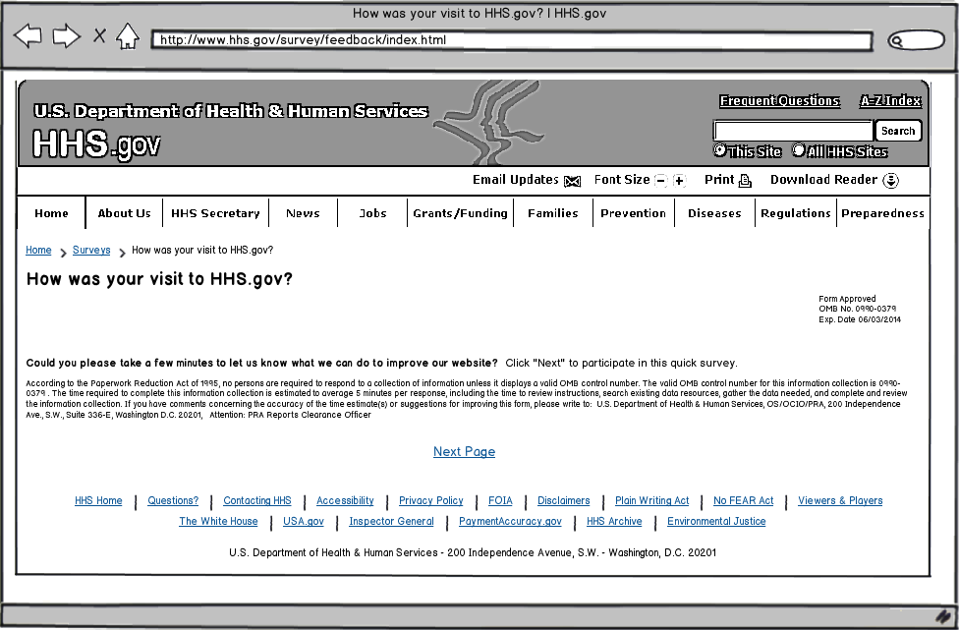

## Questions

1. What were you looking for on HHS.gov today?
   * Get information about HHS and offices within HHS
   * Learn more about the HHS Secretary
   * Get health information privacy (HIPAA) information
   * Find job openings within HHS
   * Learn about a specific disease or health condition
   * Get answers for health insurance questions
   * Get news and updates about HHS.gov
   * I had nothing specific in mind when I came to the website today.
   * Other: ______________________
2. Were you able to find what you were looking for?
   * Yes
   * Partially
   * No

**[If Q2 response is YES]**

1. How long did it take to find the information?
   * Immediately
   * Few minutes
   * A long time
2. Did you find the information helpful?
   * Yes
   * Partially
   * No

**[If Q4 response is YES]**

1. What did you like best about the content?
2. Based on today’s visit, how would you rate the following?
   * Overall site experience
   * Site design
   * Ease of navigation
3. How can we improve HHS.gov?

**[If Q4 response is PARTIALLY or NO]**

1. What can we do to make the information more helpful?
2. Based on today’s visit, how would you rate the following:
   1. Overall site experience
   2. Site design
   3. Ease of navigation
3. What can we do to make HHS.gov better?

**[If Q2 response is PARTIALLY or NO]**

1. What information were you looking for and did not find on HHS.gov?
2. Based on today’s visit, how would you rate the following:
   1. Overall site experience
   2. Site design
   3. Ease of navigation
3. What can we do to make HHS.gov better?

## Thank You Text

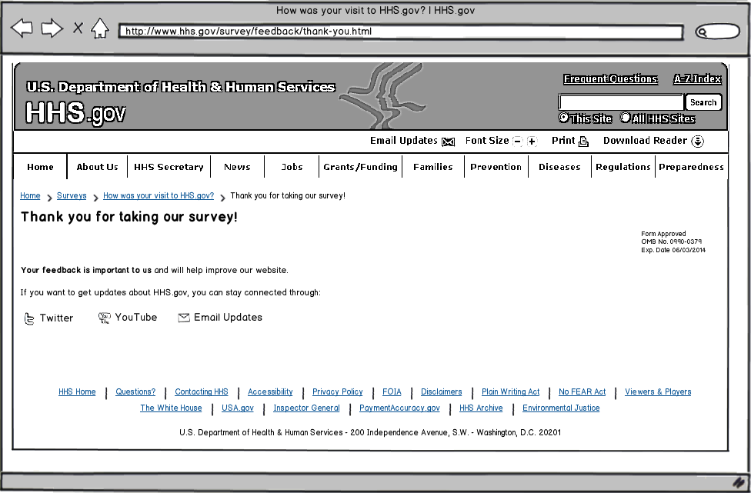

# Page-Level Survey

## Layout

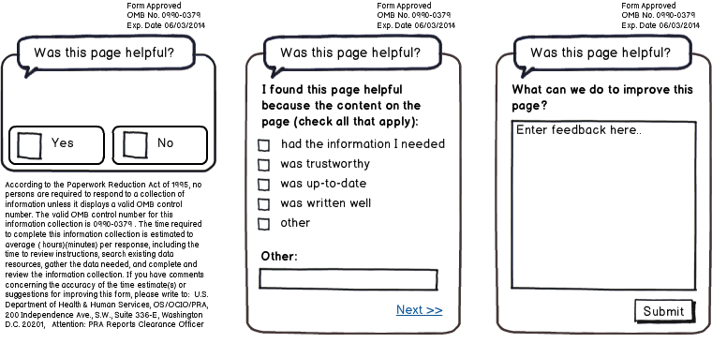

## Questions

1. Was this page helpful?
   * Yes
   * No

**[IF Q1 RESPONSE is YES]**

1. I found this page helpful because the content on the page: (check all that apply)
   * Had the information I needed
   * Was trustworthy
   * Was up-to-date
   * Was written well
   * Other: ____________________________
2. What can we do to improve this page?

**[IF Q1 RESPONSE is NO]**

1. I did not find this page helpful because the content on the page: (check all that apply)
   1. Had too little information
   2. Had too much information
   3. Was confusing
   4. Was out-of-date
   5. Was poorly written
   6. Other: ____________________________
2. What can we do to improve this page?