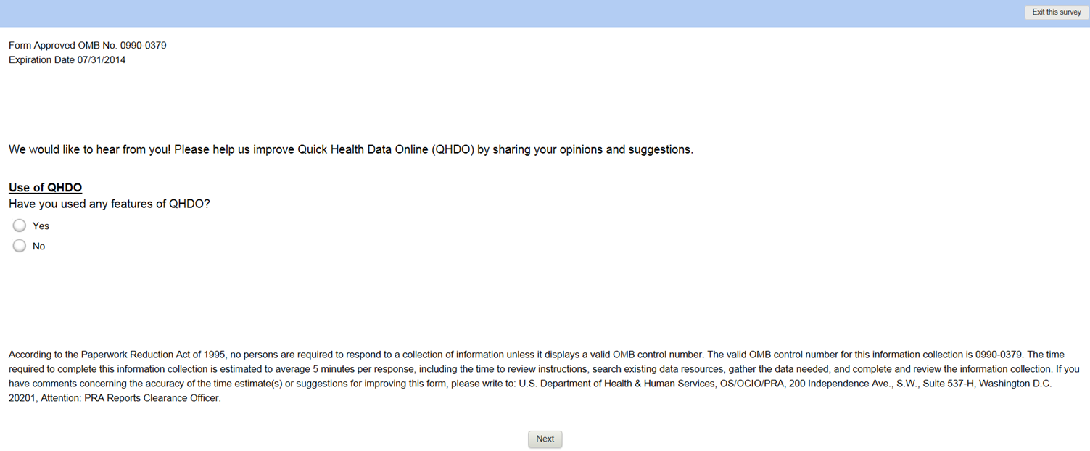

**[FOR THOSE RESPONDING YES; A NO RESPONSE SKIPS TO LAST ITEM]**

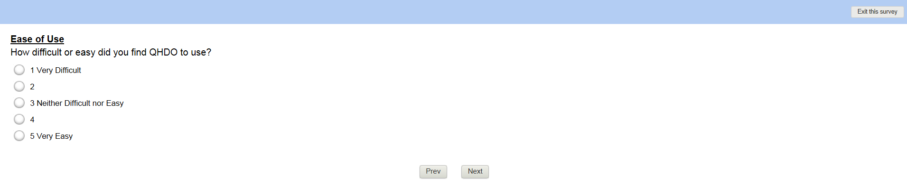

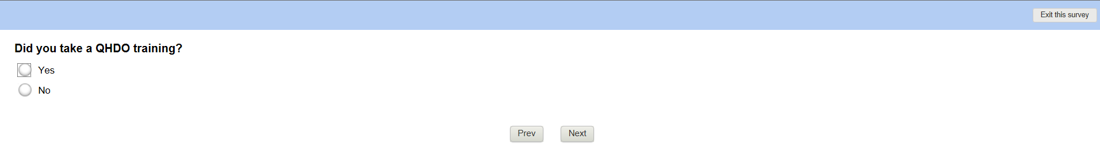

**[FOR THOSE RESPONDING YES; A NO RESPONSE SKIPS TO ‘REPORTS’ QUESTION]**

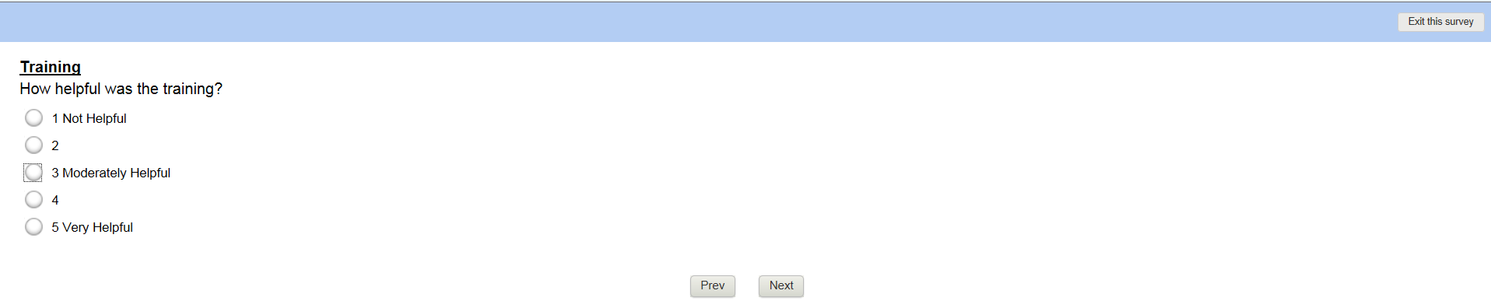

**[FOR THOSE RESPONDING MODERATELY HELPFUL TO NOT HELPFUL; OTHER RESPONSES SKIP TO ‘REPORTS’ QUESTION]**

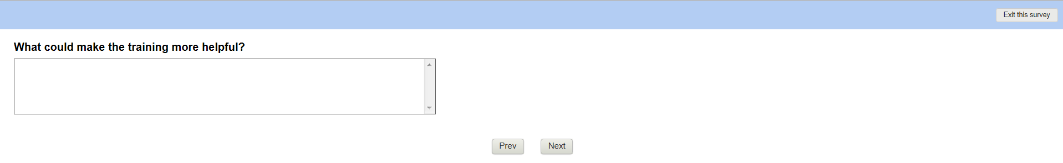

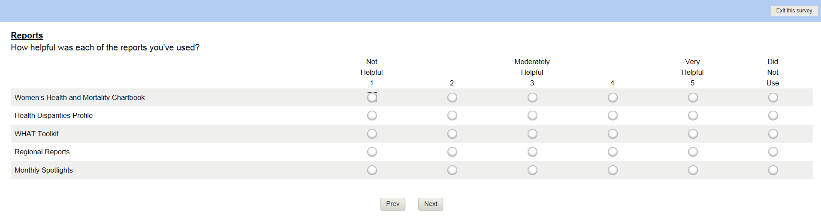

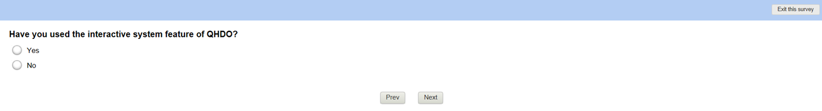

**[FOR THOSE RESPONDING YES; A NO RESPONSE SKIPS TO ‘HOW DID YOU FIRST HEAR ABOUT QHDO’ QUESTION]**

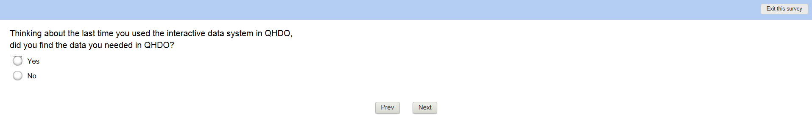

**[FOR THOSE RESPONDING YES; A NO RESPONSE SKIPS TO ‘WHAT DATA WERE YOU LOOKING FOR?’ QUESTION]**

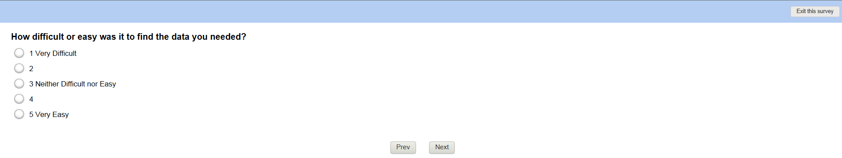

**[FOR THOSE RESPONDING 1, 2, OR 3; A RESPONSE OF 4 OR 5 SKIPS TO ‘SYSTEM OUTPUT’ QUESTION]**

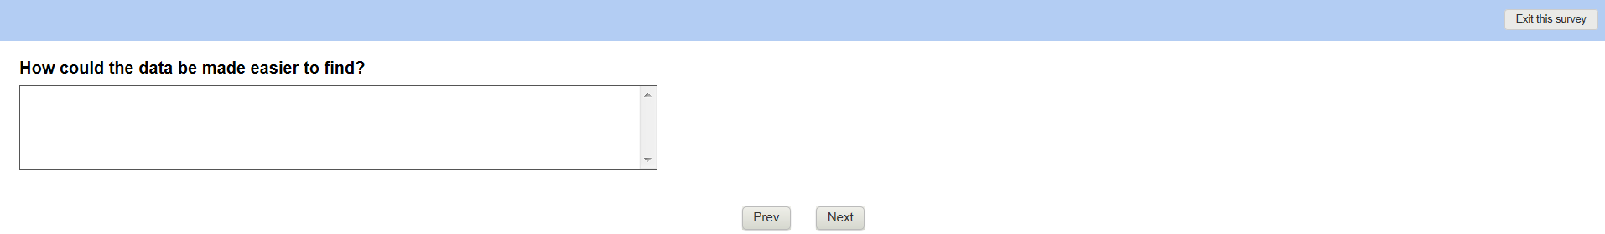

**[FOR THOSE RESPONDING NO ABOVE]**

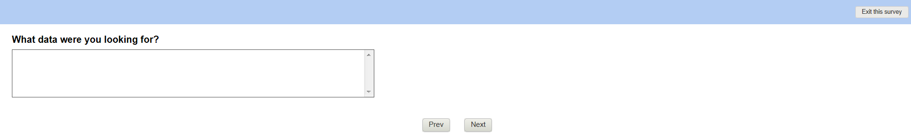

**[A YES OR NO RESPONSE TO THE PRIOR LEADS TO THE FOLLOWING QUESTIONS]**

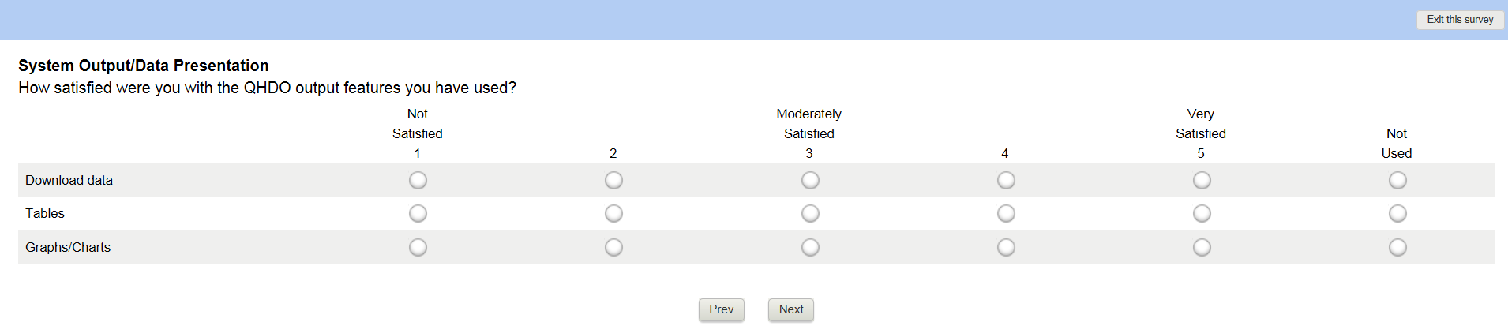

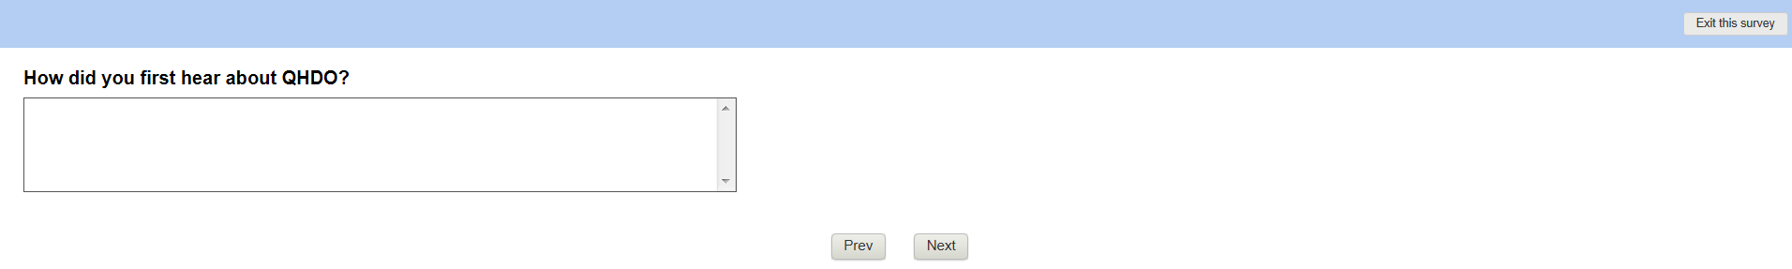

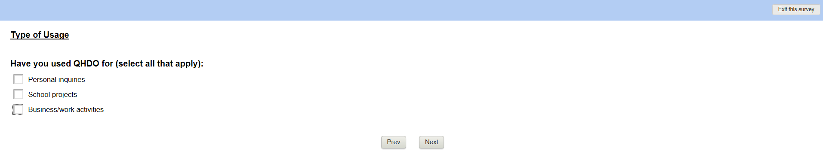

**[FOR THOSE RESPONDING ‘BUSINESS/WORK ACTIVITY’; OTHERS WILL SKIP TO ‘TELL US WHAT YOU THINK’]**

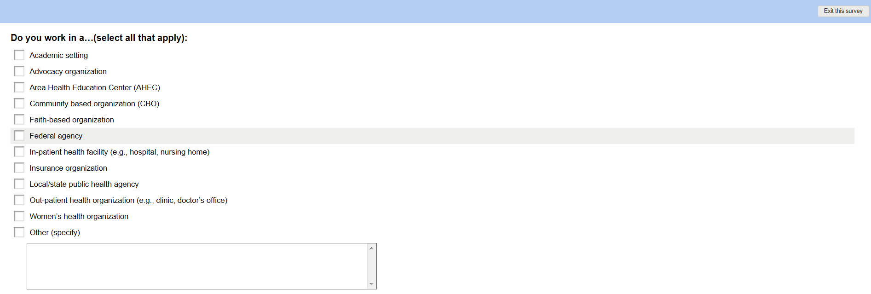

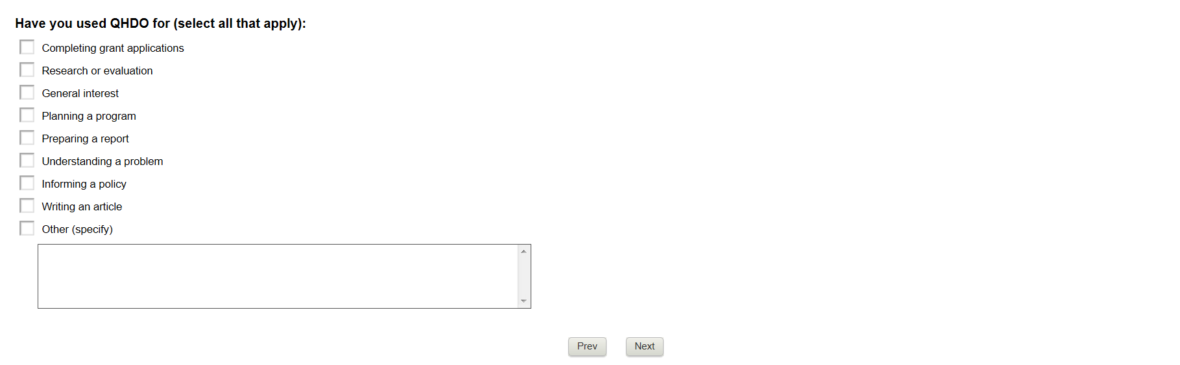

**[A RESPONSE OF PERSONAL, SCHOOL, OR BUSINESS LEADS TO THE FOLLOWING]**

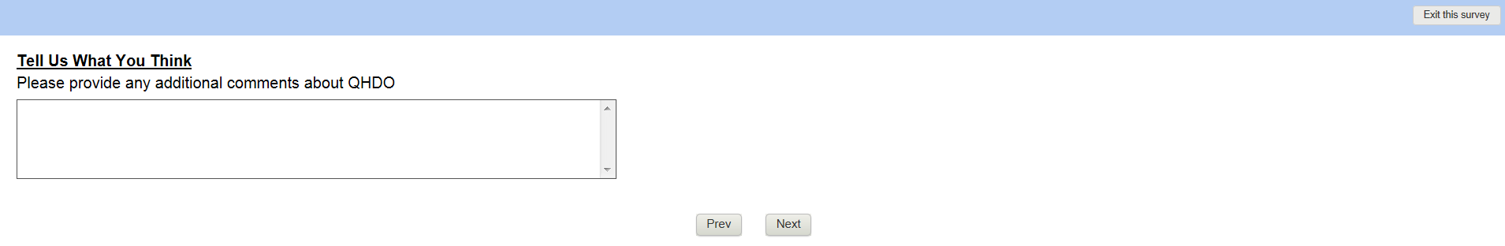

**[ALL RESPONDENTS GET TO THIS FINAL ITEM]**

