Voice-of-Customer Surveys

for Vaccines.gov

# Site-Level Survey for Visitor Feedback

## Introductory Text

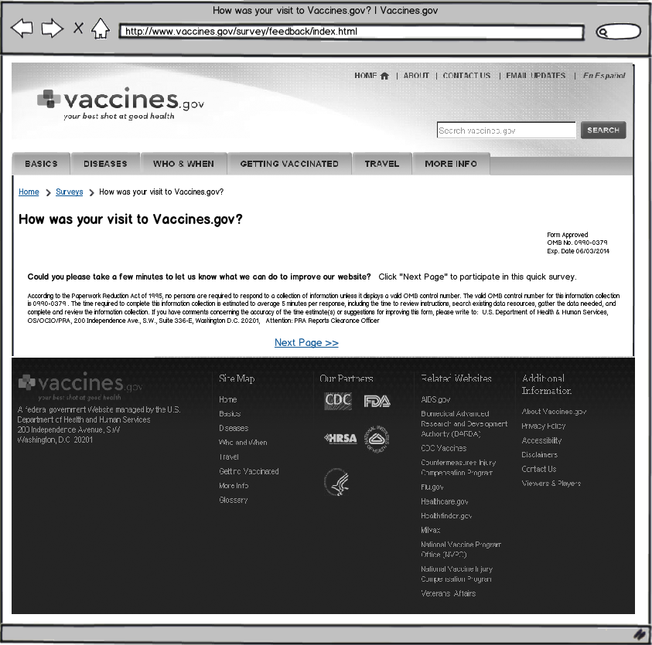

## Questions

1. What were you looking for on Vaccines.gov today?
   * Find out what I should know before getting vaccinated.
   * Get information about a vaccine for a particular disease.
   * Learn about vaccines for an infant or young child.
   * Learn about vaccines for older people.
   * Find out what I should do/get vaccinated for before I travel.
   * I had no agenda in mind when I came to the website today.
   * Other: ______________________
2. For whom were you looking for information on Vaccines.gov?
   * Myself
   * My spouse, partner or significant other
   * My child(ren)
   * My parents
   * A relative
   * A friend
   * No one in particular
3. Were you able to find what you were looking for?
   * Yes
   * Partially
   * No

**[If Q3 response is YES]**

1. How long did it take to find the information?
   * Immediately
   * Few minutes
   * A long time
2. Did you find the information helpful?
   * Yes
   * Partially
   * No

**[If Q5 response is YES]**

1. What did you like best about the content?
2. Based on today’s visit, how would you rate the following?
   * Overall site experience
   * Site design
   * Ease of navigation
3. How can we improve Vaccines.gov?
4. Would you recommend Vaccines.gov to a family member or friend?
5. Based on the information you found on this website, rate the probability of this statement**: I am going to get the vaccine(s) I was researching because of information I found on Vaccines.gov.**
   * Most likely
   * Likely
   * Not likely
   * No impact – I get vaccinated regularly
   * No impact – I don’t get vaccinated regularly
6. Based on the information you found on this website, rate the probability of this statement**: I am going to get the flu vaccine because of information I found on Vaccines.gov.**
   * Most likely
   * Likely
   * Not likely
   * No impact – I get the flu vaccine every year
   * No impact – I don’t get the flu vaccine every year

**[If Q5 response is PARTIALLY or NO]**

1. What can we do to make the information more helpful?
2. Based on today’s visit, how would you rate the following:
   1. Overall site experience
   2. Site design
   3. Ease of navigation
3. What can we do to make Vaccines.gov better?
4. Would you recommend Vaccines.gov to a family member or friend?
5. Based on the information you found on this website, rate the probability of this statement**: I am going to get the vaccine(s) I was researching because of information I found on Vaccines.gov.**
   1. Most likely
   2. Likely
   3. Not likely
   4. No impact – I get vaccinated regularly
   5. No impact – I don’t get vaccinated regularly
6. Based on the information you found on this website, rate the probability of this statement**: I am going to get the flu vaccine because of information I found on Vaccines.gov.**
   1. Most likely
   2. Likely
   3. Not likely
   4. No impact – I get the flu vaccine every year
   5. No impact – I don’t get the flu vaccine every year

**[If Q3 response is PARTIALLY or NO]**

1. Are there questions about a vaccine or vaccines in general you didn’t find the answer to?
2. Based on today’s visit, how would you rate the following: How will this be rated? Qualitative comments wanted
   1. Overall site experience
   2. Site design
   3. Ease of navigation
3. What can we do to make Vaccines.gov better?
4. Based on the information you found on this website, rate the probability of this statement**: I am going to get the vaccine(s) I was researching because of information I found on Vaccines.gov.**
   1. Most likely
   2. Likely
   3. Not likely
   4. No impact – I get vaccinated regularly
   5. No impact – I don’t get vaccinated regularly
5. Based on the information you found on this website, rate the probability of this statement**: I am going to get the flu vaccine because of information I found on Vaccines.gov.**
   1. Most likely
   2. Likely
   3. Not likely
   4. No impact – I get the flu vaccine every year
   5. No impact – I don’t get the flu vaccine every year

## Thank You Text

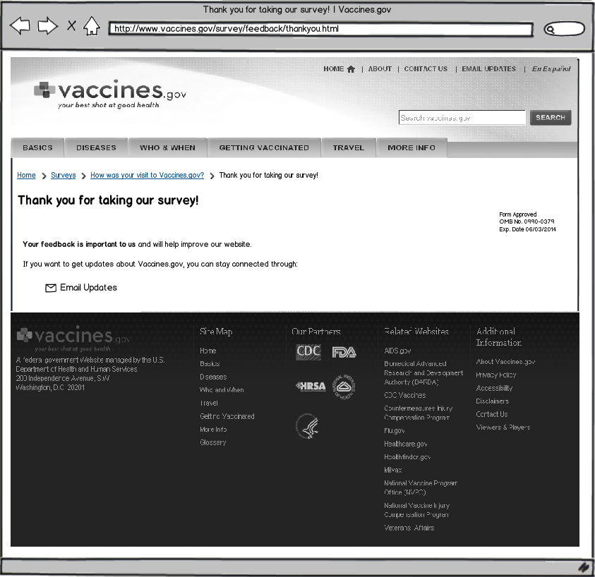

# Page-Level Survey

## Layout

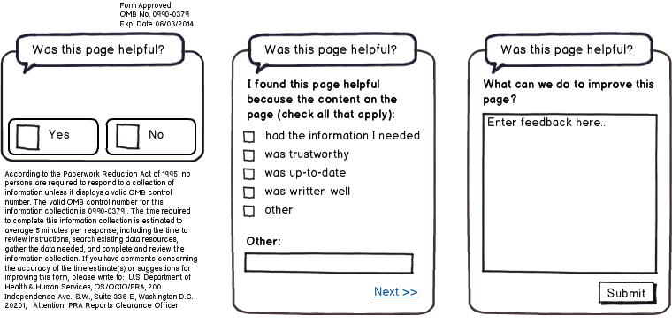

## Questions

1. Was this page helpful?
   * Yes
   * No

**[IF Q1 RESPONSE is YES]**

1. I found this page helpful because the content on the page: (check all that apply)
   * Had the information I needed
   * Was trustworthy
   * Was up-to-date
   * Was written clearly
   * Other: ____________________________
2. What can we do to improve this page?

**[IF Q1 RESPONSE is NO]**

1. I did not find this page helpful because the content on the page: (check all that apply)
   1. Had too little information
   2. Had too much information
   3. Was confusing
   4. Was out-of-date
   5. Other: ____________________________
2. What can we do to improve this page?