Voice-of-Customer Surveys

for Flu.gov

Site-Level Survey for Visitor Feedback

Introductory Text
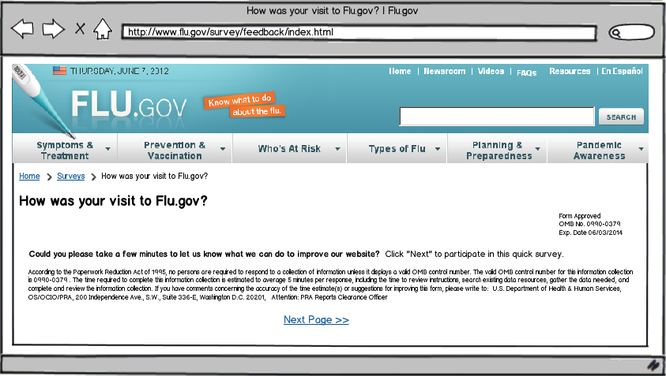

Questions
- What were you looking for on Flu.gov today?
  - Get information about seasonal flu.
  - Learn about H1N1 (swine) or H5N1 (avian) flu.
  - Find out what the symptoms for the flu are.
  - Learn what I can do to treat the flu.
  - Get information about flu prevention or vaccination.
  - Learn how to prepare for a flu pandemic.
  - Find research information about flu.
  - Find a place to get a flu vaccine.
  - Get news and updates
  - Other: ______________________
- For whom were you looking for information on Flu.gov?
  - Myself
  - My spouse, partner or significant other
  - My child(ren)
  - My parents
  - A relative
  - A friend
  - No one in particular
- Were you able to find what you were looking for?
  - Yes
  - Partially
  - No
[If Q3 response is YES]
- How long did it take to find the information?
  - Immediately
  - Few minutes
  - A long time
- Did you find the information helpful?
  - Yes
  - Partially
  - No
[If Q5 response is YES]
- What did you like best about the content?
- Based on today’s visit, how would you rate the following?
  - Overall site experience
  - Site design
  - Ease of navigation
- How can we improve Flu.gov?
- Based on the information you found on this website, rate the probability of this statement: I am going to get the flu vaccine because of information I found on Flu.gov.
  - Most likely
  - Likely
  - Not likely
  - No impact – I get the flu vaccine every year
  - No impact - I don’t get the flu vaccine every year
[If Q5 response is PARTIALLY or NO]
- What can we do to make the information more helpful?
- Based on today’s visit, how would you rate the following:
  - Overall site experience
  - Site design
  - Ease of navigation
- What can we do to make Flu.gov better?
- Based on the information you found on this website, rate the probability of this statement: I am going to get the flu vaccine because of information I found on Flu.gov.
  - Most likely
  - Likely
  - Not likely
  - No impact – I get the flu vaccine every year
  - No impact - I don’t get the flu vaccine every year
[If Q3 response is PARTIALLY or NO]
- What information were you looking for and did not find on Flu.gov?
- Based on today’s visit, how would you rate the following:
  - Overall site experience
  - Site design
  - Ease of navigation
- What can we do to make Flu.gov better?
- Based on the information you found on this website, rate the probability of this statement: I am going to get the flu vaccine because of information I found on Flu.gov.
  - Most likely
  - Likely
  - Not likely
  - No impact – I get the flu vaccine every year
  - No impact - I don’t get the flu vaccine every year

Thank You Text
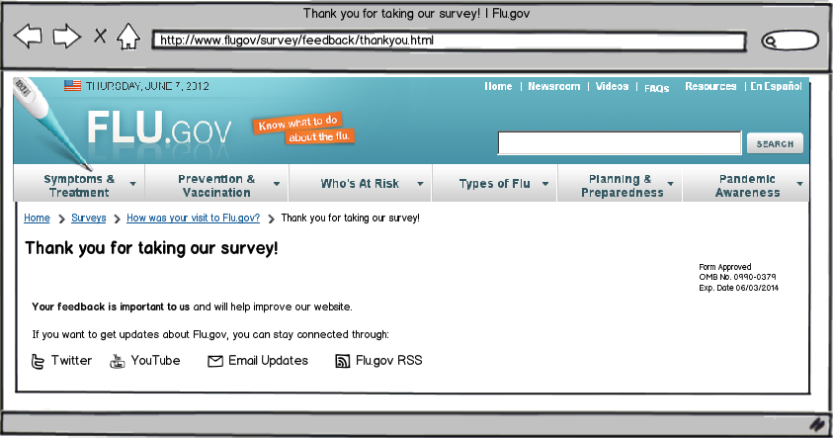

Page-Level Survey

Layout
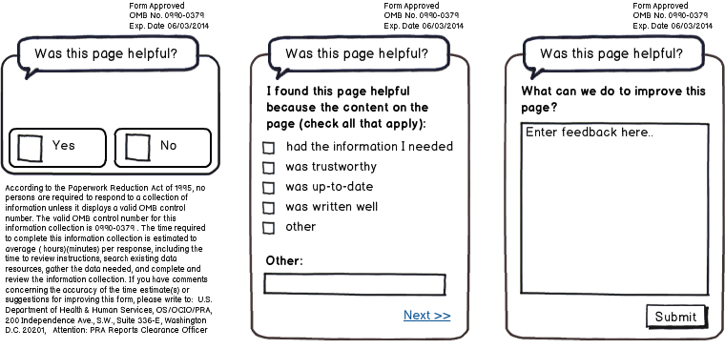

Questions
- Was this page helpful?
  - Yes
  - No
[IF Q1 RESPONSE is YES]
- I found this page helpful because the content on the page: (check all that apply)
  - Had the information I needed
  - Was trustworthy
  - Was up-to-date
  - Was written well
  - Other: ____________________________
- What can we do to improve this page?
[IF Q1 RESPONSE is NO]
- I did not find this page helpful because the content on the page: (check all that apply)
  - Had too little information
  - Had too much information
  - Was confusing
  - Was out-of-date
  - Was poorly written
  - Other: ____________________________
- What can we do to improve this page?

