Voice-of-Customer Surveys

for BeTobaccoFree.gov

Site-Level Survey for Visitor Feedback

Introductory Text
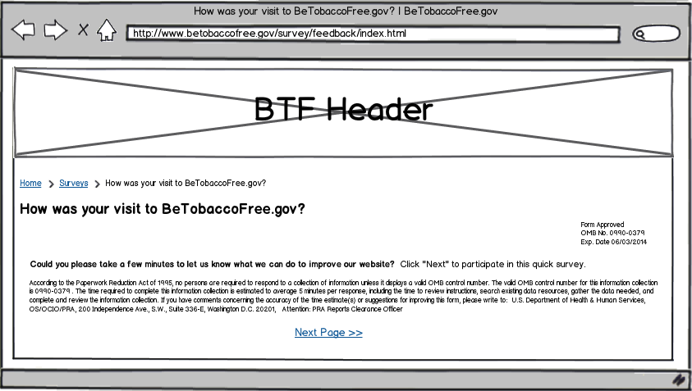

Questions
- What were you looking for on BeTobaccoFree.gov today?
  - To find information on quitting
  - To find information on health effects and diseases caused by smoking and tobacco use
  - To learn about the latest research on smoking and tobacco use
  - To find resources on preventing smoking and tobacco use
  - To find out about the latest tobacco control laws and policies
  - To see the latest educational campaigns about smoking and tobacco use
  - To find out facts about smoking and tobacco use
  - I had no agenda in mind when I came to the website today.
  - Other: ______________________
- For whom were you looking for information on BeTobaccoFree.gov?
  - Myself
  - My spouse, partner or significant other
  - My child(ren)
  - My parents
  - A relative
  - A friend
  - No one in particular
- Were you able to find what you were looking for?
  - Yes
  - Partially
  - No
[If Q3 response is YES]
- How long did it take to find the information?
  - Immediately
  - Few minutes
  - A long time
- Did you find the information helpful?
  - Yes
  - Partially
  - No
[If Q5 response is YES]
- What did you like best about the content?
- Based on today’s visit, how would you rate the following?
  - Overall site experience
  - Site design
  - Ease of navigation
- How can we improve BeTobaccoFree.gov?
- Would you recommend BeTobaccoFree.gov to a family member or friend?
[If Q5 response is PARTIALLY or NO]
- What can we do to make the information more helpful?
- Based on today’s visit, how would you rate the following:
  - Overall site experience
  - Site design
  - Ease of navigation
- What can we do to make BeTobaccoFree.gov better?
- Would you recommend BeTobaccoFree.gov to a family member or friend?
[If Q3 response is PARTIALLY or NO]
- Are there questions about smoking or tobacco in general you didn’t find the answer to?
- Based on today’s visit, how would you rate the following:
  - Overall site experience
  - Site design
  - Ease of navigation
- What can we do to make BeTobaccoFree.gov better?
- Would you recommend BeTobaccoFree.gov to a family member or friend?

Thank You Text
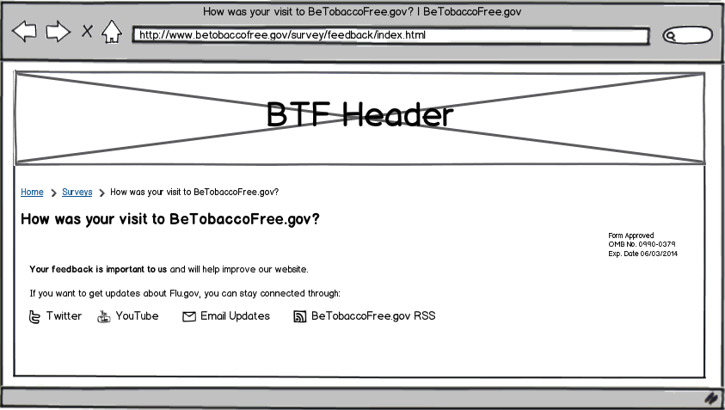

Page-Level Survey

Layout
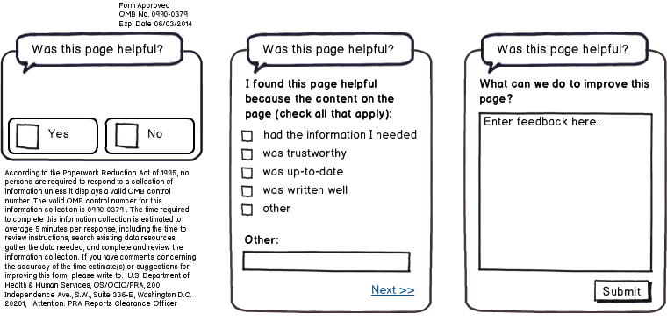

Questions
- Was this page helpful?
  - Yes
  - No
[IF Q1 RESPONSE is YES]
- I found this page helpful because the content on the page: (check all that apply)
  - Had the information I needed
  - Was trustworthy
  - Was up-to-date
  - Was written clearly
  - Other: ____________________________
- What can we do to improve this page?
[IF Q1 RESPONSE is NO]
- I did not find this page helpful because the content on the page: (check all that apply)
  - Had too little information
  - Had too much information
  - Was confusing
  - Was out-of-date
  - Other: ____________________________
- What can we do to improve this page?

