# Screenshots for healthfinder.gov Tree Testing

**Welcome**

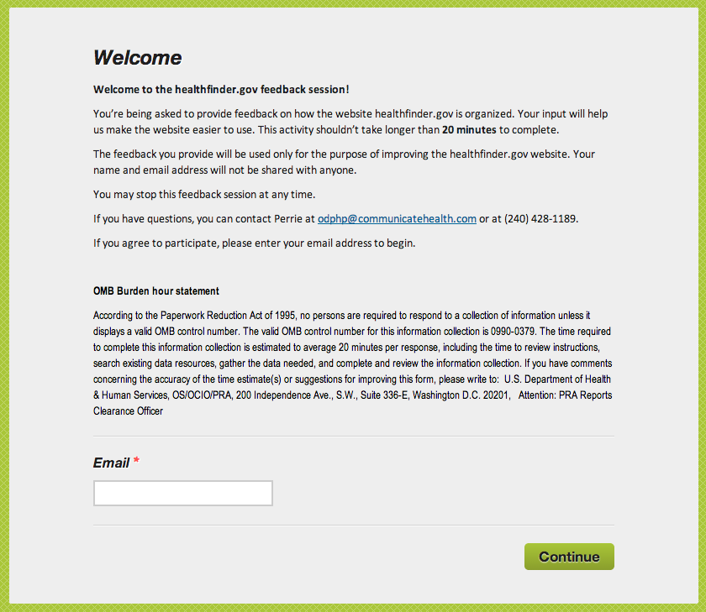

Form Approved

OMB No. 0990-0379

Exp. Date 07/31/2014

**Instructions**

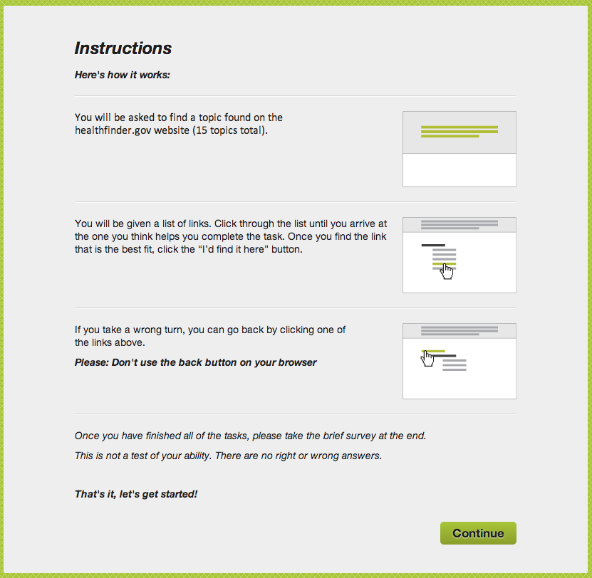

rm Approved

OMB No. 0990-0379

Exp. Date 07/31/2014

**Task 1**

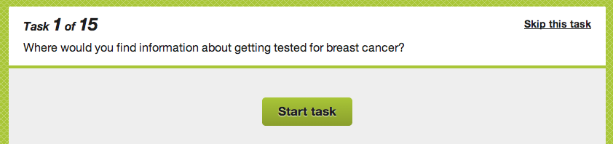

|  |  |  |  |
| --- | --- | --- | --- |
| **Macintosh HD:Users:huijuanwu:Desktop:Screen Shot 2014-01-13 at 11.21.31 AM.png** | **Macintosh HD:Users:huijuanwu:Desktop:Screen Shot 2014-01-13 at 11.21.51 AM.png** | **Macintosh HD:Users:huijuanwu:Desktop:Screen Shot 2014-01-13 at 11.24.20 AM.png** | **Macintosh HD:Users:huijuanwu:Desktop:Screen Shot 2014-01-13 at 11.25.25 AM.png** |

**Task 2**

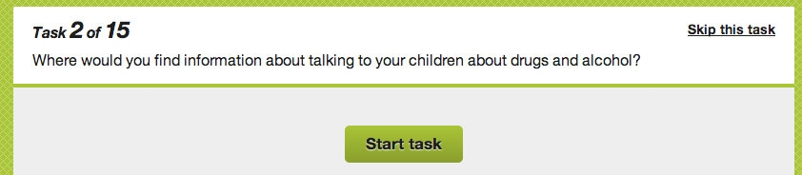

|  |  |  |  |
| --- | --- | --- | --- |
| **Macintosh HD:Users:huijuanwu:Desktop:Screen Shot 2014-01-13 at 11.21.31 AM.png** | **Macintosh HD:Users:huijuanwu:Desktop:Screen Shot 2014-01-13 at 11.21.51 AM.png** |  |  |

**Task 3**

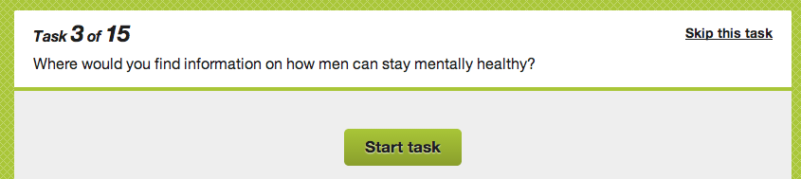

|  |  |  |  |
| --- | --- | --- | --- |
| **Macintosh HD:Users:huijuanwu:Desktop:Screen Shot 2014-01-13 at 11.21.31 AM.png** | **Macintosh HD:Users:huijuanwu:Desktop:Screen Shot 2014-01-13 at 11.21.51 AM.png** |  |  |

# Screenshots for healthypeople.gov Tree Testing

**Welcome**

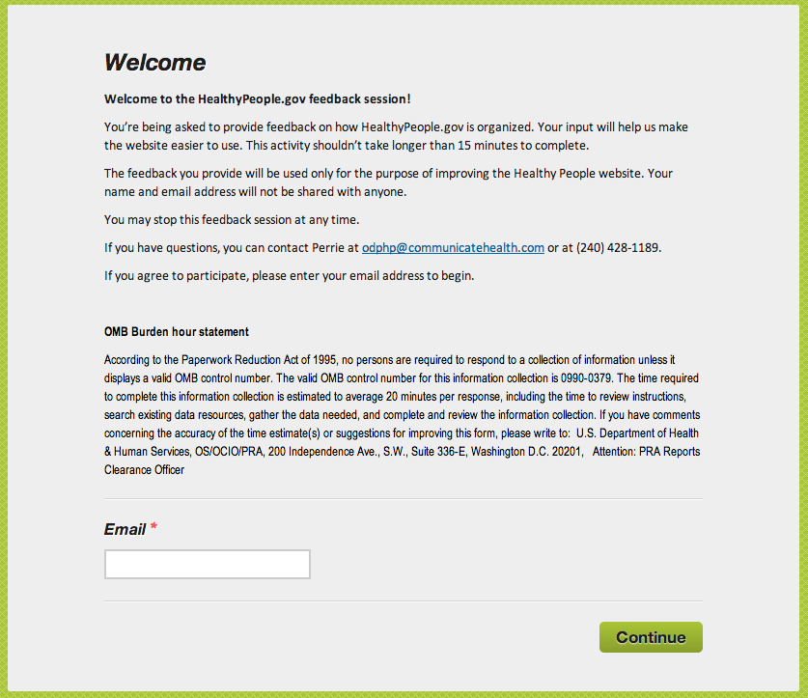

Form Approved

OMB No. 0990-039

Exp. Date 07/31/2014

**Instructions**

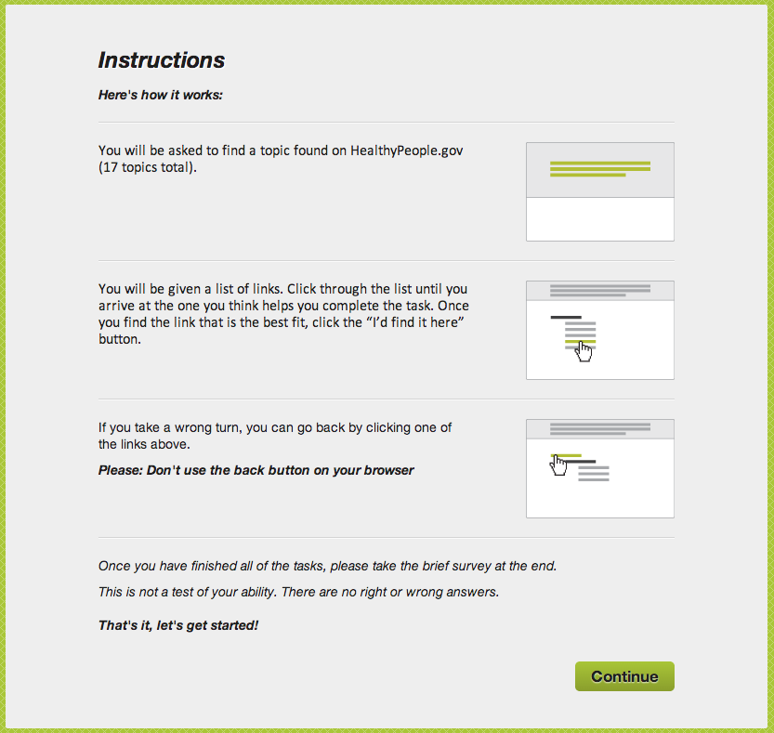

Form Approved

OMB No. 0990-039

Exp. Date 07/31/2014

**Task 1**

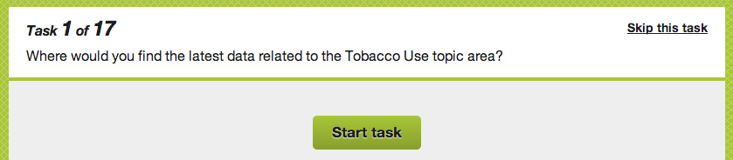

|  |  |  |  |
| --- | --- | --- | --- |
|  |  |  |  |
|  | | | |

**Task 2**

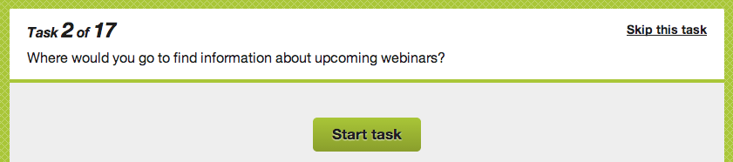

|  |  |  |
| --- | --- | --- |
|  |  |  |

**Task 3**



      
      
      