Voice-of-Customer Surveys

for SurgeonGeneral.gov

# Site-Level Survey for Visitor Feedback

## Introductory Text

**Could you please take a few minutes to let us know what we can do to improve our website.** Click “Next” to participate in this quick survey.

## Questions

1. What were you looking for on SurgeonGeneral.gov today?
   * Learn basic information about the Surgeon General (leadership, roles and responsibilities)
   * Find Reports and Publications of the Office of the Surgeon General
   * Learn more about Office of the Surgeon General initiatives
   * Learn more about the National Prevention Strategy and the National Prevention Council
   * Get news and updates about the Office of the Surgeon General
   * I had nothing specific in mind when I came to the website today
   * Other: ______________________
2. For whom were you looking for information on SurgeonGeneral.gov?
   * Myself
   * My spouse, partner or significant other
   * My child, grandchild, or a child I know
   * My parents
   * A relative
   * A friend
   * No one in particular
3. Were you able to find what you were looking for?
   * Yes
   * Partially
   * No

**[If Q3 response is YES]**

1. How long did it take to find the information?
   * Immediately
   * Few minutes
   * A long time
2. Did you find the information helpful?
   * Yes
   * Partially
   * No

**[If Q5 response is YES]**

1. What did you like best about the content?
2. Based on today’s visit, how would you rate the following?
   * Overall site experience
   * Site design
   * Ease of navigation
3. What can we do to make SurgeonGeneral.gov better?
4. Would you recommend SurgeonGeneral.gov to a family member or friend?

**[If Q5 response is PARTIALLY or NO]**

1. What can we do to make the information more helpful?
2. Based on today’s visit, how would you rate the following:
   1. Overall site experience
   2. Site design
   3. Ease of navigation
3. What can we do to make SurgeonGeneral.gov better?
4. Would you recommend SurgeonGeneral.gov to a family member or friend?

**[If Q3 response is PARTIALLY or NO]**

1. Are there questions in general you didn’t find the answer to? If yes, what are they?
2. Based on today’s visit, how would you rate the following:
   1. Overall site experience
   2. Site design
   3. Ease of navigation
3. What can we do to make SurgeonGeneral.gov better?
4. Would you recommend SurgeonGeneral.gov to a family member or friend?

## Thank You Text

**Your feedback is important to us** and will help improve our website.

If you want to get updates about SurgeonGeneral.gov, you can stay connected through:

* Email updates
* Twitter
* YouTube

# Page-Level Survey

## Layout

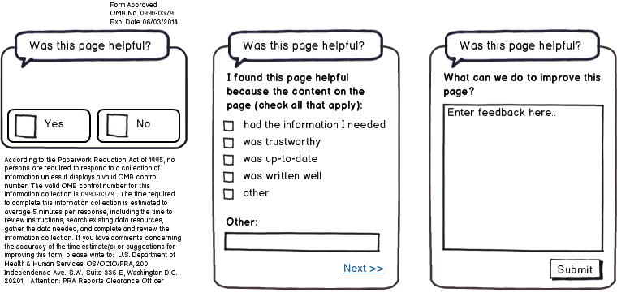

## Questions

1. Was this page helpful?
   * Yes
   * No

**[IF Q1 RESPONSE is YES]**

1. I found this page helpful because the content on the page: (check all that apply)
   * Had the information I needed
   * Was trustworthy
   * Was up-to-date
   * Was written clearly
   * Other: ____________________________
2. What can we do to improve this page?

**[IF Q1 RESPONSE is NO]**

1. I did not find this page helpful because the content on the page: (check all that apply)
   1. Had too little information
   2. Had too much information
   3. Was confusing
   4. Was out-of-date
   5. Other: ____________________________
2. What can we do to improve this page?