Voice-of-Customer Surveys

for HHS.gov

Site-Level Survey for Visitor Feedback

Introductory Text
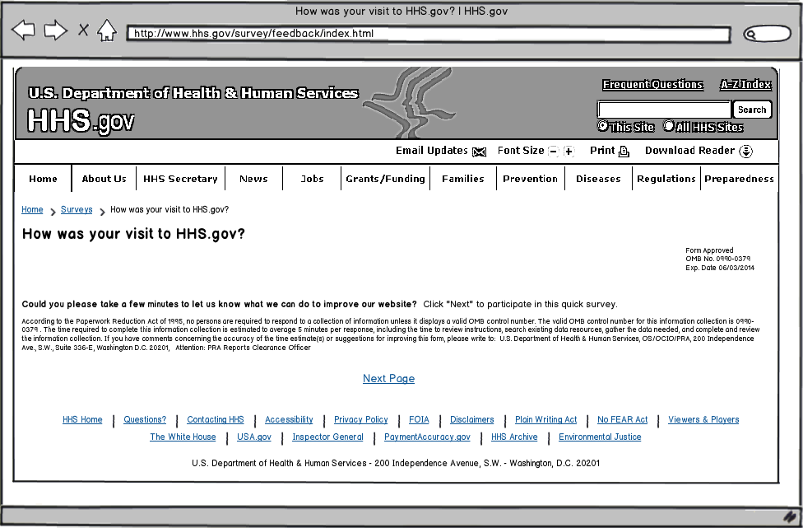

Questions
- What were you looking for on HHS.gov today?
  - Get information about HHS and offices within HHS
  - Learn more about the HHS Secretary
  - Get health information privacy (HIPAA) information
  - Find job openings within HHS
  - Learn about a specific disease or health condition
  - Get answers for health insurance questions
  - Get news and updates about HHS.gov
  - I had nothing specific in mind when I came to the website today.
  - Other: ______________________
- Were you able to find what you were looking for?
  - Yes
  - Partially
  - No
[If Q2 response is YES]
- How long did it take to find the information?
  - Immediately
  - Few minutes
  - A long time
- Did you find the information helpful?
  - Yes
  - Partially
  - No
[If Q4 response is YES]
- What did you like best about the content?
- Based on today’s visit, how would you rate the following?
  - Overall site experience
  - Site design
  - Ease of navigation
- How can we improve HHS.gov?
[If Q4 response is PARTIALLY or NO]
- What can we do to make the information more helpful?
- Based on today’s visit, how would you rate the following:
  - Overall site experience
  - Site design
  - Ease of navigation
- What can we do to make HHS.gov better?
[If Q2 response is PARTIALLY or NO]
- What information were you looking for and did not find on HHS.gov?
- Based on today’s visit, how would you rate the following:
  - Overall site experience
  - Site design
  - Ease of navigation
- What can we do to make HHS.gov better?

Thank You Text
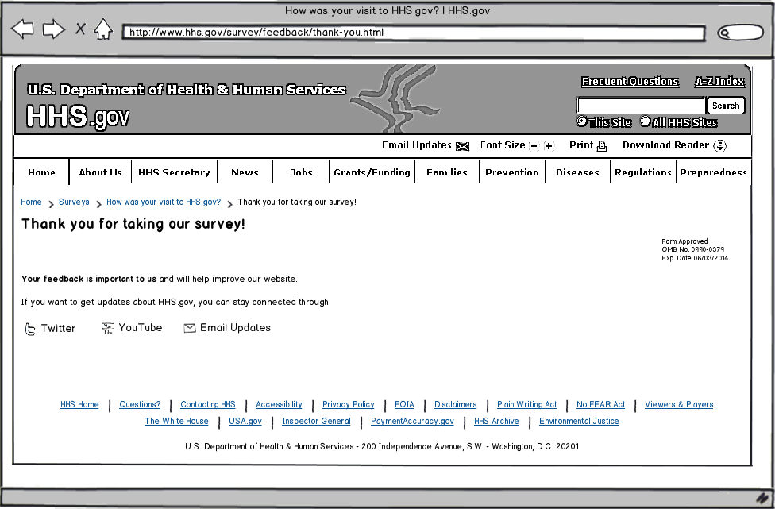

Page-Level Survey

Layout
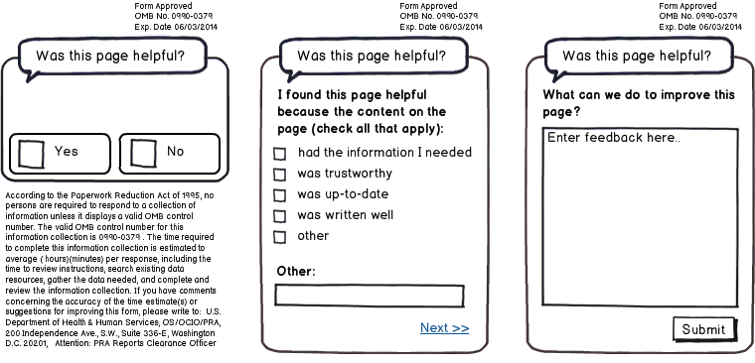

Questions
- Was this page helpful?
  - Yes
  - No
[IF Q1 RESPONSE is YES]
- I found this page helpful because the content on the page: (check all that apply)
  - Had the information I needed
  - Was trustworthy
  - Was up-to-date
  - Was written well
  - Other: ____________________________
- What can we do to improve this page?
[IF Q1 RESPONSE is NO]
- I did not find this page helpful because the content on the page: (check all that apply)
  - Had too little information
  - Had too much information
  - Was confusing
  - Was out-of-date
  - Was poorly written
  - Other: ____________________________
- What can we do to improve this page?

