Voice-of-Customer Surveys

for SurgeonGeneral.gov

Site-Level Survey for Visitor Feedback

Introductory Text
Could you please take a few minutes to let us know what we can do to improve our website. Click “Next” to participate in this quick survey.

Questions
- What were you looking for on SurgeonGeneral.gov today?
  - Learn basic information about the Surgeon General (leadership, roles and responsibilities)
  - Find Reports and Publications of the Office of the Surgeon General
  - Learn more about Office of the Surgeon General initiatives
  - Learn more about the National Prevention Strategy and the National Prevention Council
  - Get news and updates about the Office of the Surgeon General
  - I had nothing specific in mind when I came to the website today
  - Other: ______________________
- For whom were you looking for information on SurgeonGeneral.gov?
  - Myself
  - My spouse, partner or significant other
  - My child, grandchild, or a child I know
  - My parents
  - A relative
  - A friend
  - No one in particular
- Were you able to find what you were looking for?
  - Yes
  - Partially
  - No
[If Q3 response is YES]
- How long did it take to find the information?
  - Immediately
  - Few minutes
  - A long time
- Did you find the information helpful?
  - Yes
  - Partially
  - No
[If Q5 response is YES]
- What did you like best about the content?
- Based on today’s visit, how would you rate the following?
  - Overall site experience
  - Site design
  - Ease of navigation
- What can we do to make SurgeonGeneral.gov better?
- Would you recommend SurgeonGeneral.gov to a family member or friend?
[If Q5 response is PARTIALLY or NO]
- What can we do to make the information more helpful?
- Based on today’s visit, how would you rate the following:
  - Overall site experience
  - Site design
  - Ease of navigation
- What can we do to make SurgeonGeneral.gov better?
- Would you recommend SurgeonGeneral.gov to a family member or friend?
[If Q3 response is PARTIALLY or NO]
- Are there questions in general you didn’t find the answer to? If yes, what are they?
- Based on today’s visit, how would you rate the following:
  - Overall site experience
  - Site design
  - Ease of navigation
- What can we do to make SurgeonGeneral.gov better?
- Would you recommend SurgeonGeneral.gov to a family member or friend?

Thank You Text
Your feedback is important to us and will help improve our website.
If you want to get updates about SurgeonGeneral.gov, you can stay connected through:
- Email updates
- Twitter
- YouTube

Page-Level Survey

Layout
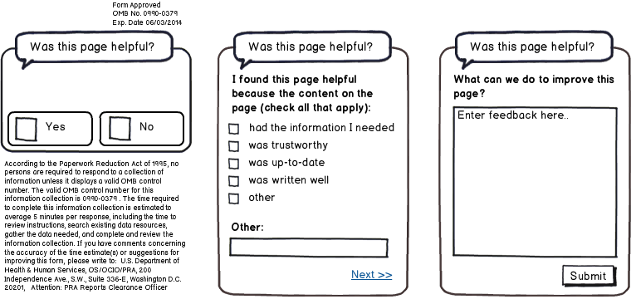

Questions
- Was this page helpful?
  - Yes
  - No
[IF Q1 RESPONSE is YES]
- I found this page helpful because the content on the page: (check all that apply)
  - Had the information I needed
  - Was trustworthy
  - Was up-to-date
  - Was written clearly
  - Other: ____________________________
- What can we do to improve this page?
[IF Q1 RESPONSE is NO]
- I did not find this page helpful because the content on the page: (check all that apply)
  - Had too little information
  - Had too much information
  - Was confusing
  - Was out-of-date
  - Other: ____________________________
- What can we do to improve this page?

