mHealth Privacy and Security Consumer Research

Question 1 Visual Guide

The following will be shown on a flip chart:

|  |  |  |
| --- | --- | --- |
| **Internet** | **Cell Phones** | **Smart Phone /**  **iPad type device** |
|  |  |  |

**Visual of YELP:**



**Visual of Four Square**

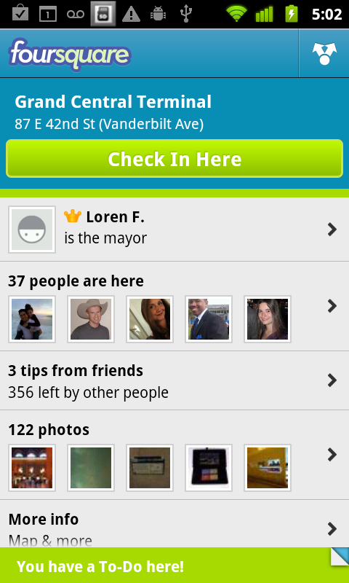

mHealth Privacy and Security Consumer Research

Question 2a Visual Guide

The following will be shown on a flip chart:

|  |  |  |  |  |  |
| --- | --- | --- | --- | --- | --- |
| [*Moderator writes*  *What you do online #1*] | | [*Moderators writes*  *What you do online #2*] | | [*Moderator writes*  *What you do online #3*] | |
| Very convenient |  | Very convenient |  | Very convenient |  |
| Convenient |  | Convenient |  | Convenient |  |
| Somewhat convenient |  | Somewhat convenient |  | Somewhat convenient |  |
| Not convenient |  | Not convenient |  | Not convenient |  |

mHealth Privacy and Security Consumer Research

Question 6 Visual Guide

The following visuals will be shown via a power point presentation:

Mammogram screening reminder

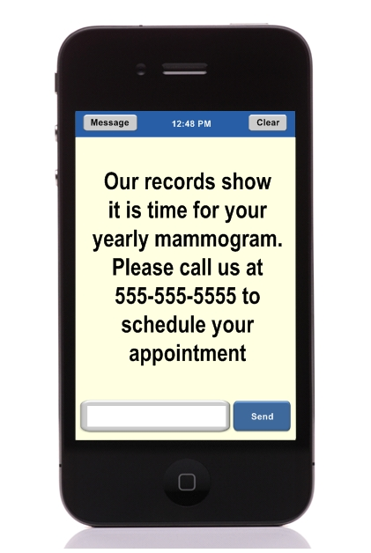

Annual Physical reminder

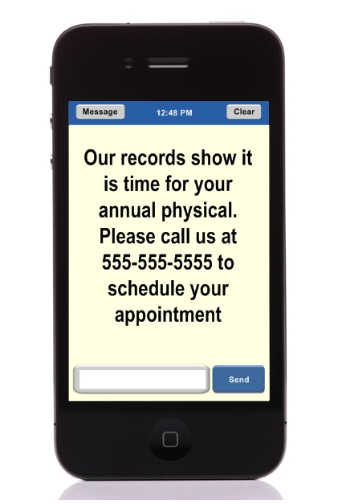

Dental visit reminder

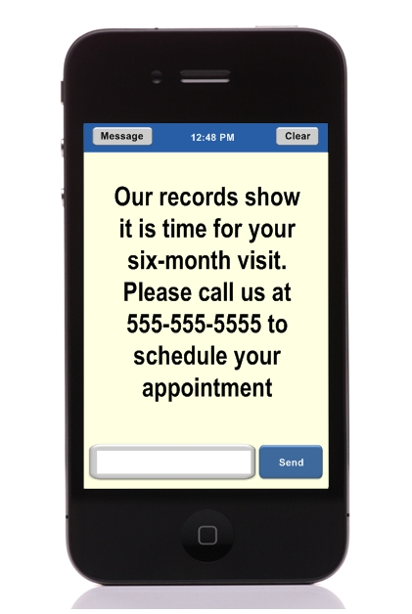

Flu shot reminder

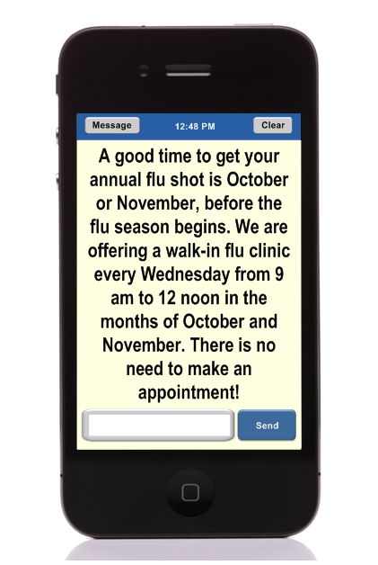

Lower your cholesterol reminder

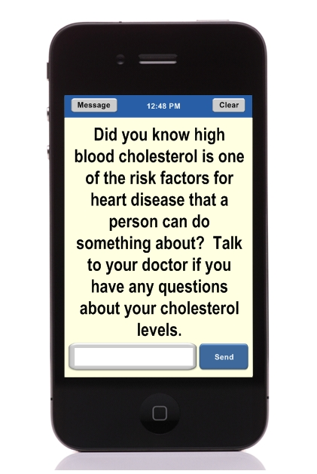

Eating fruits and vegetables

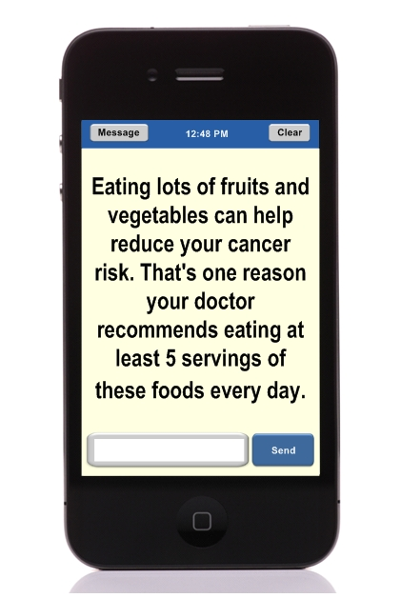

STD testing text message

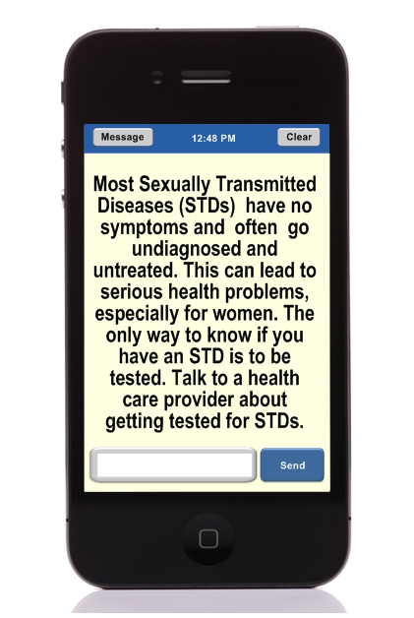

mHealth Privacy and Security Consumer Research

Question 7 Visual Guide

The following will be shown on a flip chart:

|  |  |  |
| --- | --- | --- |
| **Types of personal health information you are not comfortable exchanging through mobile devices** | | |
|  |  |  |
|  |  |  |
|  |  |  |
|  |  |  |
|  |  |  |
|  |  |  |
|  |  |  |

mHealth Privacy and Security Consumer Research

Question 8 Visual Guide

The following will be shown on a flip chart:

|  |  |  |
| --- | --- | --- |
| **Types of personal health information your provider might send to you or you might send to him/her through mobile communication** | | |
| **Type of information** | **Thoughts** | **Preference of device v. phone** |
| Lab test results (see visual on next page) |  |  |
| Information about yourself you collect at home: weight |  |  |
| Information about yourself you collect at home: diet |  |  |
| Information about yourself you collect at home: glucose levels |  |  |
| Information about yourself you collect at home: blood pressure results |  |  |
| Medication/refill reminders of information |  |  |
| Images (for example, ending your provider a picture of an ankle injury or your provider sending you an image of a health condition) |  |  |
| Diagnostic information such as blood sugar readings that go directly from your glucometer to your provider’s office |  |  |
| Information from your electronic health record |  |  |

mHealth Privacy and Security Consumer Research

Question 8 Visual Guide

Lab test results

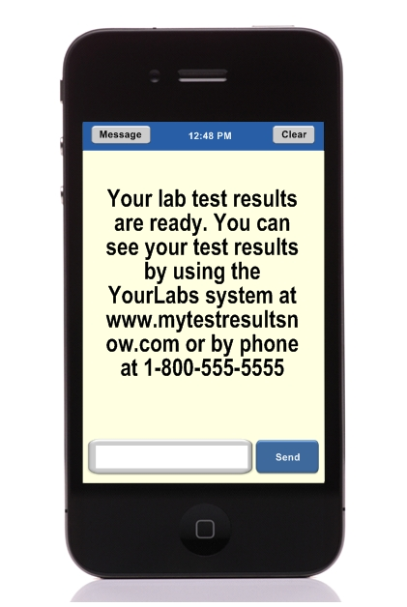

mHealth Privacy and Security Consumer Research

Question 12a and 12b Visual Guide

The following will be shown on a flip chart:

|  |  |
| --- | --- |
| **Communication** | **Type of privacy protections that would be adequate for you to use your mobile device to communicate with your provider** |
| Blood test results |  |
| Diagnoses |  |
| Medication taking |  |
| Blood pressure monitoring |  |
| Monitoring the amount of movement and exercise you get for 24 hours |  |