OMB Control Number: 1024-0224

Expiration Date: 8-31-2014

**Sound Survey: *A Rating of the Soundscape***

***Survey No: ________________________ Date: ________________________***

***Issuing Location: ______________________ Time: ________________________***

We are seeking to help park managers understand visitor perception of natural and man-made sounds in the park. Your participation is voluntary. We would like to ask you follow the instruction below to complete this brief questionnaire.

1. While walking along the trail, take the time to be mindful of the various sounds that you hear.
2. Please stop every 30 to 60 minutes (a total of 4 to 6 times) during your hike to reflect upon the all of the sounds you’ve heard during that time interval.
3. When you are at a safe place, off the trail, please complete the questions below for each location. Record the time, answer the questions and mark your approximate location on the map (on the back page of the booklet).
4. Your safety and wellbeing are our highest concern today. When you stop, be careful to step off the trail so that others may pass. Please use your best judgment when stopping along the trail.
5. Remember thatall sounds are included, both man-made and natural.
6. Please return this survey to us at the end of your hike. If, no one is there, please it to Ranger Station, Visitor Center, or entry/exit gate.

**A few questions about you before we get started**

1. What is your gender? □ Male □ Female
2. Please mark your age range □ 16 TO 25 □ 25 TO 40 □ 40 TO 60 □ OVER 60
3. If you are a us citizen or permanent resident, please write your home zip code; if you are a Canadian visitor, please write your home province; if you are a foreign visitor, please write your home country ___________________
4. Is everyone in your group 16 years or older? □ Yes □ No
5. Is this your first time hiking this trail? □ Yes □ No
6. How important is natural quiet to you?

□ Not at all important

□ Slightly important

□ Moderately important

□ Very important

□ Extremely important

**Location 1**

CURRENT TIME ______________

Please mark an **X** for each sound that you heard along this past segment of the trail.

|  |  |  |  |
| --- | --- | --- | --- |
| □ Wind | □ Walking sounds | □ Running water | □ Jet plane |
| □ Thunder | □ Propeller plane | □ Helicopter | □ Bird |
| □ Insect | □ Motor vehicle | □ Voices | □ Yelling |
| □ Other. What else do you hear? ___________________________________________________ | | | |

Please rate the *PLEASANTNESS* or *UNPLEASANTNESS* of the overall sound that you heard along this past segment of the trail. Mark your single choice with an X.

|  |  |  |  |  |  |  |
| --- | --- | --- | --- | --- | --- | --- |
| Very  pleasant | Moderately  pleasant | A little  pleasant | Neutral | A little  unpleasant | Moderately unpleasant | Very  unpleasant |
|  |  |  |  |  |  |  |

**Please mark your approximate current position on the map with # 1**

**Location 2**

CURRENT TIME __________________

Please mark an **X** for each sound that you heard along this past segment of the trail.

|  |  |  |  |
| --- | --- | --- | --- |
| □ Wind | □ Walking sounds | □ Running water | □ Jet plane |
| □ Thunder | □ Propeller plane | □ Helicopter | □ Bird |
| □ Insect | □ Motor vehicle | □ Voices | □ Yelling |
| □ Other. What else do you hear? __________________________________________________ | | | |

Please rate the *PLEASANTNESS* or *UNPLEASANTNESS* of the overall sound that you heard along this past segment of the trail. Mark your single choice with an X.

|  |  |  |  |  |  |  |
| --- | --- | --- | --- | --- | --- | --- |
| Very  pleasant | Moderately  pleasant | A little  pleasant | Neutral | A little  unpleasant | Moderately unpleasant | Very  unpleasant |
|  |  |  |  |  |  |  |

**Please mark your approximate current position on the map with # 2**

**Location 3**

CURRENT TIME ______________

Please mark an **X** for each sound that you heard along this past segment of the trail.

|  |  |  |  |
| --- | --- | --- | --- |
| □ Wind | □ Walking sounds | □ Running water | □ Jet plane |
| □ Thunder | □ Propeller plane | □ Helicopter | □ Bird |
| □ Insect | □ Motor vehicle | □ Voices | □ Yelling |
| □ Other. What else do you hear? ___________________________________________________ | | | |

Please rate the *PLEASANTNESS* or *UNPLEASANTNESS* of the overall sound that you heard along this past segment of the trail. Mark your single choice with an X.

|  |  |  |  |  |  |  |
| --- | --- | --- | --- | --- | --- | --- |
| Very  pleasant | Moderately  pleasant | A little  pleasant | Neutral | A little  unpleasant | Moderately unpleasant | Very  unpleasant |
|  |  |  |  |  |  |  |

**Please mark your approximate current position on the map with # 3**

**Location 4**

CURRENT TIME __________________

Please mark an **X** for each sound that you heard along this past segment of the trail.

|  |  |  |  |
| --- | --- | --- | --- |
| □ Wind | □ Walking sounds | □ Running water | □ Jet plane |
| □ Thunder | □ Propeller plane | □ Helicopter | □ Bird |
| □ Insect | □ Motor vehicle | □ Voices | □ Yelling |
| □ Other. What else do you hear? ___________________________________________________ | | | |

Please rate the *PLEASANTNESS* or *UNPLEASANTNESS* of the overall sound that you heard along this past segment of the trail. Mark your single choice with an X.

|  |  |  |  |  |  |  |
| --- | --- | --- | --- | --- | --- | --- |
| Very  pleasant | Moderately  pleasant | A little  pleasant | Neutral | A little  unpleasant | Moderately unpleasant | Very  unpleasant |
|  |  |  |  |  |  |  |

**Please mark your approximate current position on the map with # 4**

**Location 5**

CURRENT TIME ______________

Please mark an **X** for each sound that you heard along this past segment of the trail.

|  |  |  |  |
| --- | --- | --- | --- |
| □ Wind | □ Walking sounds | □ Running water | □ Jet plane |
| □ Thunder | □ Propeller plane | □ Helicopter | □ Bird |
| □ Insect | □ Motor vehicle | □ Voices | □ Yelling |
| □ Other. What else do you hear? ___________________________________________________ | | | |

Please rate the *PLEASANTNESS* or *UNPLEASANTNESS* of the overall sound that you heard along this past segment of the trail. Mark your single choice with an X.

|  |  |  |  |  |  |  |
| --- | --- | --- | --- | --- | --- | --- |
| Very  pleasant | Moderately  pleasant | A little  pleasant | Neutral | A little  unpleasant | Moderately unpleasant | Very  unpleasant |
|  |  |  |  |  |  |  |

**Please mark your approximate current position on the map with # 5**

**Location 6**

CURRENT TIME __________________

Please mark an **X** for each sound that you heard along this past segment of the trail.

|  |  |  |  |
| --- | --- | --- | --- |
| □ Wind | □ Walking sounds | □ Running water | □ Jet plane |
| □ Thunder | □ Propeller plane | □ Helicopter | □ Bird |
| □ Insect | □ Motor vehicle | □ Voices | □ Yelling |
| □ Other. What else do you hear? ___________________________________________________ | | | |

Please rate the *PLEASANTNESS* or *UNPLEASANTNESS* of the overall sound that you heard along this past segment of the trail. Mark your single choice with an X.

|  |  |  |  |  |  |  |
| --- | --- | --- | --- | --- | --- | --- |
| Very  pleasant | Moderately  pleasant | A little  pleasant | Neutral | A little  unpleasant | Moderately unpleasant | Very  unpleasant |
|  |  |  |  |  |  |  |

**Please mark your approximate current position on the map with # 6**

**End of Hike**

CURRENT TIME ______________

Please rate the *PLEASANTNESS* or *UNPLEASANTNESS* of the overall sound that you heard along ***the entire hike, the whole trail.*** Mark your single choice with an X.

|  |  |  |  |  |  |  |
| --- | --- | --- | --- | --- | --- | --- |
| Very  pleasant | Moderately  pleasant | A little  pleasant | Neutral | A little  unpleasant | Moderately unpleasant | Very  unpleasant |
|  |  |  |  |  |  |  |

|  |  |
| --- | --- |
| During my hike I heard natural sounds…. | |
|  | Almost always clearly without interference from man-made sounds |
|  | Usually clearly without interference from man-made sounds |
|  | Sometimes clearly without interference from man-made sounds |
|  | Usually interfered with by man-made sounds |
|  | Almost always interfered with by man-made sounds |

Please use this map to identify each location along the trail that you stopped. For each question answered, clearly mark the corresponding question number on the map.

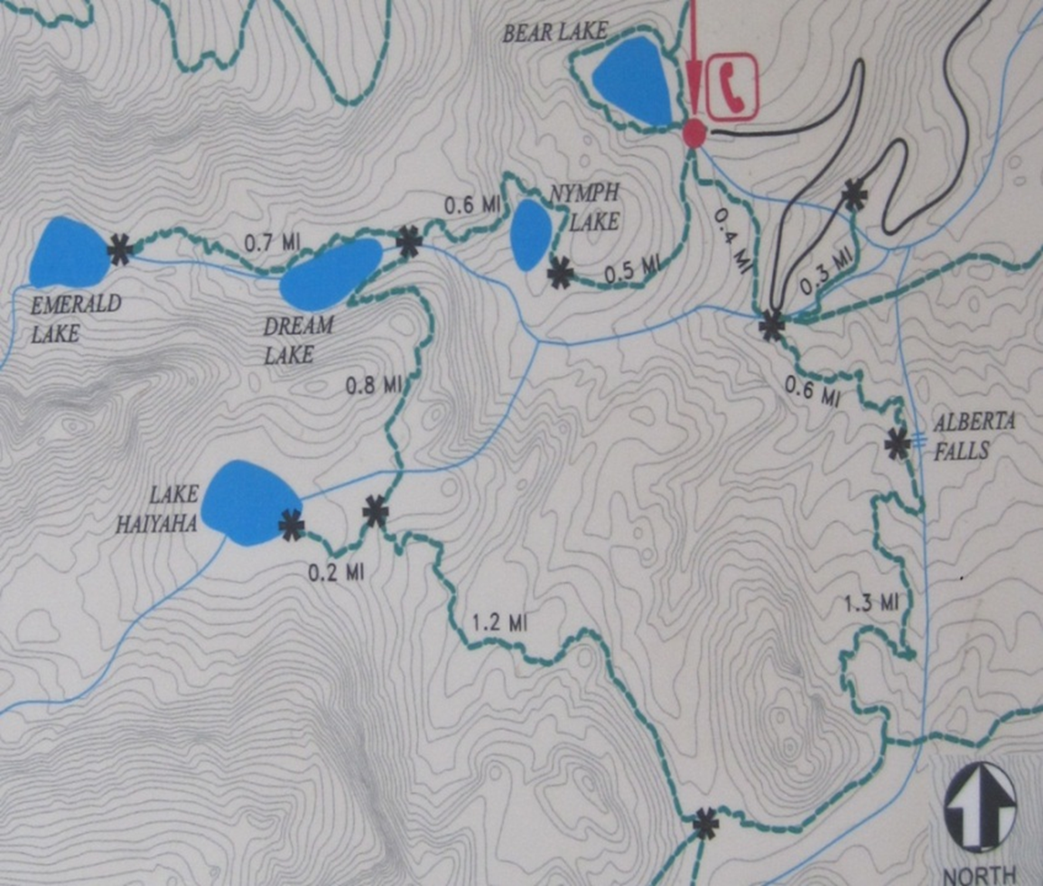

**PAPERWORK REDUCTION ACT STATEMENT**: The National Park Service is authorized by 16 U.S.C. 1a-7 to collect this information. This information will be used by park managers understand visitor perception of natural and man-made sounds in the park. Your response to this request is voluntary and anonymous. No action may be taken against you for refusing to supply the information requested. An agency may not conduct or sponsor, and a person is not required to respond to, a collection of information unless it displays a currently valid OMB control number.

**BURDEN ESTIMATE STATEMENT**: Public reporting burden for this form is estimated to be 20 minutes per response. Direct comments regarding the burden estimate or any other aspect of this form to Frank Turina, Program Manager Division Chief; National Park Service, Natural Sounds and Night Skies Division, [frank_turina@nps.gov](mailto:frank_turina@nps.gov) (email); 1201 Oakridge Drive, Fort Collins, CO 80525.