Katmai National Park and Preserve Visitor Study

Follow-up mailing letters

1st follow-up: note printed on a scenic park postcard (sent to all participants 11 working days after completion of survey)

Dear Visitor:

Thank you for participating in the Katmai National Park and Preserve visitor study. We look forward to hearing from you.

A select number of people were contacted for this study, so your opinions are very important!

If you have already returned your questionnaire, thank you. If not, please mail it today.

Superintendent
Katmai National Park and Preserve
OMB Approval 1024-0224
Expiration Date: 2014

2nd follow-up: letter with replacement questionnaire (sent to non-respondents 21 working days after completion of survey)

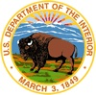  IN REPLY REFER TO: | United States Department of the Interior  NATIONAL PARK SERVICE  Katmai National Park & Preserve  1000 Silver Street, Bldg 603 P.O. Box 7  King Salmon, AK 99613 | 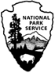

Month, 2014

Dear Visitor:

The National Park Service would like to thank you for participating in the Katmai National Park and Preserve visitor study. Only a select number of visitors were contacted, therefore each visitor's opinions are very important.

If you have already returned your questionnaire, thank you. If you have not returned your questionnaire, please mail it today. Unless your questionnaire was mailed in the last few days, we would appreciate you completing the enclosed replacement questionnaire since we have not received yours as of today.

If you have any questions, please contact Lena Le, Director, SESRC, Wilson-Short Hall #133, Washington State University, Pullman, WA 99164-4014, 509-335-1512 (phone), lena.le@wsu.edu(email).

Thank you for sharing your opinions with us.

Sincerely,

Insert signature

name
Superintendent

OMB Approval 1024-0224
Expiration Date: 2014

3rd follow-up: letter with replacement questionnaire (sent to non-respondents 35 working days after completion of survey)

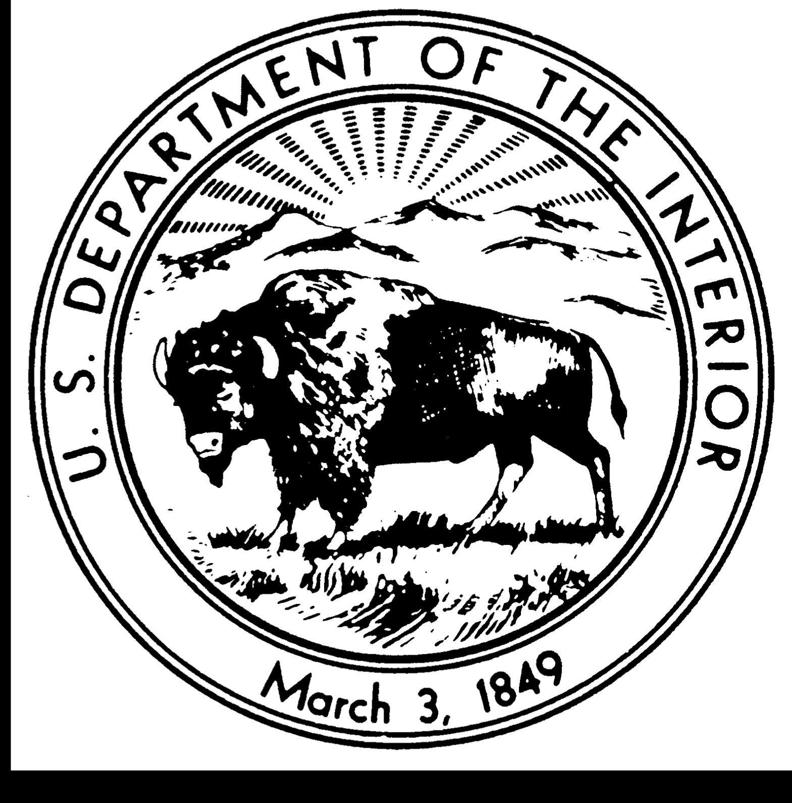  IN REPLY REFER TO: | United States Department of the Interior  NATIONAL PARK SERVICE  Social and Economic Sciences Research Center  Washington State University  PO Box 644014, Wilson-Short Hall #133  Pullman, WA 99164-4014

Month, 2014

Dear Visitor:

I am writing about the visitor study at Katmai National Park and Preserve, in which you agreed to participate. The waiting period for incoming questionnaires is almost over, and as of today we have not yet received yours. I would appreciate you completing another one, unless you mailed it within the past few days.

The staff of Katmai National Park and Preserve is anxiously awaiting the survey results. They want to use your ideas and opinions in making decisions about services and programs to provide for visitors in the future.

I urge you to complete the enclosed questionnaire and return it by Month Day. Your contribution to the success of this study is greatly appreciated.

If you have any questions, please contact Lena Le, Director, SESRC, Wilson-Short Hall #133, Washington State University, Pullman, WA 99164-4014, 509-335-1512 (phone), lena.le@wsu.edu(email).
.

Sincerely,

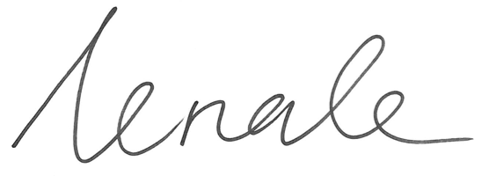
Lena Le
Director, SESRC

OMB Approval: 1024-0224
Expiration Date: 2014

