|  |  |  |
| --- | --- | --- |
|  | | |
| doi_logo | U.S. Department of the InteriorNational Park Service **Social Science Program**  **Visitor Services Project** | w npslogo |

# Chickamauga and Chattanooga

# National Military Park

### Visitor Study

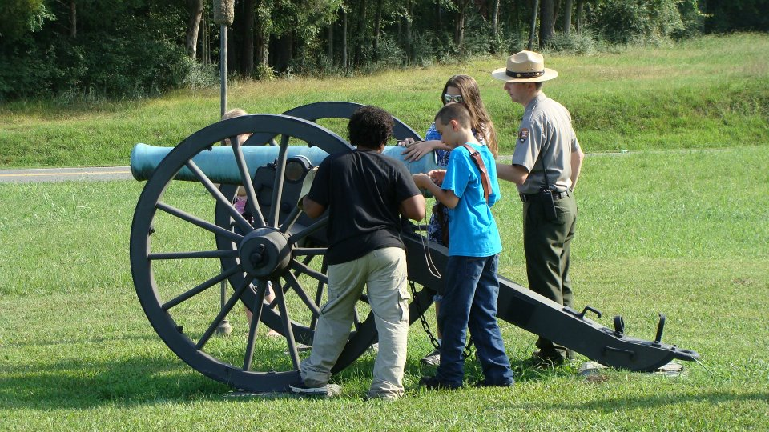

OMB Approval 1024-0224

Expiration date: 2014

|  |  |  |
| --- | --- | --- |
| doi_logo  IN REPLY REFER TO: | **United States Department of the Interior**  NATIONAL PARK SERVICE  Chickamauga and Chattanooga  National Military Park P.O. Box 2128 Fort Oglethorpe, Georgia 30742 | Description: w npslogo |
| Summer 2014  Dear Visitor:  Thank you for participating in this important study. Our goal is to learn about the expectations, opinions, and interests of visitors to Chickamauga and Chattanooga National Military Park. This information will assist us in our efforts to better manage this park and to serve you.  This questionnaire is only being given to a select number of visitors, so your participation is very important. It should only take about 20 minutes after your visit to complete.  When your visit is over, please complete this questionnaire. Seal it in the postage-paid envelope provided and drop it in any U.S. mailbox.  If you have any questions, please contact Lena Le, College of Natural Resources, University of Idaho, 875 Perimeter Drive MS1139, Moscow, Idaho 83844-1139, 208-885-2585 (phone), [lenale@uidaho.edu](mailto:lenale@uidaho.edu) (email).  We appreciate your help.  Sincerely,  *Insert signature*  Superintendent | | |

|  |
| --- |
| **DIRECTIONS**  At the end of your visit:  1. Please have the selected individual (at least 16 years old) complete this questionnaire.  2. For questions that use circles (O), please mark your answer by filling in the circle with ***black or blue ink***. Please do not use pencil.  Description: bubble-fill-example  3. Seal it in the postage-paid envelope provided.  4. Drop it in a U.S. mailbox. |

|  |
| --- |
| **Paperwork Reduction Act Statement:** The National Park Service is authorized by 16 U.S.C. 1a-7 to collect this information. We will use this information to evaluate visitor experiences at Chickamauga & Chattanooga National Military Park. Your response is voluntary. Your name and contact information have been requested for follow-up mailing purposes only. When analysis of the questionnaire is completed, all name and address files will be destroyed and will in no way be connected with the results of this survey. A Federal agency may not conduct or sponsor, and you are not required to respond to, a collection of information unless it displays a currently valid OMB Control Number.  We estimate that it will take about 20 minutes to complete this. You may send comments concerning the burden estimates or any aspect of this information collection to: Lena Le, College of Natural Resources, University of Idaho, 875 Perimeter Drive MS1139, Moscow, Idaho 83844-1139, 208-885-2585 (phone), [lenale@uidaho.edu](mailto:lenale@uidaho.edu) (email). |

**NOTE TO OMB REVIEWER:**

**For the purposes of this review and submission the questions in this survey are all included and are consistent with the currently approved pool questions for the NPS Programmatic Review Process (OMB Control #1024-0224 – Current Expiration Date: 8-31-2014).**

**Your Visit To Chickamauga and Chattanooga National Military Park**

NOTE: In this questionnaire, your **personal group** is defined as anyone with whom you are visiting the park, such as a spouse, family, friends, etc. This does not include the larger group that you might be traveling with, such as a school, church, scout, or tour group.

**Topic Area 3** – TRIPC14

1. On this visit to Chickamauga and Chattanooga National Military Park (NMP), which routes did your personal group use to reach the park? Please mark (•) **all** that apply.

O Interstate 75 O Scenic Highway (148)

O Interstate 24 O Georgia State Route 2

O US 27 O Ochs Highway

O Other routes (Please specify)

**Topic Area 6** – EVALSERV4

2. On this visit, were the signs directing your personal group to Chickamauga and Chattanooga NMP adequate? Please mark (•) **one** answer for each.

|  |  |  |  |  |  |  |
| --- | --- | --- | --- | --- | --- | --- |
| a) Interstate signs | O | Yes | O | No | O | Did not use |
| b) State highway signs | O | Yes | O | No | O | Did not use |
| c) Signs in local communities | O | Yes | O | No | O | Did not use |
| d) Battlefield Tour route signs | O | Yes | O | No | O | Did not use |

**Topic Area 6** – EVALSERV5

e) If you answered NO for any of the above, please explain.

Interstate signs

State highway signs

Signs in local communities

Signs along Battlefield Tour route

**Topic Area 5** – CROWD5

3. For each site listed below, was the parking adequate? Please mark (•) **one** answer for each.

|  |  |  |  |  |  |  |
| --- | --- | --- | --- | --- | --- | --- |
| a) Tour route | O | Yes | O | No | O | Did not use |
| b) Visitor Center | O | Yes | O | No | O | Did not use |
| c) Recreational sites | O | Yes | O | No | O | Did not use |

**Topic Area 5** – CROWD8

d) If you answered NO for any of the above, please explain.

Tour route

Visitor Center

Recreational sites

**Topic Area 3** – ITIN5

4. For this visit, please indicate the order in which your personal group visited the following sites at Chickamauga and Chattanooga NMP by writing 1, 2, 3, etc., in the boxes on the map below. If you did not visit a site, please leave that box blank.

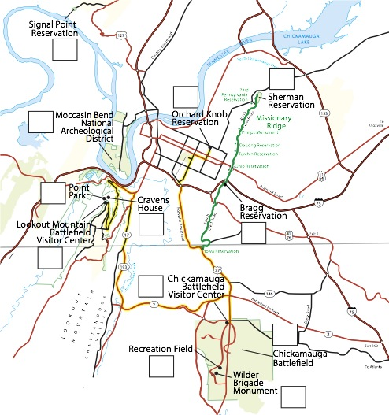

**Topic Area 3** – TRIPC8

5. a) **On this visit** to Chickamauga and Chattanooga NMP, how much time in **total** did your personal group spend visiting battlefield sites? Please list partial hours as ¼, ½, or ¾.

Total number of hours

**Topic Area 3** – TRIPC6

b) Did your personal group visit the battlefield on more than one day?

O No O Yes 🡺 c) If YES, how many days?

**Topic Area 1** – KNOW9

6. a) For each park site listed below please indicate in column (a) if your personal group was aware of the site prior to visiting Chickamauga and Chattanooga NMP. Please mark (•) one for each site.

**Topic Area 1** – KNOW10B

b) For each site that you **were aware of prior to this visit**, in column (b) please tell us how became aware of the site.

|  |  |  |  |
| --- | --- | --- | --- |
|  | a) **Aware of site *prior to park visit*?** | |  |
| **Park site** | **Yes** | **No** | b) **How did you become aware of the site?** |
| Bragg Reservation | O | O |  |
| Chickamauga Battlefield | O | O |  |
| Cravens House Reservation | O | O |  |
| Moccasin Bend National Archeological District | O | O |  |
| Orchard Knob Reservation | O | O |  |
| Point Park | O | O |  |
| Recreation Field at Chickamauga Battlefield | O | O |  |
| Sherman Reservation | O | O |  |
| Signal Point | O | O |  |
| Visitor Center at Lookout Mountain | O | O |  |
| Visitor Center at Chickamauga Battlefield | O | O |  |
| Wilder Brigade Monument | O | O |  |

**Topic Area 3** – ACT1C

7. On this visit, in which activities did your personal group participate within Chickamauga and Chattanooga NMP? Please mark (•) **all** that apply.

|  |  |
| --- | --- |
|  | **Activity** |
| O | Bicycling |
| O | Conducting genealogy or historical research |
| O | Creative arts (photography, drawing, painting, writing) |
| O | Dog walking |
| O | Hiking/walking/jogging |
| O | Horseback riding |
| O | Listening to audio-tape tour |
| O | Participate in Junior Ranger program |
| O | Picnicking |
| O | Rock climbing |
| O | Taking self-guided tour other than cell phone tour |
| O | Taking self-guided tour with cell phone |
| O | Visit visitor center |
| O | Wildlife Viewing |
| O | Other (Specify) \_\_\_\_\_\_\_\_\_\_\_\_\_\_\_\_\_\_\_\_\_\_\_\_\_\_\_\_\_\_\_\_\_\_\_\_ |

**Topic Area 3** – ACT28

8. a) During this visit to Chickamauga and Chattanooga NMP, did your personal group have any personal interaction with a park ranger?

O Yes O No 🡺 **Go on to Question 9**

**Topic Area 6** – EVALSERV10

1. If YES, please rate the quality of your interaction with the park ranger. Please mark (•) **one** answer for each

|  |  |  |  |  |  |
| --- | --- | --- | --- | --- | --- |
|  | **Very poor** | **Poor** | **Average** | **Good** | **Very good** |
| Helpfulness | O | O | O | O | O |
| Courteousness | O | O | O | O | O |
| Information provided | O | O | O | O | O |

**Topic Area 6** – OPMGMT5

9. Please rate how appropriate you feel the following activities are at Chickamauga and Chattanooga NMP. Please mark (•) **one** answer for each activity.

|  |  |  |  |  |  |
| --- | --- | --- | --- | --- | --- |
| **Activity** | **Very inappropriate** | **Somewhat inappropriate** | **No opinion** | **Somewhat appropriate** | **Very appropriate** |
| Bicycling | O | O | O | O | O |
| Horseback riding | O | O | O | O | O |
| Jogging/running | O | O | O | O | O |
| Picnicking | O | O | O | O | O |
| Rock climbing | O | O | O | O | O |
| Sunbathing | O | O | O | O | O |
| Throwing footballs, baseballs, etc. | O | O | O | O | O |
| Throwing frisbees, | O | O | O | O | O |

**Topic Area 3** – TRIPC19

10. On this trip to Chickamauga and Chattanooga NMP, please mark (•) **all** other attractions that your personal group visited **in the area** (within 100 miles of park).

O Did not visit any of the following places 🡺 **Go on to Question 11**

O Chattanooga Arboretum and Nature Center

O Chattanooga Riverwalk

O Hunter Museum

O Kennesaw Mountain National Battlefield Park

O Rock City

O Ruby Falls

O Stones River National Battlefield

O Tennessee Aquarium

O Other (Please specify)

**Topic Area 6** – EVALSERV13

11. a) Please mark (•) **all** the services and facilities that your personal group **used** at Chickamauga and Chattanooga NMP during this visit.

b) For only those services and facilities that your personal group **used**, please rate their importance to your visit from 1-5.

c) For only those services and facilities that your personal group **used**, please rate their quality from 1-5.

|  |  |  |
| --- | --- | --- |
| a) **Visitor services/facilities used** | b) **If used,**  **how important?**  1=Not at all important  2=Slightly important  3=Moderately important  4=Very important  5=Extremely important | c) **If used,**  **what quality?**  1=Very poor  2=Poor  3=Average  4=Good  5=Very good |

O Access for disabled persons

O Assistance from park staff/volunteers

O Cannon/weapons firing demonstration

O Indoor exhibits

O Junior Ranger program

O Living history programs

O Outdoor exhibits

O Park brochure/map

O Used Park website: www.nps.gov/chch

before or during visit

O Picnic areas

O Restrooms

O Trails

O Visitor center at Chickamauga Battlefield

O Visitor center at Lookout Mt Battlefield

12. Two of the purposes of Chickamauga and Chattanooga NMP are to present multiple viewpoints on the impacts of the Civil War on American culture, and the history of American Indians in the Southeast.

**Topic Area 3**– LEARN2

1. Please mark (•) **all** the topics that your personal group learned about via park films/exhibits/ranger programs during this visit to Chickamauga and Chattanooga NMP.

**Topic Area 6-**EVALSERV31B

1. For only those topics that you learned about, please rate their importance (from 1-5) in presenting different viewpoints of the Civil War and the history of Southeastern American Indians.

**Topic Area 6**– EVALSERV31C

c) **For only those topics that you learned about**, please rate (from 1-4) the amount of information that you received.

|  |  |  |  |
| --- | --- | --- | --- |
| a) **Learned**  **About ?**  a) | **Topic** | b) **1=Not at all important**  **2=Somewhat important**  **3=Moderately important**  **4=Very important**  **5=Extremely important** | c) **1=Not enough**  **2=About right**  **3=Too much** |
| O | Events of the Campaign for Chattanooga | \_\_\_\_\_\_\_\_\_ | \_\_\_\_\_\_\_\_ |
| O | Events of the Civil War | \_\_\_\_\_\_\_\_\_ | \_\_\_\_\_\_\_\_ |
| O | Impact of European contact on Southeastern American Indians | \_\_\_\_\_\_\_\_\_ | \_\_\_\_\_\_\_\_ |
| O | Impact of the Civil War on American history | \_\_\_\_\_\_\_\_\_ | \_\_\_\_\_\_\_\_ |
| O | Impact of the Civil War on civilian life | \_\_\_\_\_\_\_\_\_ | \_\_\_\_\_\_\_\_ |
| O | Natural setting where events occurred | \_\_\_\_\_\_\_\_\_ | \_\_\_\_\_\_\_\_ |
| O | Roles of African Americans in the Civil War | \_\_\_\_\_\_\_\_\_ | \_\_\_\_\_\_\_\_ |
| O | Roles of slavery in causing the Civil War | \_\_\_\_\_\_\_\_\_ | \_\_\_\_\_\_\_\_ |
| O | Roles of Southeastern American Indians | \_\_\_\_\_\_\_\_\_ | \_\_\_\_\_\_\_\_ |

**Topic Area 6**– EVALSERV20B

d) Which stories presented at Chickamauga and Chattanooga NMP need to be emphasized or strengthened?

**Topic Area 3**– LEARN11

13. a) During this visit (while viewing exhibits, movies, taking a tour, etc.), did you learn something about the Civil War or the history of American Indians in the Southeast that is relevant or meaningful to your life today?

O Yes O No 🡺 **Go on to Question 14**

b) If YES, what did you learn that is relevant or meaningful to your life today?

c) What else can be done to help you to make a personal connection to the story presented at Chickamauga and Chattanooga NMP?

**Topic Area 3** – ACT7

14. a) Please indicate the ranger-led tours or programs that your personal group attended during this visit to Chickamauga and Chattanooga NMP. Please mark (•) **all** that apply.

O Did not attend any program 🡺 **Go on to Question 15**

O Guided walk at O Car caravan tour at

Lookout Mt. Battlefield Chickamauga Battlefield

O Costumed living history program O Special program

**Topic Area 6** – EVALSERV22

b) On the line below, please specify one program you attended, then mark (•) **one** response for each of the following aspects of that program.

Program: \_\_\_\_\_\_\_\_\_\_\_\_\_\_\_\_\_\_\_\_\_\_\_\_\_\_\_\_\_\_\_\_\_\_\_\_\_\_\_\_\_\_\_\_\_\_\_\_\_\_\_\_

|  |  |  |  |  |
| --- | --- | --- | --- | --- |
| c) Program **length**: | O | Too short | O | Too long |
| Ability to **attend at desired time** | O | Able to attend program at desired time | O | NOT able to attend program at desired time |
| Ability to **see**: | O | Able to see well | O | Had difficulty seeing |
| Ability to **hear**: | O | Able to hear well | O | Had difficulty hearing |
| **Topics discussed**: | O | Of interest | O | NOT of interest |

**Topic Area 3** – ACT1

15. a) Did your personal group visit the park bookstore?

O Yes O No 🡺 **Go on to Question 16**

**Topic Area 3** – FVIS19

b) If YES, were there any sales items that your personal group would have liked to purchase that are not currently available?

O Yes O No 🡺 **Go on to Question 16**

**Topic Area 3** – FVIS19

c) If YES, which items would your personal group like to have available for purchase on a future visit? Please mark (•) **all** that apply.

O Additional publications (books, brochures, etc.)

🡾 List subjects you are interested in

O CDs, DVDs, downloadable digital files such as podcasts, MP3, etc.

O Additional maps (other than park brochure/map)

O Other (Please specify)

**Topic Area 1** – GR2

16. a) Does anyone in your personal group have a physical condition that made it difficult to access or participate in park activities or services?

O Yes O No 🡺 **Go to Question 17**

b) If YES, what services or activities were difficult to access/participate in?

**Topic Area 6** – EVALSERV3

17. a) What did your personal group like **most** about your visit to Chickamauga and Chattanooga NMP?

**Topic Area 6** – EVALSERV2

b) What did your personal group like **least** about your visit to Chickamauga and Chattanooga NMP?

**Topic Area 6** – EVALSERV1

18. Overall, how would you rate the quality of the facilities, services, and recreational opportunities provided to your personal group at Chickamauga and Chattanooga NMP during this visit? Please mark (•) **one**.

Very poor Poor Average Good Very good

O O O O O

**Topic Area 3** – FVIS5

19. If you were to visit Chickamauga and Chattanooga NMP in the future, how would your personal group prefer to learn about cultural and natural history at the park sites listed below? For each site, please mark (•) **all** that apply.

O Not interested in learning about the park 🡺 **Go to Question 20**

|  |  |  |  |  |  |  |  |  |  |
| --- | --- | --- | --- | --- | --- | --- | --- | --- | --- |
| **Method of learning about the park** | **Site** | | | | | | | | |
| Bragg Reservation | Chickamauga Battlefield | Cravens House Reservation | Moccasin Bend National Archeological District | Orchard Knob Reservation | Point Park | Sherman Reservation | Signal Point | Wilder Brigade Monument |
| As a volunteer in the park | O | O | O | O | O | O | O | O | O |
| Children’s activities | O | O | O | O | O | O | O | O | O |
| Electronic media/devices (podcasts, cell phone tours, interactive computer exhibits, etc.) | O | O | O | O | O | O | O | O | O |
| Films, movies, videos | O | O | O | O | O | O | O | O | O |
| Indoor exhibits | O | O | O | O | O | O | O | O | O |
| Living history/costumed interpretive programs | O | O | O | O | O | O | O | O | O |
| Outdoor exhibits | O | O | O | O | O | O | O | O | O |
| Park website: www.nps.gov/chch | O | O | O | O | O | O | O | O | O |
| Printed materials (brochures, books, maps, etc.) | O | O | O | O | O | O | O | O | O |
| Ranger-guided walks/talks | O | O | O | O | O | O | O | O | O |
| Self-guided tours | O | O | O | O | O | O | O | O | O |
| Other (Please specify)  \_\_\_\_\_\_\_\_\_\_\_\_\_\_\_\_\_\_\_\_\_\_ | O | O | O | O | O | O | O | O | O |

**Topic Area 1** – GR1

20. a) On this visit, which type of personal group (not guided tour/school/club/other organized group) were you with? Please mark (**•**) only **one**.

O Alone O Friends

O Family O Family and friends

O Other (Please specify)

**Topic Area 1** – GR3

b) On this visit, how many people were in your personal group, including yourself?

Number of people in personal group

**Topic Area 1** – GR2

c) On this visit, were you with an organized group (guided tour/school/club/church)?

O Yes O No Number of people in organized group

**Topic Area 1** –AGE1

21. For your personal group on this visit, please provide the following. If you do not know the answer, please leave blank.

|  |  |  |  |  |
| --- | --- | --- | --- | --- |
|  | a) **Gender** | b) **Current age** | c) **U.S. ZIP code**  **or name of country**  **other than U.S.** | d) **Frequency of visits**  (including this visit)  1 = First time visit  2 = Several times a week  3 = Several times a month  4 = Several times a year  5 = Once a year |
| Yourself |  |  |  |  |
| Member #2 |  |  |  |  |
| Member #3 |  |  |  |  |
| Member #4 |  |  |  |  |
| Member #5 |  |  |  |  |
| Member #6 |  |  |  |  |
| Member #7 |  |  |  |  |

**Topic Area 1** –ED1

22. For you only, what is the highest level of education you have completed? Please mark (•) **one.**

O Some high school O Bachelor’s degree

O High school diploma/GED O Graduate degree

O Some college

**Topic Area 1** –RACE/ETH1

23. a) Are members of your personal group Hispanic or Latino? Please mark (•) **one** for each group member.

|  |  |  |  |  |  |  |  |
| --- | --- | --- | --- | --- | --- | --- | --- |
|  | Yourself | Member #2 | Member #3 | Member #4 | Member #5 | Member #6 | Member #7 |
| Yes, Hispanic or Latino | O | O | O | O | O | O | O |
| No, not Hispanic or Latino | O | O | O | O | O | O | O |

**Topic Area 1** –RACE/ETH3

b) What is the race of each member of your personal group? Please mark (•) **one or more** for each group member.

|  |  |  |  |  |  |  |  |
| --- | --- | --- | --- | --- | --- | --- | --- |
|  | **Yourself** | **Member #2** | **Member #3** | **Member #4** | **Member #5** | **Member #6** | **Member #7** |
| American Indian or Alaska Native | O | O | O | O | O | O | O |
| Asian | O | O | O | O | O | O | O |
| Black or African American | O | O | O | O | O | O | O |
| Native Hawaiian or other Pacific Islander | O | O | O | O | O | O | O |
| White | O | O | O | O | O | O | O |

**Topic Area 7** –ECON1A

24. a) For you only, which category best represents your annual **household** income? Please mark (**•**) only **one**.

|  |  |  |  |  |  |
| --- | --- | --- | --- | --- | --- |
| O | Less than $24,999 | O | $50,000-$74,999 | O | $150,000-$199,999 |
| O | $25,000-$34,999 | O | $75,000-$99,999 | O | $200,000 or more |
| O | $35,000-$49,999 | O | $100,000-$149,999 | O | Do not wish to answer |

**Topic Area 7** –ECON1B

b) How many people are in your household? Number of people

**Topic Area 6** – OPMGMT3

25. Is there anything else your personal group would like to tell us about your visit to Chickamauga and Chattanooga NMP?

Thank you for your help! Please seal the questionnaire in the postage-paid envelope provided and drop it in any U.S. mailbox.

 Printed on recycled paper

**OFFICIAL BUSINESS**

**Visitor Services Project**

**Park Studies Unit**

**College of Natural Resources**

**University of Idaho**

**P.O. Box 441139**

**Moscow, Idaho 83844-1139**