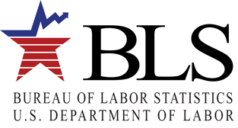
U.S. Department of Labor
Bureau of Labor Statistics

Green Technologies and Practices (GTP) - Options for Reporting Your Data

The Bureau of Labor Statistics is pleased to offer these options for reporting your use of green technologies and practices.
- Report your data using an Internet form.
- Request an electronic fillable form by e-mail, enter your data, and then e-mail the form back to us. Instructions for the fillable form are on the back of this flyer.
- Complete the mailed form and return it in the enclosed postage-paid envelope.
If you need help, please use one of the Help resources listed on the back page of these instructions.

Option 1: Use the Internet

Step 1: Register with the BLS

Before reporting your data, you must register with the BLS even if you registered in previous years for other BLS surveys.

- Go to https://idcf.bls.gov on your Internet browser. The “s” in “https” is required.

- Enter the 12-digit Account Number (omit the dash) beginning with 105 in the field labeled “Account Number” and the Temporary Password in the field labeled “Password”. See the example below. Click I Accept.

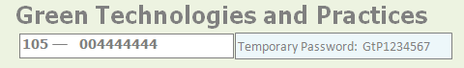
Sample – Cover of Form
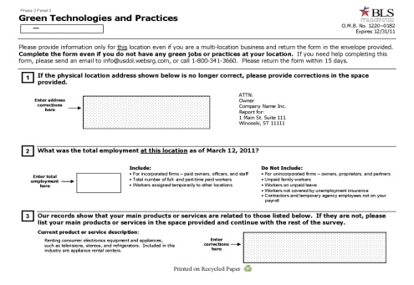

You will need the Account Number and Temporary Password if you report via the Internet.

- Enter and confirm your email address. Click Continue.

- Complete the “Enter New User Information” and “Create a Permanent Password” pages. Save your password, as you will need again in order to return to the online form.

- Click Continue on the “Confirmation Notice” page.

Step 2: Report Your Data

- Select Green Technologies and Practices Survey from the Please Select a Survey drop-down box and click Continue.

- Read the “Dear Employer” screen and click Continue.

- Enter your data. Each time you click Save & Continue on a page, the data you entered are saved.

- When finished, click Submit Your Data to BLS.

You may complete the survey in more than one session. 30 minutes of inactivity within the system will automatically log you out. To log back in and complete the survey, you will need to enter your account number and permanent password. If you need to update or change any of your data after clicking Submit Your Data to BLS, you will need to call the phone number printed in the HELP section on the back of these instructions.

OMB No. 1220-0182
Expires: 12/31/2011

Option 2: Use a Fillable Form and Return It Using E-mail

You may obtain an electronic fillable form of the survey, which allows you to type your information directly into each data field.
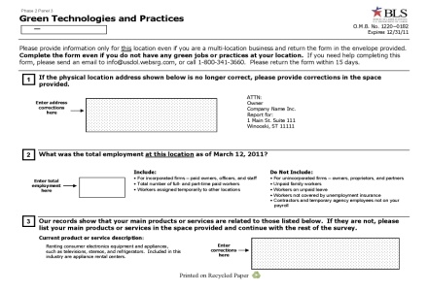
Sample

You will need your company address and your Account Number if you report via e-mail.

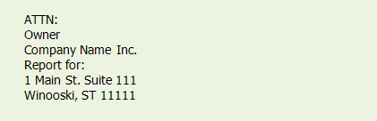

- Obtain an electronic fillable form of the survey (Adobe ® PDF fillable form) by sending a blank e-mail to GTP@idcf.bls.gov. You can also download the fillable form at www.bls.gov/respondents/gtp/forms.htm

- Save the form to your computer and open it using Adobe Reader®. If you do not have Adobe Reader, you can download it for free from www.Adobe.com.

- Enter your establishment’s identifying information and green technologies and practices data. Navigate through the fields on the form by using the TAB key or mouse.

- Save the form on your computer when you have entered all of your green technologies and practices data.

- Attach the completed form to an e-mail and send your data to info@usdol.websrg.com. You will receive a confirmation from the BLS that your data submission has been received.

Need help?

Try one of these:
  - Click the Help link that appears on each online screen.
  - For step-by-step website registration instructions, or website technical help, go to www.bls.gov/idcf/instructions.htm .
  - For questions regarding your participation in the survey or completing the survey online contact GTPhelpdesk@bls.gov.
  - For information about the survey, to download forms, or to get answers to your questions go to www.bls.gov/respondents/gtp.
  - Call 1-800-341-3660.

