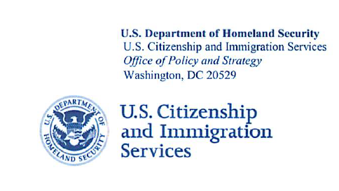

Decemebr 2013

Dear ____________________:

The U.S. Citizenship and Immigration Services (USCIS) of the Department of Homeland Security (DHS) is working to improve the communication, outreach,and educational activities for the E-Verify program. As part of this effort, we have authorized Westat, an independent social science research organization, to conduct a survey of webinar participants to study the effectiveness of these webinars. The first step in this process is to develop and test survey questions to ensure that the questionnaire will be clearly worded and easy to answer.

Your participation in this study will help Westat collect important information about our E-Verify related webinars, which will be used to better design future presentations. The information you provide will be kept private, to the extent permitted by law. Westat will not provide DHS or others who are not part of the evaluation team with data containing identifiable information about organizations or individuals. The survey report will contain only summary results and not include any information that might be used to identify you or your company.

Although it is your choice to participate, I would very much appreciate your full cooperation with Westat’s request that you participate in this important evaluation. If you have any concerns regarding this evaluation of the E-Verify program, please call Natasha McCann, Program Manager at (202) 272-8122.

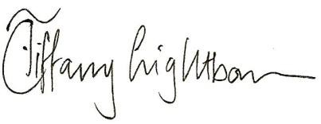Sincerely,

Tiffany Lightbourn, Ph.D.

Chief, Research and Evaluation Division

Office of Policy and Strategy