February 8, 2010

Dear Course Participant:

You recently attended a course with the National Preparedness Directorate, Emergency Management Institute (EMI). EMI is now conducting long-term evaluation as part of our ongoing course review and revision process. The purpose of this evaluation is to determine the extent to which the knowledge and/or skills you obtained from EMI have been beneficial and applicable to your present position or emergency management assignment.

I would be grateful if you would complete the survey on the back of this letter. All responses will be treated confidentially. We do not ask for your name. However, for statistical purposes, please put your two-letter state abbreviation on the form.

Enclosed is an envelope to return your survey. Thank you for taking the time to complete the evaluation form. Your feedback will help to improve the effectiveness of EMI training.

Sincerely,
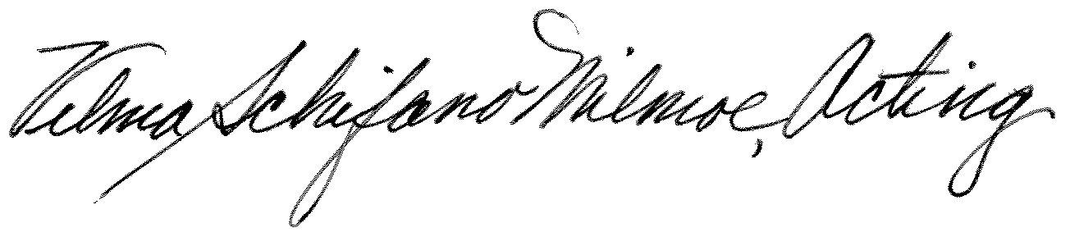
Vilma Schifano-Milmoe
Acting Superintendent
Emergency Management Institute

