**PAPERWORK REDUCTION ACT BURDEN DISCLOSURE NOTICE**

Public reporting burden for this survey is estimated to take 10 minutes per response. The burden estimate includes the time for reviewing instructions, searching existing data sources, gathering and maintaining the data needed, and completing and submitting the survey. This collection of information is voluntary. You are not required to respond to this collection of information unless it displays a valid OMB control number displayed in the upper right corner of this form. Send comments regarding accuracy of the burden estimate and any suggestions for reducing the burden to: Information Collections Management, Department of Homeland Security, Federal Emergency Management Agency, 500 C Street, SW Washington DC 20472-3100, Paperwork Reduction Project (1660-0130). **NOTE: Do not send your completed form to the above address.**

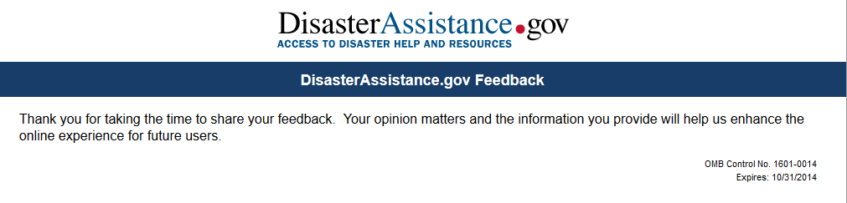

**How would you rate your overall experience today?**

| Outstanding | Above Average | Average | Below Average | Poor |
| --- | --- | --- | --- | --- |
|  |  |  |  |  |

If "Below Average" or "Poor" please let us know why.



What was the main purpose of your visit to DisasterAssistance.gov?

Apply for Assistance



Check Status of my application (already applied)



Research only.  I did not apply for assistance or check my application status.





*Page 2*

**Were you able to complete the purpose of your visit?**

Yes



No



If "No", please describe why you could not complete the purpose of your visit. (bad link, complicated process, etc.)



Select the rating that best describes your experience with the Find Assistance (questionnaire) process?

| Extremely easy to use | Somewhat easy to use | Neutral | Somewhat difficult to use | Very difficult to use | I didn't use Find Assistance (questionnaire) |
| --- | --- | --- | --- | --- | --- |
|  |  |  |  |  |  |

If you chose "difficult to use", please share your comments on ways we can improve the process.



*Page 3*

Select the rating that best describes your experience with the Apply Online process?

| Extremely easy to use | Somewhat easy to use | Neutral | Somewhat difficult to use | Very difficult to use |
| --- | --- | --- | --- | --- |
|  |  |  |  |  |

If you chose "difficult to use", please share your comments on ways we can improve the process.



Select the rating that best describes your experience with the Check Your Status process?

| Extremely easy to use | Somewhat easy to use | Neutral | Somewhat difficult to use | Very difficult to use |
| --- | --- | --- | --- | --- |
|  |  |  |  |  |

If you chose "difficult to use", please share your comments on ways we can improve the process.



*Page 4*

Select the rating that best describes the following research options.

|  | Extremely easy to use | Somewhat easy to use | Neutral | Somewhat difficult to use | Very difficult to use | I didn't use this option |
| --- | --- | --- | --- | --- | --- | --- |
| **Frequently Asked Questions (FAQs)** |  |  |  |  |  |  |
| **Address Look-up (to determine if a disaster has been declared for my area)** |  |  |  |  |  |  |
| **General Disaster Information** |  |  |  |  |  |  |
| **Contact Us** |  |  |  |  |  |  |
| **Newsfeeds** |  |  |  |  |  |  |

If you chose "difficult to use" please share your comments on ways we can improve the process.



*Page 5*

**Would you return to this website if you could get this information or service from another source?**

Yes



No



**How likely are you to recommend this website to a friend or colleague?**

Very Likely Somewhat Likely Not Likely



**Please share any additional comments you have about your experience using DisasterAssistance.gov.**



*Page 6*

***Demographics questions - optional***

The following information is not required but will help us see who uses our site.  There is also an option for you to volunteer to talk with us in the future.  But, if you prefer to skip the questions, simply click **Done** at the bottom of the page.

**Which category below includes your age?**

18-20



21-29



30-39



40-49



50-59



60 or older



**How often do you access the Internet?**

Once a month or less



Once a week



Several times a week



Every day



Several times a day



**When you access the Internet, which of the following do you usually do?  (check all that apply)**

Send or receive email



Use the Web for research, banking, entertainment, etc.



Play computer games



Create, edit and/or upload documents, presentations, etc.



At times we are given the opportunity to speak directly with disaster survivors to find out how we can make your online experience better.

**If you would be willing to speak with us in the future, please provide your contact information below.**

Name



City/Town



State/Province



Email Address



The information provided will only be used for website feedback.  Providing your name and email will not impact your Disaster Assistance Application or FEMA's decision.