APPENDIX A: RECRUITMENT MATERIALS
State PISA Main StudyLetter 2
School District PISA Main Study Letter 3
School PISA Main Study Letter 4
PISA 2012 Main Study Brochure 5
PISA 2012 Main Study FAQ for School Leaders 7
PISA 2012 Main Study Student FAQ 9
PISA 2012 Main Study Timeline of Activities 10
PISA 2012 Main Study Instructions for the School Coordinator 12

[Date]
State PISA 2012 Assessment Letter

[Title] [Name First] [Name Last]
[Title/Department]
[State]
[Address 1]
[Address 2]
[City], [State] [Zip code]

Dear [Title] [Name Last]:

I am writing to inform you that one or more schools in your state have been selected to participate in the Program for International Student Assessment (PISA) in the fall of 2012 and to ask for your support in encouraging the selected schools to participate. PISA is the largest international education study in the world. More than 60 countries participate, representing approximately 90 percent of the world economy. PISA results are used by researchers and policy makers to chart national progress against international standards and the educational progress of our economic peers and competitors. Participating schools can use the results to benchmark their performance against schools across the world.

PISA is administered every three years and provides comparative information on the performance of 15-year-old U.S. students in mathematics, reading and science with that of 15-year-old students in other countries. PISA 2012 will also include assessments of problem-solving and financial literacy. For the first time in the United States, PISA will include computer-based assessments as well as paper-based assessments.

PISA is described in more detail in the enclosed materials. PISA is sponsored in the United States by the National Center for Education Statistics (NCES) in the U.S. Department of Education and is conducted by Westat in Rockville, Maryland. The U.S. Office of Management and Budget has approved the data collection under OMB #1850-0755. For information on the confidentiality of the data collected, please see the enclosed FAQ. While participation in this study is voluntary, we ask your agency to support participation on the part of schools in your state so that the United States has a representative sample of schools across the country.

Within the next few weeks, a representative of Westat will contact sampled school districts and schools to discuss conducting data collection. In the meantime, if you have questions about the study, please do not hesitate to call David Kastberg at 1-888-638-2597 or send an email to PISAHELP@westat.com. You may also get more information about PISA by contacting Dana Kelly at the U.S. Department of Education at 202-219-7101 or visiting the PISA website at: http://nces.ed.gov/surveys/pisa/.

Thank you for your time and support.

Sincerely,

Jack Buckley
Commissioner

cc: [State assessment coordinator name]

NCES is authorized to conduct this study under the Education Sciences Reform Act of 2002 (ESRA 2002), 20 U.S. Code, § 9543. By law, the data provided by your schools, staff, and students may only be used for statistical purposes and may not be disclosed, or used, in identifiable form for any other purpose except as required by law (20 U.S. Code, § 9573).

School District PISA 2012 Assessment Letter
[Date]

[Title] [Name First] [Name Last], [Title/Department]
[School District]
[Address 1]
[City], [State] [Zip code]

Dear [Title] [Name Last]:

I am writing to inform you that one or more schools in your district have been selected to participate in the Program for International Student Assessment (PISA) in the fall of 2012 and to ask for your support in encouraging the selected schools to participate. PISA is the largest international education study in the world. More than 60 countries participate, representing approximately 90 percent of the world economy. PISA results are used by researchers and policy makers to chart national progress against international standards and the educational progress of our economic peers and competitors. Participating schools can use the results to benchmark their performance against schools across the world.

PISA is administered every three years and provides comparative information on the performance of 15-year-old U.S. students in mathematics, reading and science with 15-year-old students in other countries. PISA 2012 will also include assessments of problem-solving and financial literacy. For the first time in the United States, PISA will include computer-based assessments as well as paper-based assessments. Participating schools will receive $200 and each school’s PISA school coordinator (school staff person designated to liaise with PISA staff) will receive $200 as compensation for the coordinator’s time and effort. Each student who is assessed will receive $25 and students selected to take both the paper-based and computer-based assessments will receive an additional $15.

PISA is described in more detail in the enclosed materials. PISA is sponsored in the United States by the National Center for Education Statistics (NCES) in the U.S. Department of Education and is conducted by Westat in Rockville, Maryland. The U.S. Office of Management and Budget has approved the data collection under OMB #1850-0755. For information on the confidentiality of the data collected, please see the enclosed FAQ. While participation in this study is voluntary, we ask your agency to support participation on the part of schools in your district so that the United States has a representative sample of schools across the country.

Within the next few days, a representative of Westat will contact the following school or schools in your district that have been selected to participate in the study: [LIST SAMPLED SCHOOLS HERE…].

If you have any questions, please do not hesitate to call David Kastberg at 1-888-638-2597 or send an email to PISAHELP@westat.com. You may also get more information about this study by contacting Dana Kelly at the U.S. Department of Education at 202-219-7101 or visiting the PISA website at: http://nces.ed.gov/surveys/pisa/.

Thank you for your time and support.

Sincerely,

Jack Buckley
Commissioner
NCES is authorized to conduct this study under the Education Sciences Reform Act of 2002 (ESRA 2002), 20 U.S. Code, § 9543. By law, the data provided by your schools, staff, and students may only be used for statistical purposes and may not be disclosed, or used, in identifiable form for any other purpose except as required by law (20 U.S. Code, § 9573).

[Date]
School PISA 2012 Assessment Letter
[Title] [Name First] [Name Last], [Title/Department]
[School District]
[Address 1]
[City], [State] [Zip code]

Dear [Title] [Name Last]:

I am pleased to inform you that your school has the opportunity to be a part of the upcoming Program for International Student Assessment (PISA) 2012. PISA is the largest international education study in the world. More than 60 countries participate, representing approximately 90 percent of the world economy. Each country is represented by a small sample of schools and students to represent the range of education contexts and students in the country. Your school is one of 240 across the United States that has been randomly selected to take part in PISA 2012 in the fall of 2012.

PISA 2012 will measure 15-year-old students’ performance in mathematics, reading, science, problem-solving and financial literacy, and compare that with students of other countries. PISA results are used by researchers and policy makers to chart national progress against international standards. Participating schools can use the results to benchmark their performance against schools across the world.

Your school will receive a report with information about how your students performed on PISA compared with schools across the United States and the other PISA countries (provided your school meets response rate and sample size requirements). Your school will also receive $200 and your school’s PISA school coordinator (staff person you designate to liaise with PISA staff) will receive $200 as compensation for the coordinator’s time and effort. Each student who is assessed will receive $25 and students selected to take both the paper-and-pencil and computer-based assessments will receive an additional $15. NCES may follow up with participating students as part of a study to look at the relationship between performance on PISA and other outcomes.

Materials enclosed with this letter further describe the PISA 2012 assessment process for schools. PISA is sponsored in the United States by the U.S. Department of Education’s National Center for Education Statistics (NCES) and is conducted by Westat in Rockville, Maryland. The U.S. Office of Management and Budget has approved the data collection under OMB #1850-0755. We will only disclose the names of schools to the governing district for each school, and we require that each district maintain the confidentiality of the sampled schools in the PISA 2012 study. For more information on the confidentiality of the data collected, please see the enclosed FAQ. I hope you will participate in this voluntary study because it is important that the United States has a nationally representative sample of schools.
Within the next few days, a representative of Westat will call you to answer any questions you have and discuss your participation in PISA. In the meantime do not hesitate to call David Kastberg at 1-888-638-2597, or send an email to PISAHELP@westat.com. You may also contact Dana Kelly at the U.S. Department of Education at 202-219-7101 or visit the PISA website at: http://nces.ed.gov/surveys/pisa/.

Your participation in the PISA 2012 study is vital; I hope you and your school will take advantage of this opportunity. Thank you for your time and for supporting this important international study.

Sincerely,

Jack Buckley
Commissioner

NCES is authorized to conduct this study under the Education Sciences Reform Act of 2002 (ESRA 2002), 20 U.S. Code, § 9543. By law, the data provided by your schools, staff, and students may only be used for statistical purposes and may not be disclosed, or used, in identifiable form for any other purpose except as required by law (20 U.S. Code, § 9573).
PISA 2012 Study Brochure - Outside

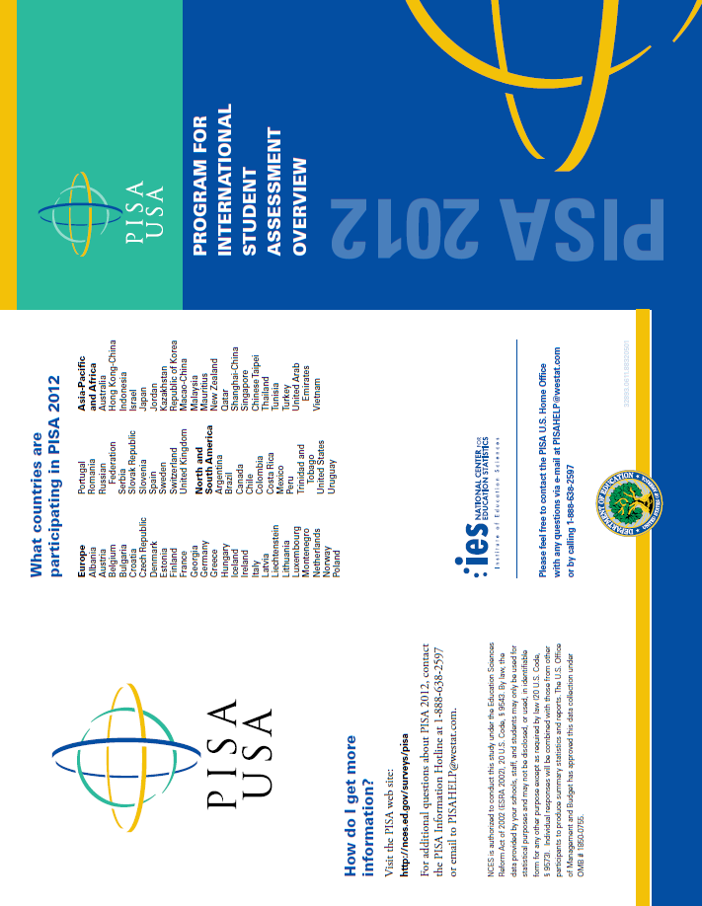

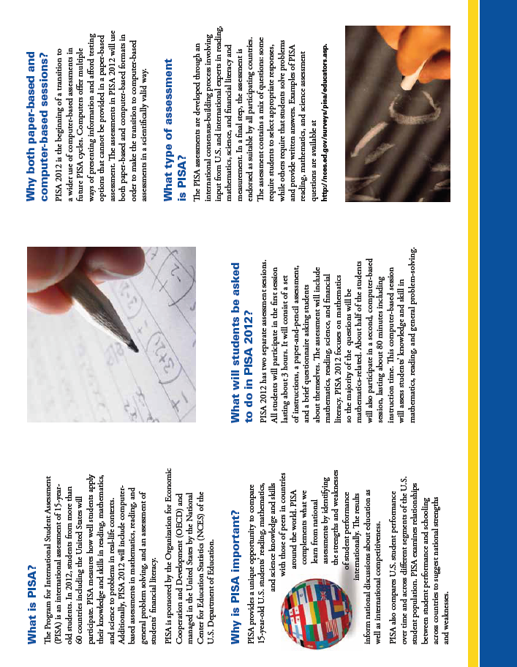
PISA 2012 Study Brochure Inside
School Leader FAQ - Front Page

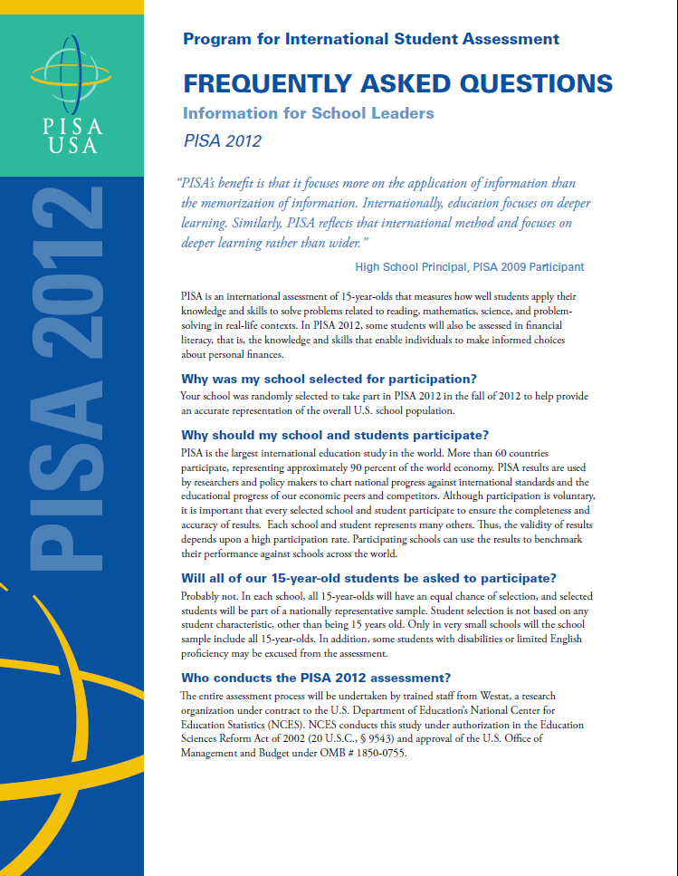

School Leader FAQ – Back Page

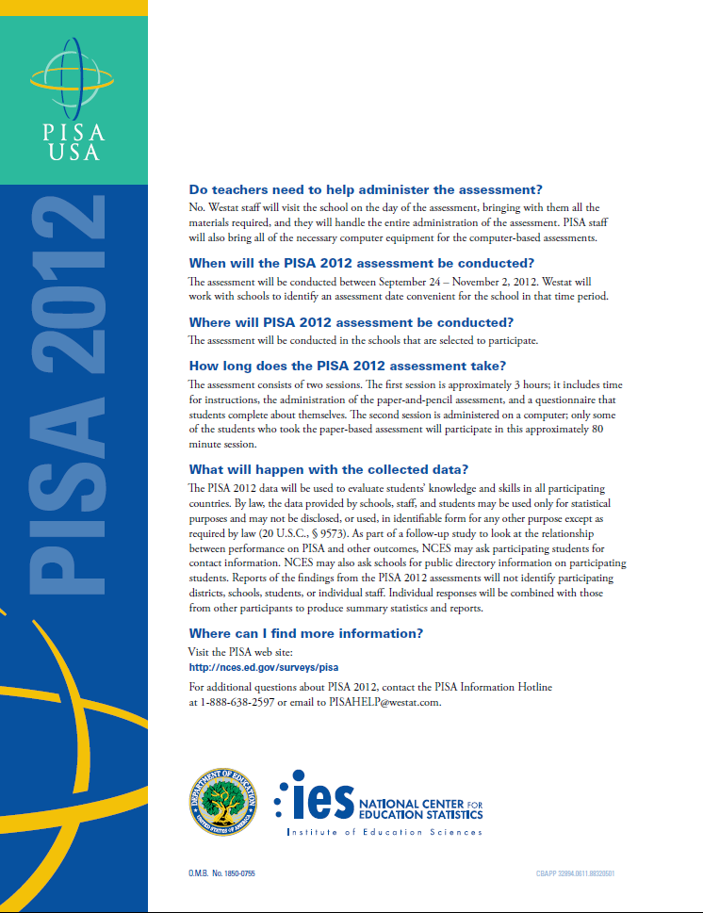

Student FAQ
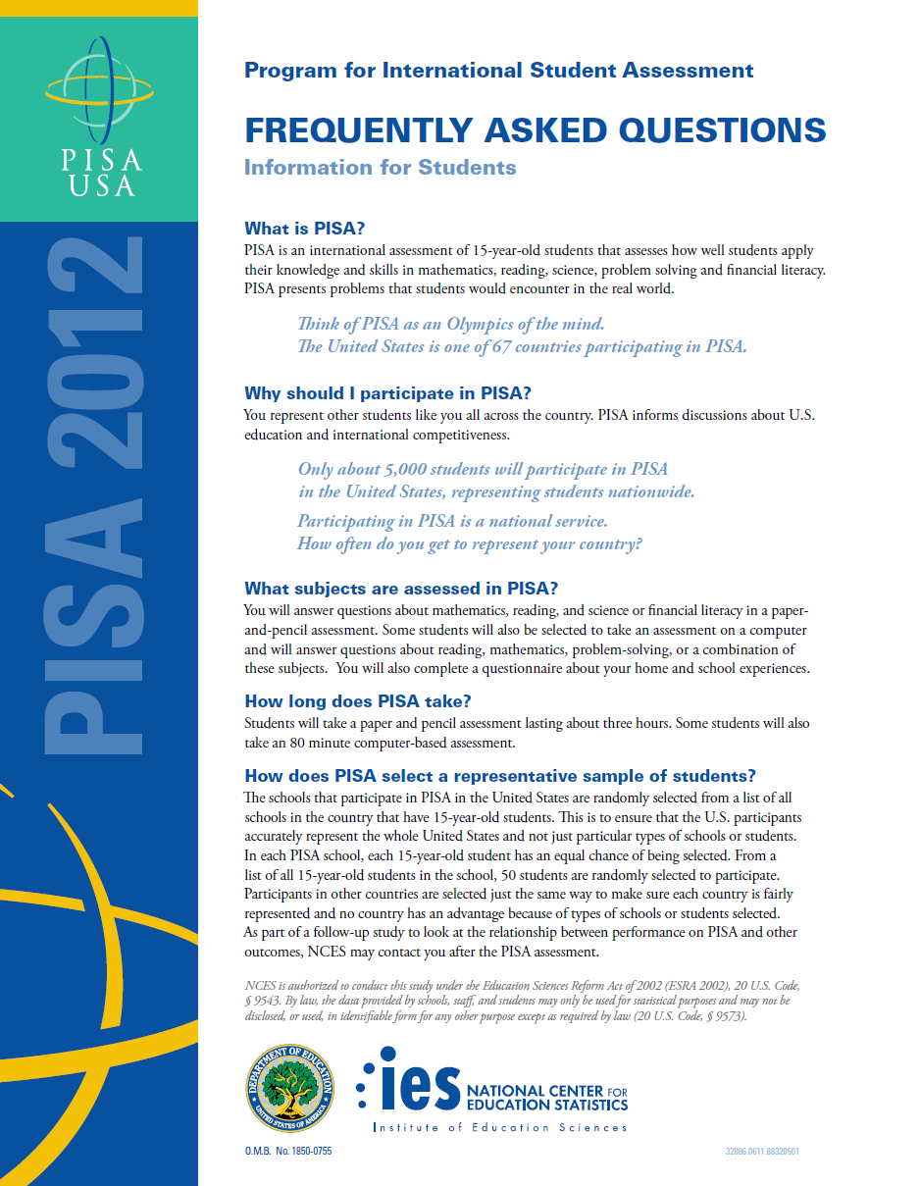

PISA 2012 Timeline of Activities - Outside
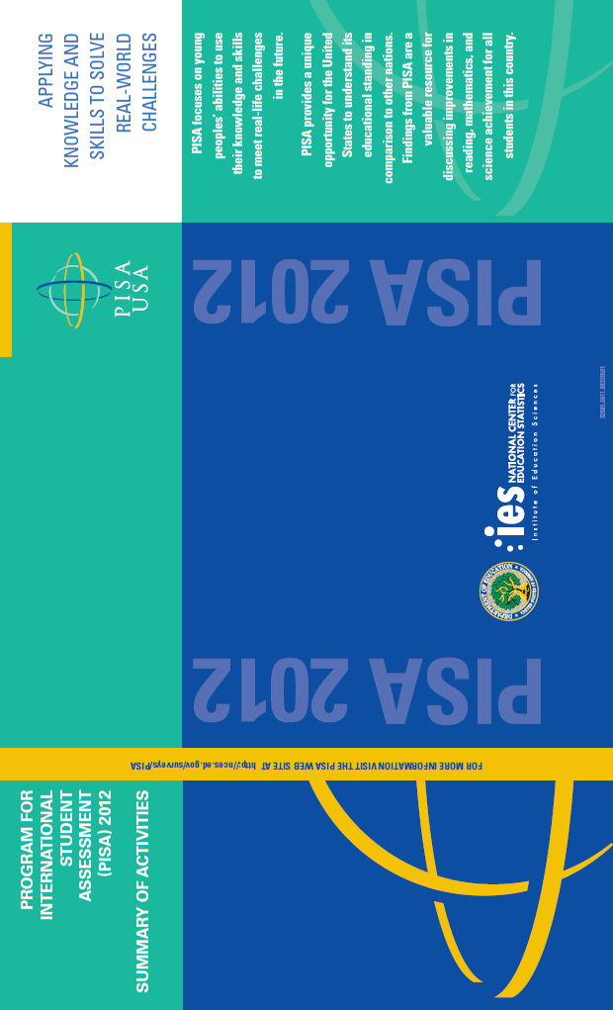
PISA 2012 Timeline of Activities – Inside

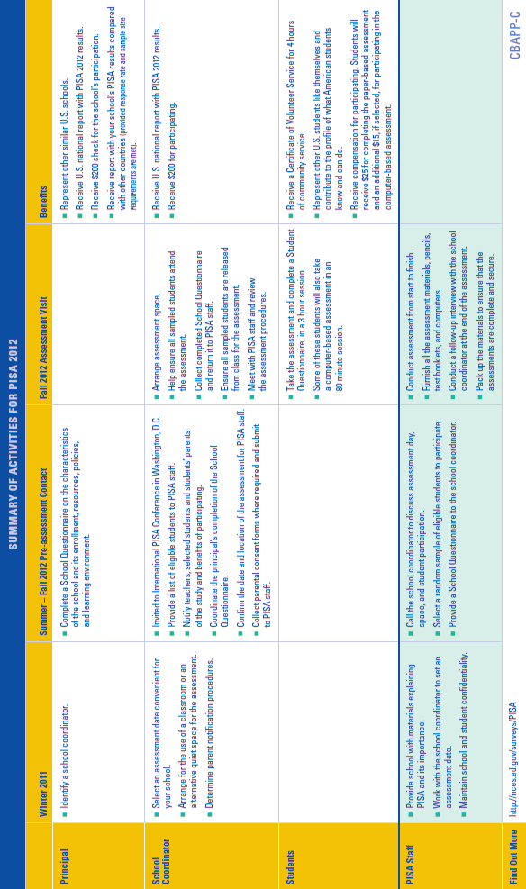
PISA 2012 Instructions for the School Coordinator Information – Front Page
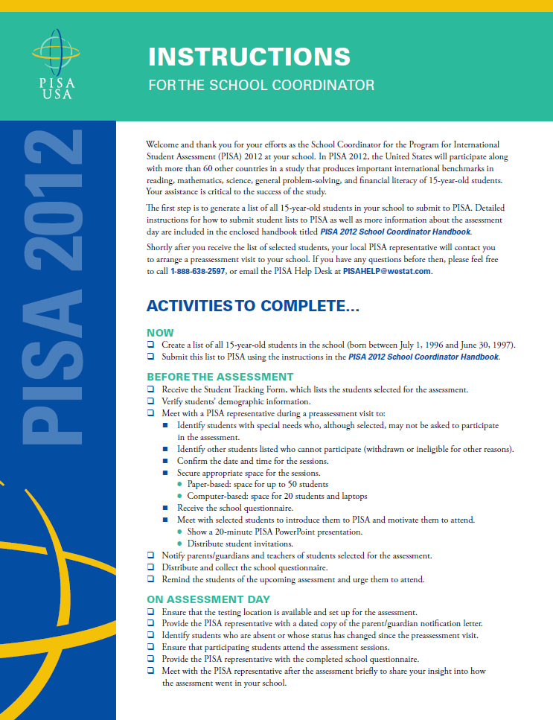
PISA 2012 Instructions for the School Coordinator Information – Back Page

