

Environmental Tap Water Pharmaceutical (TWF) Participant Collect Instructions
(EH, PB, HI) V1.0

Event: | Pregnancy Visit 1
Participant: | Pregnant Woman
Domain: | Environmental
Type of Document: | Instructions
Recruitment Groups: | EH, PB, HI

This page is intentionally blank.

Instructions for Tap Water TWF Sample
- Remove the frozen ice packs from the tap water TWF sample collection kit and place them in your freezer.  - Call FedEx (1-800-463-3399) to schedule a pickup or determine where to drop off the shipment. If FedEx cannot pick up the shipment or accept a drop off today, place the kit contents in a safe place and keep the ice packs in your freezer so you can collect the sample on another day. | - On the day of sample collection, remove contents of the TWF sample collection kit from the shipping container (Photo 1).  - If possible, before collecting the sample, avoid handling or using the following: caffeine, tobacco, home cleaning agents, or personal care products, such as antibacterial soaps, hand sanitizers, or lotions.  - Place the sample ID labels on the Tap Water TWF Questionnaire (question 4). Then write the date and mark the day of the week (questions 5 and 6).
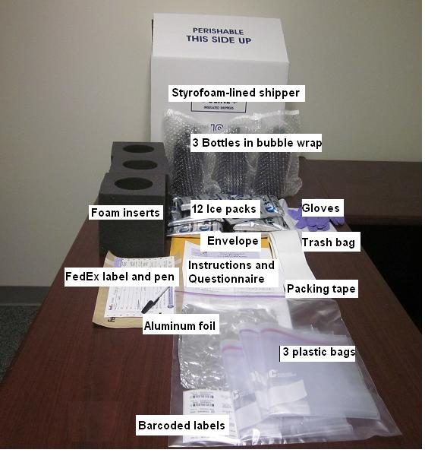
Photo 1. Contents of the Tap Water TWF sample collection kit.
To be done Monday through Thursday. The samples of your home tap water will be sent for laboratory analysis.
- At your kitchen faucet, turn on the cold water and run it at a medium flow for 5 minutes.  - Put on the provided gloves. Gloves are to protect the sample from soap or oil on your hands.  - Open the aluminum foil with inner side up and place it on the counter next to your sink.  - Place all bottles included in the TWF sample collection kit on the aluminum foil (Photo 2). | 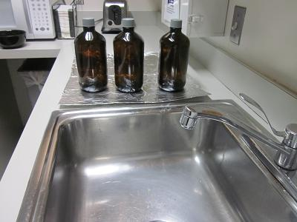  Photo 2. TWF sample collection bottles on the foil sheet.
- If needed, reduce the water flow so the water will not splash when filling the bottle.  - Hold the first bottle upright and carefully unscrew the cap. Immediately begin filling bottle to the shoulder (Photo 3).  - When handling the bottle, do not hold it close to your face.  - Do not fill the bottle completely full.  - Do not rinse the bottle.  - Do not pour out the preservative (white powder or liquid) inside the bottle. | 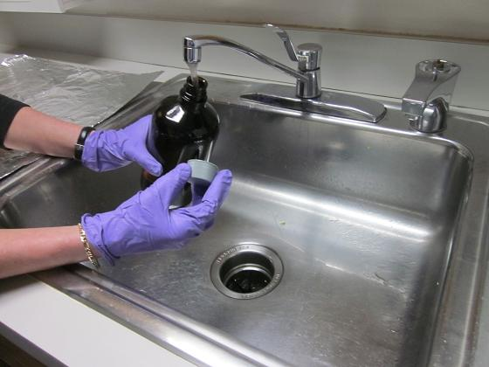  Photo 3. Filling the sample collection bottle with water.
- Immediately replace the cap after filling the bottle to the shoulder.  - Fill the second and third bottle as you filled the first.  - Label all three bottles with the provided sample ID labels (Photo 4).  - Place the bottles in the foam inserts and then into the plastic bags. Label the bags with the remaining sample ID labels. | 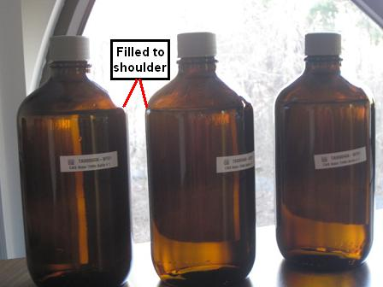  Photo 4. Three bottles filled to the shoulder with water, labeled with sample ID labels.
- Line the insulated shipper with the trash bag.  - Remove the ice packs from your freezer.  - Place five ice packs in a single layer on the bottom. Place the bottles on the ice packs. Place the rest of the ice packs around and top of the bottles. Fill the extra space with the provided packing material (Photo 5).  - Put the Styrofoam lid on and seal the insulated box. | 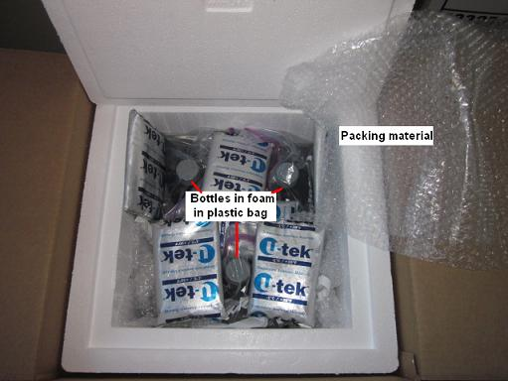  Photo 5. TWF sample bottles and frozen ice packs in the lined shipper.
- Write the date that the TWF sample is picked up or dropped off on the prepaid, prefilled FedEx label, addressed to the laboratory, and attach it to the insulated box (Photo 6).  - Ship the samples to the laboratory using FedEx.  - This is prepaid. There will be no charge to you.  - Complete rest of the Tap Water TWF Questionnaire and review it to make sure all questions were answered.  - Place the Tap Water TWF Questionnaire in the prepaid, preaddressed envelope. Seal the envelope and place it in U.S. mail.  - Mail the questionnaire to the NCS Study Center Office using U.S. mail. | 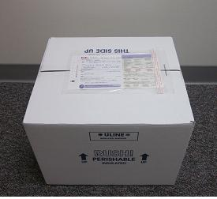  Photo 6. The prefilled FedEx label attached to the FedEx box.

Thank you for participating in the National Children’s Study.

Insert local contact information label here.

