
NCS ASA24 Protocol

Use of the Food Portion Visual
Participants will be provided a Food Portion Size Guide to assist with estimating amounts when completing the ASA24. A review of the Food Portion Size Guide by the study site research assistant will ensure the purpose and appropriate use for future ASA24 recalls.

Getting started

PASS 1:
To begin the ASA24 and after logging in, the participant will complete the name of meal, time and location. The participant will not be able to continue until all fields are complete and the green arrow is illuminated.
After completing the meal information screen, the participant will enter a general list for the first pass in the ASA24 multiple-pass approach. Enter first meal to begin.
- List all main foods for that first meal
- Screen is separated into three sections
  - Commands – allows you to edit food/ink or meal
  - My selections – place where selected food/ink needs to go to build each meal
  - Add foods – search for food/inks in this section
    - Click and drag or double click selected food to center
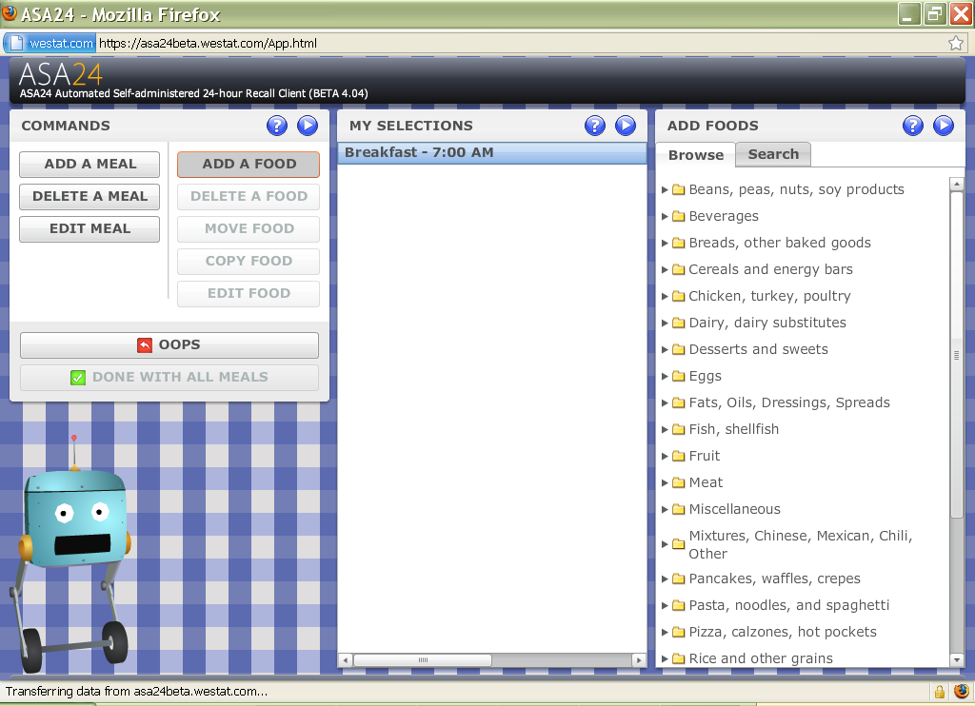

PASS 2:
Pass 2 begins with a quick review of omission (before, between and after meals). Completion of Pass 2 permits the participant to obtain greater detail of food and amounts consumed. Key points of this pass include:
- Entering food details
  - Type of food (i.e. fried egg, tap water)
  - Food amount – select best size measure
  - Enter additions to food/beverages
- Complete detail for each meal (all foods) and day (all meals)
- All detail for foods listed must be completed before able to go on to next meal. Additionally must complete all meals before going on to next pass.
Notice the meals entered are compressed at bottom (lunch and dinner).
Notice also that the food detail expands. Can select many added food items. The “oops” key allows the participant to fix foods entered accidently.

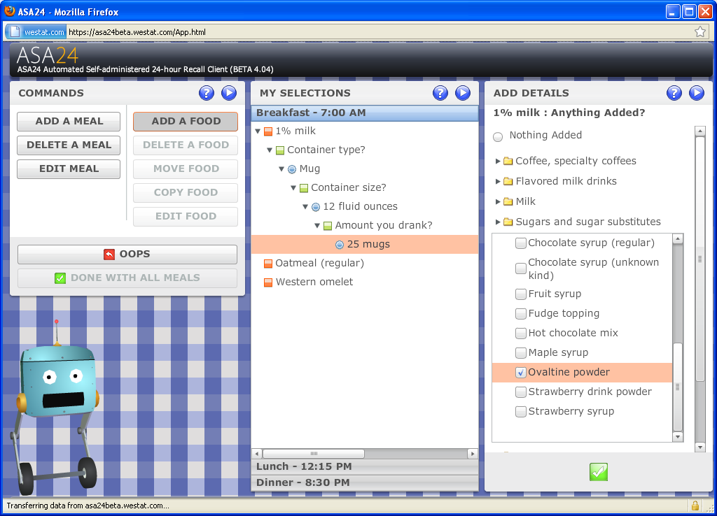

PASS 3:
At this pass, the participant or diet research interviewer will review what has been entered and for any omissions for each meal and the entire day. The following steps will complete this last pass:

- Select done with all meals.
- Review for omissions
- Suggest read food/inks out loud
- Think about all day yesterday
- Review for any forgotten foods

