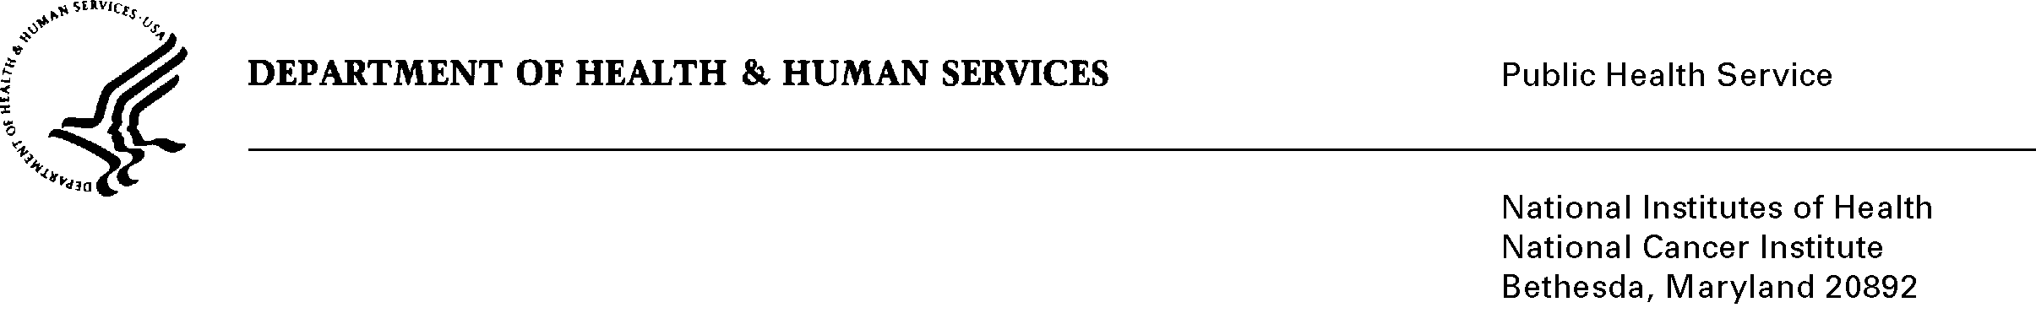

DATE: July 1, 2011

TO: Office of Management and Budget (OMB)

Through: Seleda Perryman, Program Analyst, Project Clearance Branch, OPERA, NIH
Vivian Horovitch-Kelley, PRA OMB Project Clearance Liaison, OMAA, NCI

FROM: Frances E. Thompson, Project Officer,
National Cancer Institute (NCI)/NIH

SUBJECT: Food Reporting Comparison Study (FORCS) and Food and Eating Assessment Study (FEAST) (NCI)

This submission, “Food Reporting Comparison Study (FORCS) and Food and Eating Assessment Study (FEAST) (NCI)” is being submitted as an Extension without Change (OMB #0925-0605; expiration: 10/31/2011).

The objective of the two studies is to compare the performance of the newly developed computerized Automated Self-Administered 24-Hour Recall (ASA24) approach to collecting 24 hour recall (24HR) data with the current standard, the interviewer-administered Automated Multiple Pass Method (AMPM). The ultimate goal is to determine to what extent the new automated instrument can be used instead of the more expensive interviewer-administered instrument in the collection of dietary intake data.

There has been a delay in the completion of a fully functional ASA24 Respondent application Version 1 due to a contractual conflict over intellectual property rights with a subcontractor who designed the graphic user interface. A virtual work stoppage occurred for approximately a year as legal and contractual issues were discussed with contracts staff, legal counsel, and contractors. Ultimately, NCI decided to develop a new graphical user interface for the respondent application. This work began in August of 2010 with a new contract in place. Progress has been substantial and continuous. Version 1, which is ultimately the ASA24 tool that will be available to the public in the future, will be free of the bugs in the beta version and will offer improved functionality and features, such as additional optional modules (e.g., supplement intake) and a Spanish language option is expected to be available in the summer of 2011.

