ATTACHMENT 4A: Food Reporting Comparison Study Screenshots
Screen 1.
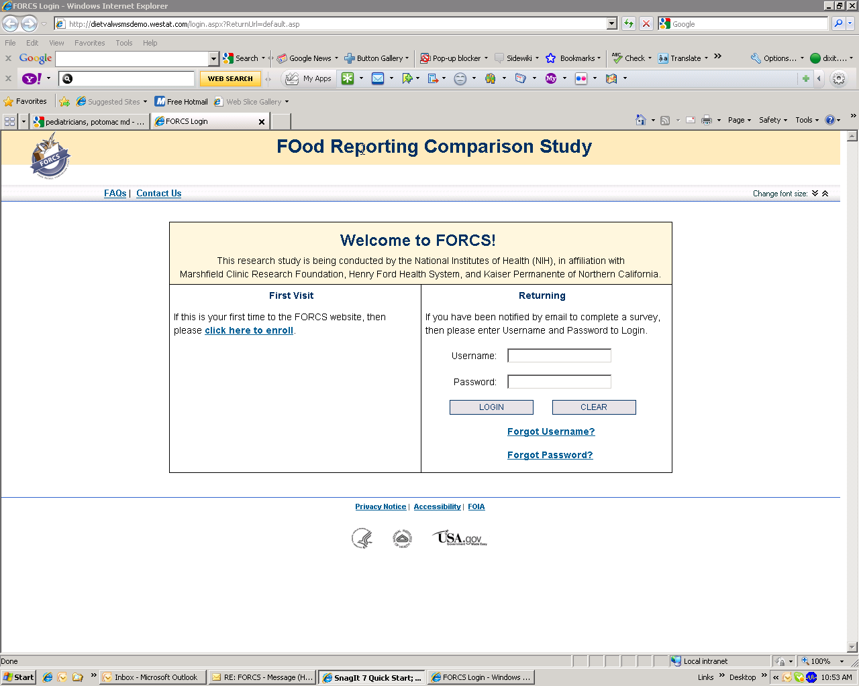

Screen 2: Displayed when respondent clicks on “CLICK HERE TO ENROLL” under FIRST VISIT
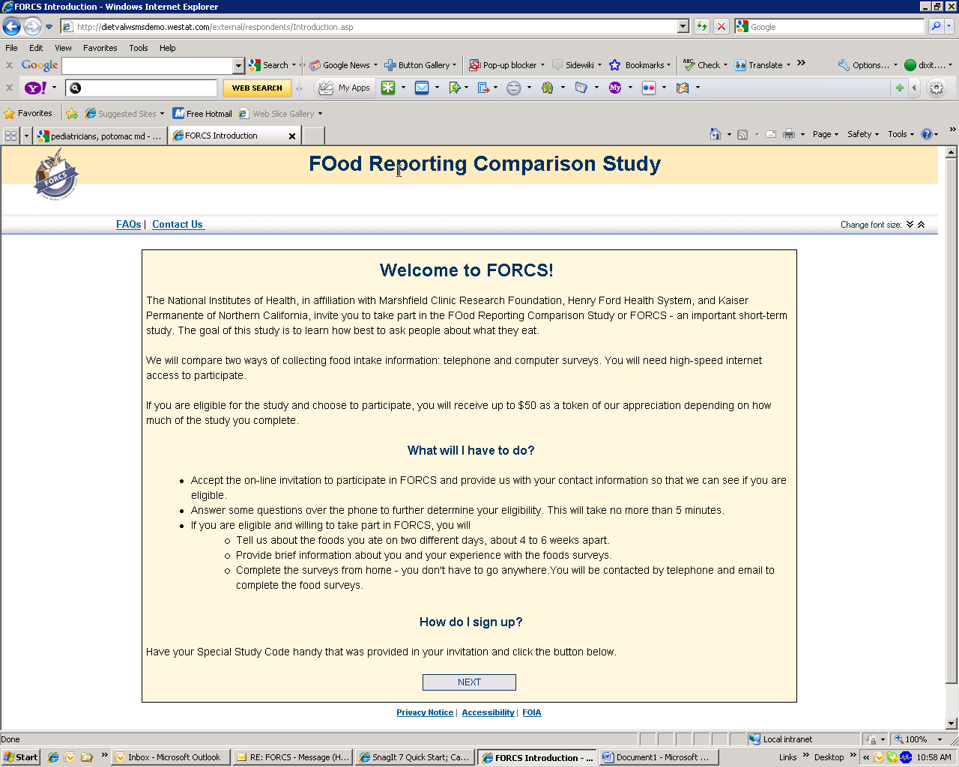

SCREEN 3: Displayed when participant enters special study code and then clicks NEXT …
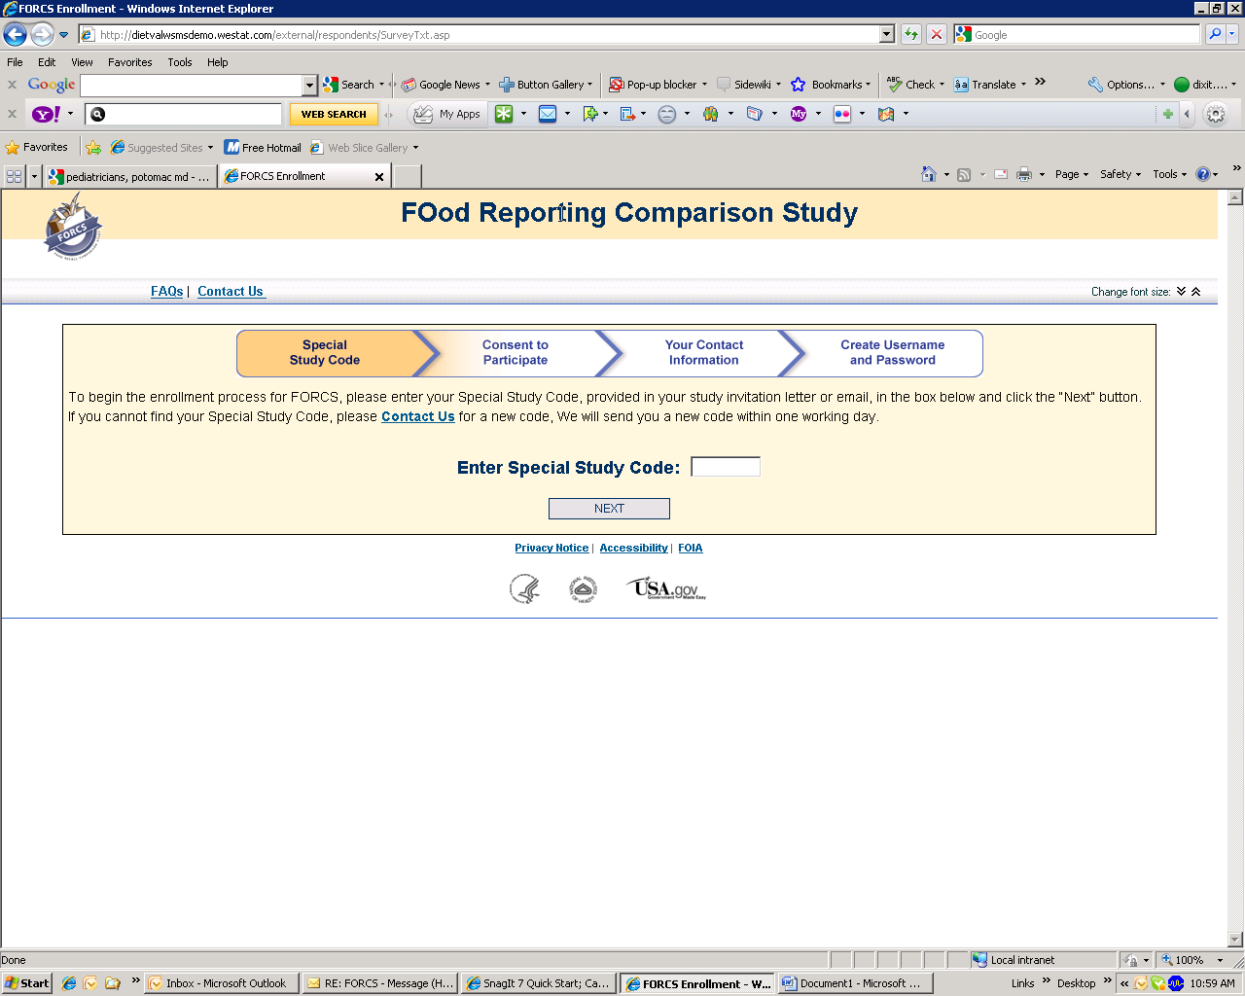

SCREEN 4: Displayed when participant clicks NEXT
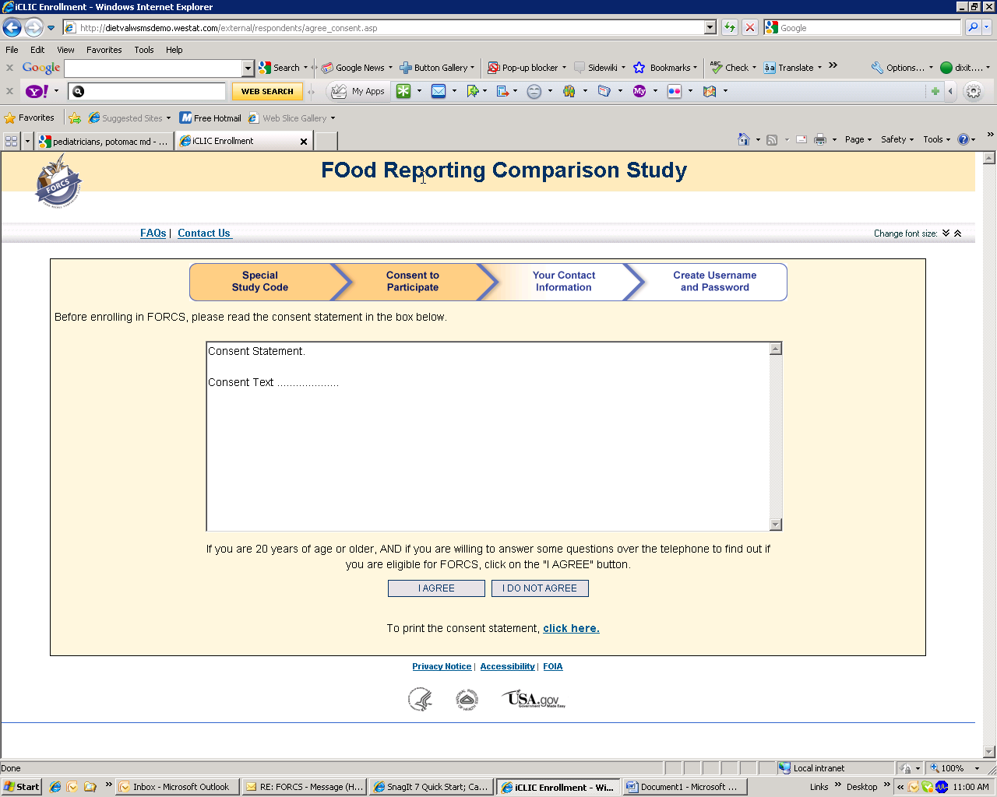
Consent text is included in Attachment 4B

SCREEN 5: Displayed after participants consents to receiving phone call to verify eligibility
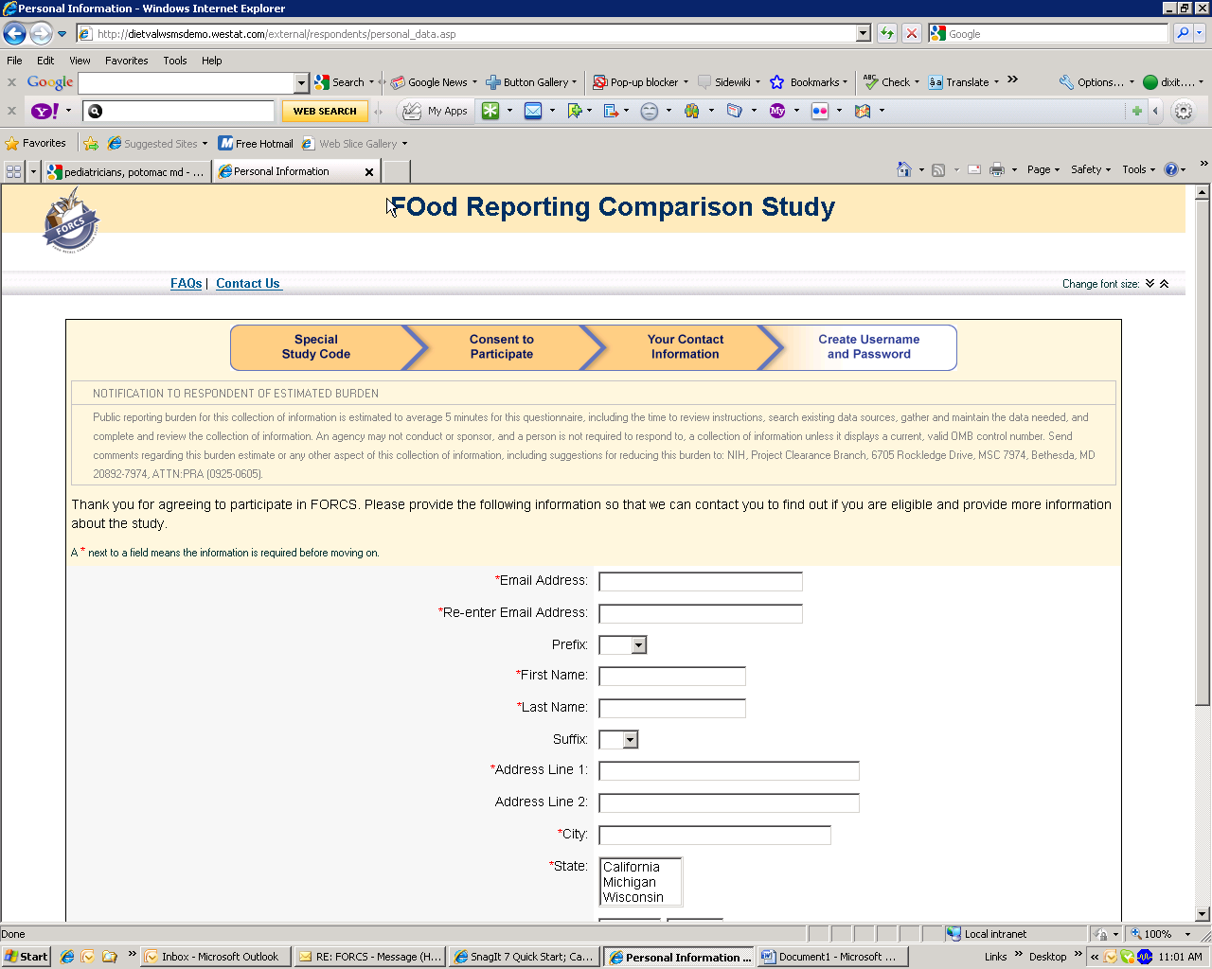
Refer to next page for entire screen content …

SCREEN 5 – entire content …

*Email Address:
*Re-enter Email Address:
Prefix:
*First Name:
*Last Name:
Suffix:
*Address Line 1:
Address Line 2:
*City:
*State:
*Zip Code: | -
*What is best time to reach you?
*What is the best number to call to reach you at the time selected above?  (numbers only - 123-456-7890) | -- X Why do we need your phone number?
Is there a back-up number to call? | -- X
Next

SCREEN 6: Displayed after participant clicks … NEXT

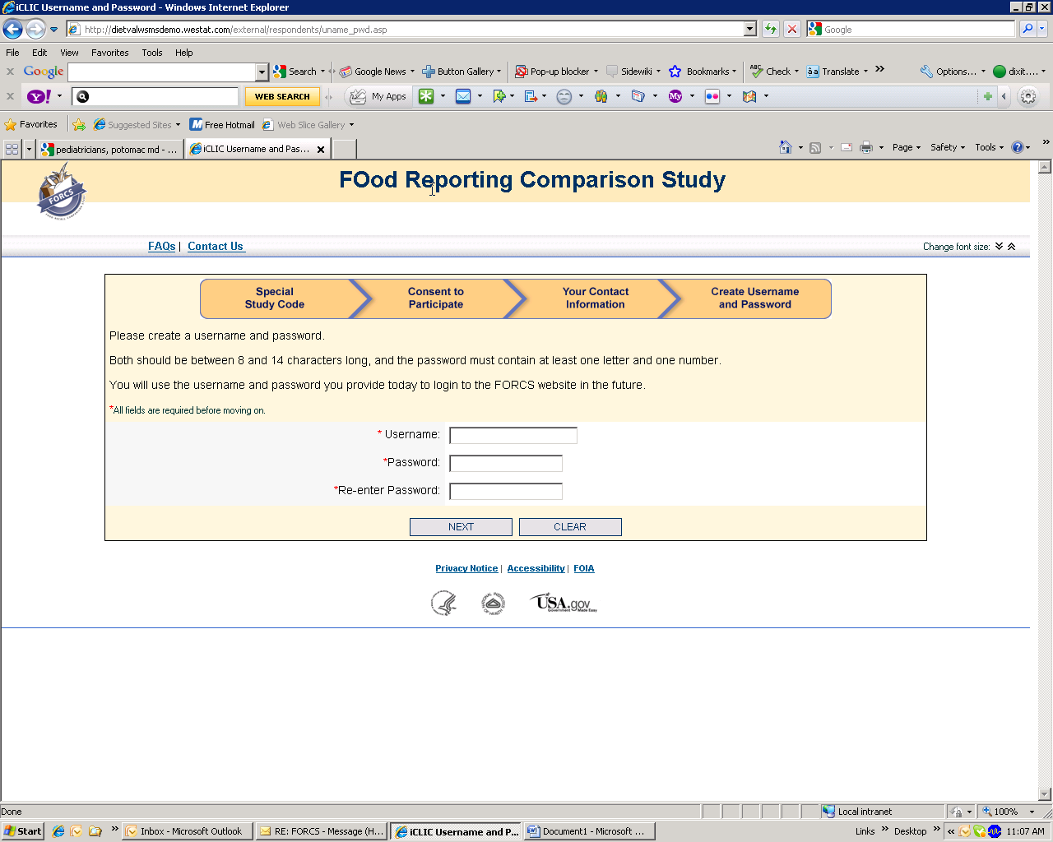

SCREEN 7: Displayed when participant clicks .. NEXT

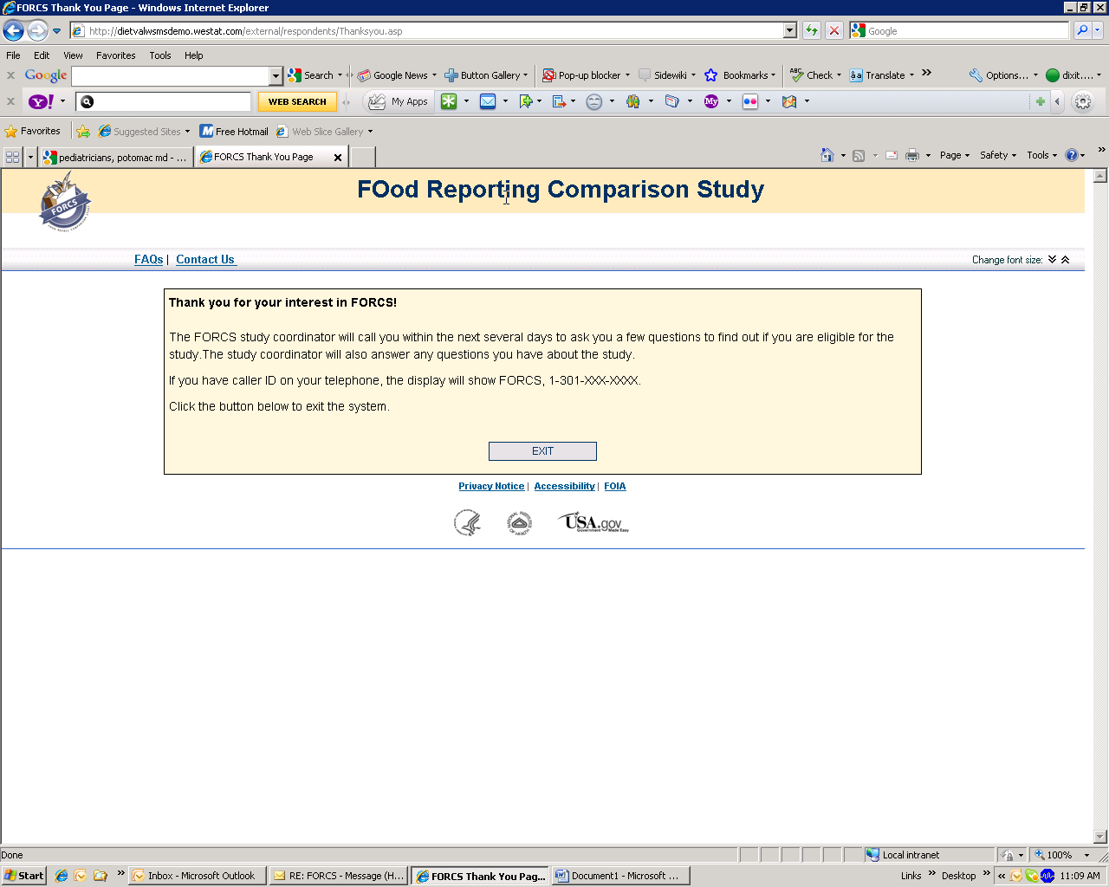

Screen 8: Displayed when participant CLICKS on SCREEN 2, DO NOT AGREE …
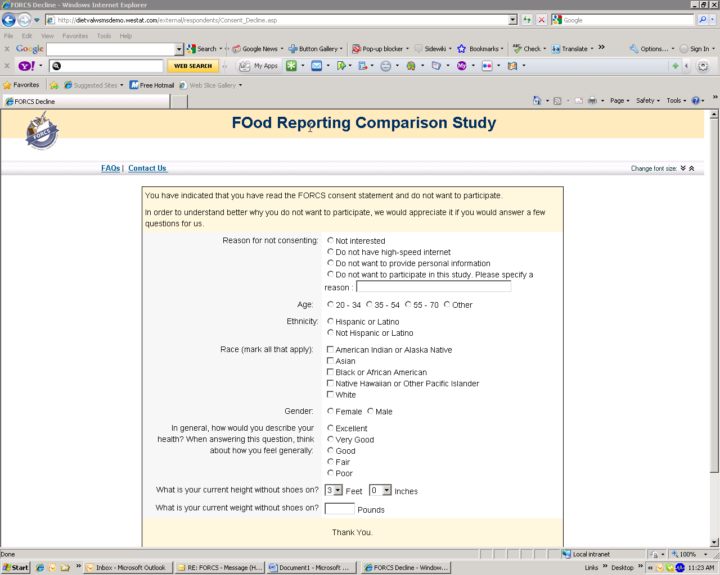
There is a CLOSE Button below Thank you. If participant clicks on this button, it takes them back to SCREEN 1.

Screen 9: Displayed when participant clicks on SCREEN 1 – Contact us (display on computer is better than seen here)

FOod Reporting Comparison Study

Change font size:

Let us know if you are having any problems or questions.
Please call us at 888-858-0281, or send us an email by completing the fields below. We will reply to you within 1 working day.
A * next to a field means the information is required before moving on.
*Your Email Address:
* Subject:
* Message:

Screen 10: Displayed when participant clicks on Screen 1: FAQs

Frequently Asked Questions (FAQs)
- General Questions
- Online Food Survey Questions
- Telephone Food Survey Questions
- Demographics Survey Questions
- Other Questions
General Questions
- What is the Food Reporting Comparison Study?
- Who is conducting this study?
- Why is my health plan involved in this study?
- Why did I receive this invitation?
- Am I eligible to participate?
- Do I have to participate?
- What will I have to do?
- Do I need my Special Study Code to participate?
- How will I know when to do the surveys?
- Can someone else complete a questionnaire in my place?
- May I obtain help from others during the questionnaire?
- Can I participate in this study by mail?
- Will my information be kept confidential?
- How is the information I provide protected from unauthorized use?
- Will I be paid for my participation? How much?
- Are there any costs to me to take part in the study?
- Will my insurance be affected?
- Who has approved this study?
- If I use my computer to participate in this study, will I be at risk of identity theft, viruses or spam?
- Who do I contact if I have questions?
- How can I drop out of the study?
- Why do I have to create a username and password to participate in the study? Will my username and password work if I only use capitalized or non-capitalized letters the same way as I entered it the first time (in other words, are they case-sensitive)?
- Why do you need my email address?
- Why do you need my phone number?
- How do I let you know I have a new email address or that other personal information has changed?
- How can I find out the results of the study?
back to top
Online Food Survey Questions
- What is the online food survey?
- How long will it take to complete the online food survey? Can I come back at a later time to complete?
- Why do you need all this detail about the foods I ate?
- What if I can't remember what I ate?
- Should I first write down what I eat during the day and then complete the online food survey the next day?
- What if yesterday was an unusual day for me? What if I didn't eat my usual foods yesterday? What if I fasted yesterday?
- How do I report the food I ate?
- I don't seem to have access to the online food survey. How can I complete it?
- My username and password will not let me into the online food survey. How can I login to complete it?
- Can I get help with the online food survey?
back to top
Telephone Food Survey Questions
- What is the telephone food survey?
- How long will it take to complete the telephone food survey?
- Why do you need all this detail about the foods I ate?
- What if I can't remember what I ate?
- Should I first write down what I eat during the day?
- What if yesterday was an unusual day for me? What if I didn't eat my usual foods yesterday? What if I fasted yesterday?
- I received some tablespoons and other measuring guides in a FedEx package. What are these for?
- I have not received a call to complete the telephone food survey. When will I receive a call?
back to top
Demographics Survey Questions
- What is the "About You" survey?
- How long will it take to complete the "About You" survey? Can I come back at a later time to complete it?
- What if I don't want to answer one or more of the questions?
- Can I get help with the "About You" survey?
back to top
Other Questions
- Are the FORCS study materials and questionnaires accessible to everyone?
- Which internet browsers can I use?
- Can I use a "dial-up" connection?
- Can I contact anyone for help?
- Do I need to have "cookies" enabled?
- How can I change the font size?
- How does this site ensure the security of my private information?
back to top
General Questions
What is the Food Reporting Comparison Study?
FORCS is a short term study about what people eat. The results of FORCS will help us to improve ways of collecting information about what people eat so that we can learn more about how the foods we eat affect our health. About 1000 adults from three health centers, including yours, are being asked to join this study. FORCS uses telephone and online surveys; you will need access to high-speed internet to participate.
back to top
Who is conducting this study?
The National Institutes of Health (NIH) is conducting the study, in affiliation with Marshfield Clinic Research Foundation, Henry Ford Health System, and Kaiser Permanente of Northern California.
back to top
Why is my health plan involved in this study?
Your health plan and the National Institutes of Health are committed to improving the health of Americans. This study will help improve methods of collecting information about what people eat. These improved methods will allow us to understand how the foods we eat affect our health. The study is funded by the National Institutes of Health, NOT by insurance premiums.
back to top
Why did I receive this invitation?
You were chosen randomly (as if by a toss of a coin) from people who have used your health center's on-line health plan information and services.
back to top
Am I eligible to participate?
If you respond to this invitation by visiting the FORCS website, you will be asked for your contact information including your telephone number so that we can call you to ask questions to find out if you are eligible. It will take about 5 minutes to answer the questions.
back to top
Do I have to participate?
Your participation is voluntary. If you choose to participate, you can refuse to answer any questions or withdraw from the study at any time.
back to top
What will I have to do?
If you are eligible and agree to participate in FORCS, you will be asked to complete two food surveys over the phone or online about 4 to 6 weeks apart. Each survey will take about 30 minutes. You will also be asked to complete a brief survey about you which will take about 5 minutes. In addition, you may be asked to answer a few questions about your experience with the surveys; these questions will take about 5 minutes.
back to top
Do I need my Special Study Code to participate?
Yes. You will need the Special Study Code found in your invitation letter or email to gain access to the FORCS website for the first time. If you no longer have your invitation letter or email, please contact us.
back to top
How will I know when to do the surveys?
You will receive a phone call and email on the days that you are to complete your surveys. If you are unable to complete the survey on the assigned day, we will attempt to contact you again.
back to top
Can someone else complete a questionnaire in my place?
No. If you have agreed to participate in the study, you are the person designated to complete the questionnaires and it is assumed that all answers are from you.
back to top
May I obtain help from others during the questionnaire?
You may ask others to help you complete the questionnaires as long as you are reporting information about yourself and not the person that is helping you.
back to top
Can I participate in this study by mail?
No. The questionnaires used in this study are only available online or by telephone.
back to top
Will my information be kept confidential?
Yes, all information you provide will be kept private under the Privacy Act. Your answers will be given a code that won't be linked to your name or other personal information. Your answers will be grouped with those of other people who participate in FORCS. Reports from the study will not include your name or any other information that could identify you.
back to top
How is the information I provide protected from unauthorized use?
The personal information you provide in this study will be kept private under the Privacy Act and secured by state-of-the-art security controls including firewalls and encryption. All data entered during the enrollment process is encrypted by your internet browser (e.g. Internet Explorer, Firefox) before it is transmitted to our servers using Secure Socket Layer technology or SSL. Once on our servers, your contact information is encrypted again and stored in a secure database behind a secure firewall.
back to top
Will I be paid for my participation? How much?
Yes, you will be paid for your participation in FORCS. If you received your invitation by mail, you have already received $2 as a token of appreciation. If you received your invitation by email, you will receive your $2 token of appreciation once you are deemed eligible to participate. If you are eligible and choose to participate in FORCS, you will receive up to $50 depending on how many surveys you complete. Incentives will be mailed to you as soon as you complete each survey.
back to top
Are there any costs to me to take part in the study?
No, there are no costs to you to take part in the study. You will complete each survey by telephone or online -- you do not have to travel anywhere to take part in the study.
back to top
Will my insurance be affected?
No, your participation in FORCS will not affect your health insurance coverage, premium costs, or relationship with your health insurance provider in any way.
back to top
Who has approved this study?
This study has been approved by the Office of Management and Budget (OMB), the office that reviews all federally-sponsored surveys. The OMB approval number for this study is 0925-0605. The study also has been approved by committees that protect human research subjects at your health center and the National Institutes of Health.
back to top
If I use my computer to participate in this study, will I be at risk of identity theft, viruses or spam?
Your online interactions with FORCS will take place on a secure website. Other parties will not be able to access your information or your computer.
back to top
Who do I contact if I have questions?
These FAQs may be able to provide the help you need. If these do not address your questions, please contact us; or you may call the study coordinator at your health center:
- Marshfield Clinic Research Foundation: Laura Coleman, 715-389-3534
- Henry Ford Health System: Michelle Holz, 313- 874-4651
- Kaiser Permanente of Northern California : name and #
back to top
How can I drop out of the study?
To withdraw from the study, you may contact us via email. Please provide your name and a telephone number where you can be contacted. We will make every attempt to get back to you in a reasonable period of time.
back to top
Why do I have to create a username and password to participate in the study? Will my username and password work if I only use capitalized or non-capitalized letters the same way as I entered it the first time (in other words, are they case-sensitive)?
You will need to create an account consisting of a username and password to participate in FORCS. Your username is not case-sensitive. Your password is case-sensitive.
back to top
Why do you need my email address?
Email addresses will be used to notify participants that a survey is ready to start. It is important that you complete your survey the day you are notified by email. You will receive an email early in the morning on the day you have been assigned a survey. We will not share your email address with any other organization or company. We will also notify you about survey assignments by phone.
back to top
Why do you need my phone number?
In case you do not check your email every day, we will notify you that your next survey is ready to start by phone using an automated voice message during the hours of 9:00 a.m. and 6:00 p.m. local time. We will not share your phone number with any other organization or company.
back to top
How do I let you know I have a new email address or that other personal information has changed?
In order to change any of your contact and personal information, please go to the "My Profile" tab on the FORCS website and enter your new information.
back to top
How can I find out the results of the study?
Participants in the study will be notified in the future when the results of the study are published.
back to top
Online Food Survey Questions
What is the name of the online food survey?
ASA24: The Automated Self-Administered 24 hour dietary food recall. ASA24 is a survey about the foods you ate the day before. For example, if you are answering the survey on Wednesday, you will provide information about the food you ate starting at 12 midnight Tuesday morning through Tuesday night (12:00 a.m. - 11:59 p.m. Tuesday).
back to top
How long will it take to complete the online food survey? Can I come back at a later time to complete?
The ASA24 will take 20-30 minutes to complete depending on the food you ate yesterday. We'd like you to complete the ASA24 in one sitting. If you wish to stop before you have reported all the food you ate, the information you provided will be saved. You will be allowed to continue the survey on the same day you started. If you do not complete the survey the same day, we may ask you to complete another online survey on a different day.
back to top
Why do you need all this detail about the foods I ate?
Your responses will be combined with other participant responses and analyzed. We will use the information to calculate the amount of nutrients, such as protein, carbohydrate, fat, vitamins, and minerals, in the study participants' diet. In order to be accurate, we need detailed information on the types of food eaten and the amount eaten.
back to top
What if I can't remember what I ate?
It may help you to remember what you had to eat and drink if you think about where you ate your meals, where you were throughout the day, or what you did during the day. It may also help to recall if you were with anybody when you ate.
back to top
Should I first write down what I eat during the day and then complete the online food survey the next day?
No. It is important that you complete the survey by remembering what you ate and drank yesterday rather than recording your food and beverages for a day and then reporting the information. This survey is intended to be a recall of what you ate and drank yesterday.
back to top
What if yesterday was an unusual day for me? What if I didn't eat my usual foods yesterday? What if I fasted yesterday?
It is very important that we know about all kinds of eating habits. The ASA24 asks you about exactly what you ate the day before. At the end of the survey you will be asked how yesterday's eating habits compare to a normal day for you.
back to top
How do I report the food I ate?
Begin reporting the food you ate by selecting the first meal you want to report. After you specify the time your meal began, you will select the foods you ate. After you select all the foods you ate at your first meal, you will enter another meal and then select the foods you ate at that meal. After you have finished reporting the foods you ate for every meal throughout the day, you will be asked more questions about each food.
back to top
I don't seem to have access to the online food survey. How can I complete it?
Not all participants in FORCS will be asked to complete ASA24. If you have not been asked to complete ASA24, please do not be concerned.
back to top
My username and password will not let me into the online food survey. How can I login to complete it?
If you see the login screen for the ASA24, then either a system error occurred or the survey timed-out due to lack of activity. To start or return to the ASA24, simply login or return to the FORCS website and click the "Start Now" link for the survey. If the "Start Now" link does not appear, the time period to complete ASA24 may have expired. We may assign you another day to complete online survey.
back to top
Can I get help with the online food survey?
The ASA24 has a "Question Mark" ("?") button on the upper left of every screen that will provide additional information and guidance. Also, these FAQs may be able to provide the help you need. If these do not address your questions, please contact us.
back to top
Telephone Food Survey Questions
What is the telephone food survey?
You will receive a call from a trained interviewer to ask you a series of questions about the foods you ate the day before. For example, if you are answering the survey on Wednesday, you will provide information about the food you ate starting at 12 midnight Tuesday morning through Tuesday night (12:00 a.m. - 11:59 p.m. Tuesday).
back to top
How long will it take to complete the telephone food survey?
The telephone food survey will take 20-30 minutes to complete depending on the food you ate yesterday. The interviewer will first ask if you have the time to complete the survey in one sitting. If the survey is not completed in one sitting, the interviewer may call back later in the day to complete. If the survey is not completed for the previous day, we may call you again to complete the survey.
back to top
Why do you need all this detail about the foods I ate?
Your responses will be combined with other participant responses and analyzed. We will use the information to calculate the amount of nutrients, such as protein, carbohydrate, fat, vitamins, and minerals, in the study participants' diet. In order to be accurate, we need detailed information on the types of food eaten and the amount eaten.
back to top
What if I can't remember what I ate?
The interviewer will help you to recall what you ate through a series of questions. The interviewers have been trained to help you recall the information.
back to top
Should I first write down what I eat during the day?
No. You will not know until you receive a call when you will be taking the survey; and the survey is intended to be a recall of what you ate and drank rather than a documented report.
back to top
What if yesterday was an unusual day for me? What if I didn't eat my usual foods yesterday? What if I fasted yesterday?
It is very important that we know about all kinds of eating habits. At the end of the survey you will be asked how yesterday's eating habits compare to a normal day for you.
back to top
I received some tablespoons and other measuring guides in a FedEx package. What are these for?
These measuring guides will be used during your telephone food survey. When reporting what you ate and drank, the interviewer will ask you to use the measuring guides to report on the amounts. Once you receive these guides, you should be getting a call within 2 weeks. Keep the measuring guides handy for use during the survey.
back to top
I have not received a call to complete the telephone food survey. When will I receive a call?
Not all participants in FORCS will complete a telephone food survey. If you have not received a call, please do not be concerned.
back to top
Demographic Survey Questions
What is the "About You" survey?
The "About You" survey is a series of 10-12 questions about exercise, health habits, and other basic information. There may also be some questions about your experience with the FORCS surveys. This survey will not be available for you to complete until after you have completed your second food survey.
back to top
How long will it take to complete the "About You" survey? Can I come back at a later time to complete it?
The "About You" survey will take no more than 10 minutes to complete. If you wish to stop before you have answered all questions, we will save the information you have provided. If you do not complete the survey, you will be notified by email to return and complete the survey.
back to top
What if I don't want to answer one or more of the questions?
Although we hope you will complete every question, you are under no obligation to do so. Complete information will help us with our research.
back to top
Can I get help with the "About You" survey?
The "About You" survey is a series of 10-12 questions. No help is provided within the survey. However, if you experience any problems are need any help, please contact us.
back to top
Other Questions
Are the FORCS study materials and questionnaires accessible to everyone?
The study researchers are committed to providing access to all invited individuals wishing to participate. In terms of accessibility for users of all activities, the study website and the study questionnaires have been designed to meet the standards set by Section 508 Subpart B, 1194.22 of the Rehabilitation Act (as amended).
back to top
Which internet browsers can I use?
The study website and its questionnaires can be accessed by the popular internet browsers, including later versions of Microsoft's Internet Explorer, Mozilla's Firefox, and Apple's Safari.
Some participants may experience difficulty when trying to access this site using other Internet browsers or devices, such as hand held computers, cell phones and personal digital assistants.
back to top
Can I use a "dial-up" connection?
No. The rate of transfer provided by a "dial-up" connection will not be able to adequately handle the graphics and other media used by the questionnaires. You will need to have a high-speed internet connection to participate in this study.
back to top
Can I contact anyone for help?
You can contact us via email; or leave us a voicemail at 1-888-858-0281. We will make every attempt to get back to you in a reasonable period of time.
back to top
Do I need to have "cookies" enabled?
Yes. You need to allow your internet browser to accept cookies.
Some websites save information in data files called "cookies" that are saved on your PC for either convenience or malicious purposes. "Persistent" cookies are cookies that can track passwords, website preferences, and other aspects relating to a specific website and can be used to direct advertisements and prepare customized Web pages. These cookies remain on your PC until you remove them or they expire.
The FORCS internet connection does not send or make use of persistent cookies on this site. However, this site uses session, non-persistent cookies to enable you to login and perform work in a secure environment. Session cookies are not used to identify you but are used to store information that ensures a secure connection between your PC and the study website. Session cookies are not stored on your hard drive and will expire when your browser is closed or you navigate away from this study site. Because session cookies are a type of cookie, you must have cookies enabled to use this site.
back to top
How can I change the font size?
On the upper right of every screen in the FORCS website, you will see "up" and "down" arrows. Clicking on these arrows will change the font size on the screens. In addition, the main menu of most browsers provides a command "View > Text size" - the wording may be slightly different depending on your browser.
back to top
How does this site ensure the security of my private information?
This study has been reviewed and approved by the U.S. Government and the health center's human subjects' protection and oversight committees. Any information you provide will be treated with the utmost security and privacy. To begin the process, you must enter the Special Study Code found on your invitation letter. If you consent to participate, you will create a personal username and password for entry into the study site itself. All data entered during the enrollment process is encrypted at your browser before it is transmitted to our servers using Secure Socket Layer technology or SSL. Once on our servers, your contact and personal information is encrypted again and stored in a protected database behind a secure firewall.
back to top

ATTACHMENT 4B
FORCS CONSENT TEXT
INVITATION TO PARTICIPATE IN FORCS

To protect your privacy, there are some things you should know about FORCS:

- Your participation is voluntary.
- Your health benefits will not be affected whether you choose to participate or not.
- You may stop your participation in the project at any time.
Participation in the study involves:
- Completing food surveys on two different days, about 4 to 6 weeks apart. You will be contacted by telephone and e-mail to complete the surveys.
- Providing brief information about yourself and your experience with the surveys.
To protect your privacy:
- A secure server is used for all surveys completed online so your responses cannot be seen by unauthorized third parties (e.g., computer hackers).
- All responses will be given a code that will not be linked to your name or other personal information.
- Your answers will be grouped with those of other people who complete the surveys.
- Reports from the study will not include your name or other information that could identify you.
If you have any questions about this study or your rights as a participant:

- You may call the FORCS coordinator, toll-free at 1-888-858-0281.
- Or you may call your center’s Study Coordinator, or a representative from the board that protects volunteers in studies:
  - Marshfield Clinic: Study Coordinator: Laura Coleman at (715) 389-3534 or board representative: 1-800-782-8581, ext. 9-3022
  - Henry Ford Health System: Study Coordinator: Michelle Groesbeck at (313) 874-6361 or board representative: (313) 916-2024
  - Northern California Kaiser Permanente: Study Coordinator: Heather Clancy at (510) 891-5962 or board representative: 1-866-241-0690

If you are 20 years of age or older AND if you are willing to answer some questions over the telephone to find out if you are eligible for FORCS, click on the "I Agree" button.

I agree |  | I do not agree

