Date: July 8, 2011

TO: Office of Management and Budget (OMB)

Through: Mary Forbes, Reports Clearance Officer, HHS
Seleda Perryman, Program Clearance Officer, OPERA, NIH
Vivian Horovitch-Kelley, PRA OMB Project Clearance Liaison, OMAA, NCI

FROM: Christine D. Berg, Chief, Early Detection Research Group
National Cancer Institute (NCI)/NIH

SUBJECT: Revisions of Prostate, Lung, Colorectal and Ovarian Cancer Screening Trial (PLCO) (OMB No. 0925-0407, Expiry Date: 10/31/2011)

This is a request for OMB to approve the revision of the submission titled, Revisions of Prostate, Lung, Colorectal and Ovarian Cancer Screening Trial (PLCO)” for 3 years.

This trial is designed to determine if screening for prostate, lung, colorectal and ovarian cancer can reduce mortality from these cancers which currently cause an estimated 254,570 deaths annually in the U.S. The design is a two-armed randomized trial of men and women aged 55 to 74 at entry. OMB first approved this study in 1993 and has approved it every 3 years since then through 2011. During the first approval period a pilot study was conducted to evaluate recruitment methods and data collection procedures. Recruitment was completed in 2001 and data collection continues through 2014. When participants enrolled in the trial they agreed to be followed for at least 13 years from the time of enrollment.
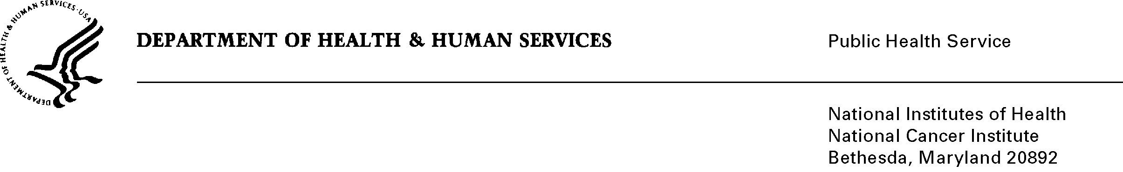

The current number of respondents in the study is 122,655; this is down from the initial total due to deaths. The primary endpoint of the trial is cancer specific mortality for each of the four cancer sites (prostate, lung, colorectal, and ovary). In addition, cancer incidence, stage shift, and case survival are to be monitored to help understand and explain results. Biologic prognostic characteristics of the cancers will be measured and correlated with mortality to determine the mortality predictive value of these intermediate endpoints. Basic demographic data, risk factor data for the four cancer sites and screening history data, as collected from all subjects at baseline, will be used to assure comparability between the screening and control groups and make appropriate adjustments in analysis. Further, demographic and risk factor information may be used to analyze the differential effectiveness of screening in high versus low risk individuals.

