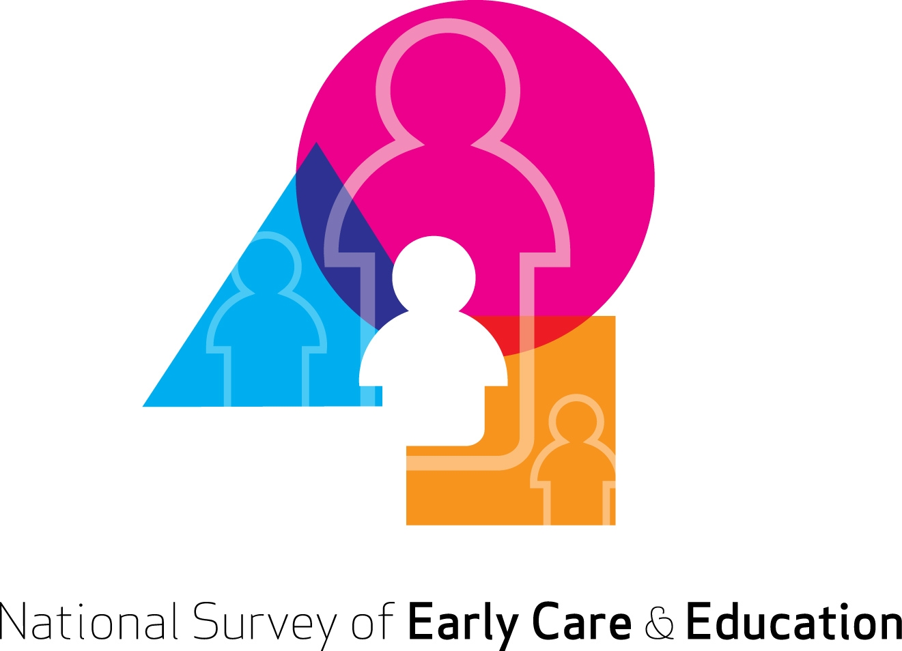

Center-Based Provider Screener – revised 6/22/11
Center-Based PROVIDER SCREENER: PROGRAM LIST UPDATING
[IF CAPI/CATI: GO TO A1. ELSE GO TO A2]
A1. My name is _________ and I am from NORC at the University of Chicago. We are conducting a study about organizations offering services to children under age 13 such as child care centers or before/after-school programs. The study is being paid for by the U.S. Department of Health and Human Services, and is designed to help the government understand how private decisions and public policies affect the supply and demand of child and school-age care in our country. I have a few questions about the childcare organizations at your address.
1. CONTINUE-->GO TO A3

A2. Thank you for taking this survey, which is conducted by NORC at the University of Chicago for the U.S. Department of Health and Human Services. This survey is designed to study organizations offering services to children under age 13 such as child care centers or before/after-school programs. The study is designed to help the government understand how private decisions and public policies affect the availability and use of child and school-age care in our country,

You should have received a personal identification number (PIN) and a password by mail or e-mail Please enter them in the fields below, and then click the "Continue" button.
1. CONTINUE-->GO TO A4
A3. INTERVIEWER INSTRUCTION: Is the roster confirmation being done in person or over the phone?
- In person-->GO TO A5
- Over the phone
A4. Our records have the address (ADDRESS). Can you tell me about programs for children under age 13 at that address?
- YES-->GO TO INSTRUCTION BEFORE A5
- NO
A5. [IF A3=2 AND A4=2, SAY: “Thank you very much. That is all I have.” HANG UP AND GO VISIT THE ADDRESS]
A6. We have been checking various records like licensing lists, head start program lists, and other records to identify programs for young children that may be located at [ADDRESS]. I’d like to quickly review the list of programs that we’ve found listed at this address. Some of these might be different names for the same program, or one program might be part of another.
[PROGRAMER NOTE: ALL PROGRAMS SHOULD BE LISTED HERE INCLUDING THE SELECTED ORGANIZATION]
 | Does [] serve children under 13 at this location [or is it part of another program on this list]?
[INSERT PROVIDER PROGRAM FROM SAMPLING FRAME] | YES, AT THIS LOCATION  YES, AT THIS LOCATION, DUPLICATE PROGRAM AS ______  YES, AT THIS LOCATION, PART OF PROGRAM_______  NO, DOES NOT SERVE CHILDREN AT THIS LOCATION  DK/REF/BLANK
[INSERT PROVIDER PROGRAM FROM SAMPLING FRAME] | YES, AT THIS LOCATION  YES, AT THIS LOCATION, DUPLICATE PROGRAM AS ______  YES, AT THIS LOCATION, PART OF PROGRAM_______  NO, DOES NOT SERVE CHILDREN AT THIS LOCATION  DK/REF/BLANK
[INSERT PROVIDER PROGRAM FROM SAMPLING FRAME] | YES, AT THIS LOCATION  YES, AT THIS LOCATION, DUPLICATE PROGRAM AS ______  YES, AT THIS LOCATION, PART OF PROGRAM_______  NO, DOES NOT SERVE CHILDREN AT THIS LOCATION  DK/REF/BLANK
[INSERT PROVIDER PROGRAM FROM SAMPLING FRAME] | YES, AT THIS LOCATION  YES, AT THIS LOCATION, DUPLICATE PROGRAM AS ______  YES, AT THIS LOCATION, PART OF PROGRAM_______  NO, DOES NOT SERVE CHILDREN AT THIS LOCATION  DK/REF/BLANK
[IF DUPLICATE OR PART OF ANOTHER PROGRAM SELECTED, ASK A7]
A7. So it seems like we have different names for one program. What is the best name to use for this program ?
___________________________PROGRAM NAME
DK/REF/BLANK
A8. A3_under13
(PROGRAMMING NOTE: IF SINGLE PROVIDER AT ADDRESS, ASK:)
[Besides the programs we just discussed], are there any other programs at this address offering early child care or school-age services to children under age 13? We are not asking about regular elementary school, grades kindergarten and up, but we do want to know about pre-kindergarten, or about before or afterschool programs for elementary school children.
- YESASK A9
- NOGO TO instruction above A11
3. DK/REF/BLANK GO TO A11

A9. Please tell me the name of any other program at [ADDRESS] that provides services such as pre-school, head start, pre-kindergarten, before or after-school care for school-age children.

A10. And what kind of program is that: a pre-school, head start, pre-kindergarten, or before or afterschool-program?

A10a. [IF NEW PROGRAM IS BEFORE/AFTER SCHOOL, ASK:] Some organizations provide a single type of activity for children. These could include tutoring programs, sports, or music or dance lessons. Would you say this program offers a single type of activity or more than one type of activity?

A10b. [IF PROGRAM IS A PRESCHOOL OR CHILD CARE CENTER (TYPE=1), ASK:]
Does <PROGRAM> offer services on a drop-in basis only or is enrollment required?

Type Single Drop-in
Activity
1. __________________________ 1 PS 2 HS 3 PK 4 AS Y N D E
2. __________________________ 1 PS 2 HS 3 PK 4 AS Y N D E
3. __________________________ 1 PS 2 HS 3 PK 4 AS Y N D E

INSTRUCTIONS:
IF BEFORE/AFTERSCHOOL PROGRAM IS MARKED AS SINGLE ACTIVITY IN A10A, THEN IT IS NOT ELIGIBLE.

IF PRESCHOOL/CHILD CARE CENTER IS MARKED AS DROP-IN AT A10b, THEN IT IS NOT ELIGIBLE.

IF ZERO OR ONE UNIQUE AND ELIGIBLE PROGRAM LEFT AT ADDRESS, SKIP TO A16 PROGRAM SELECTION. IF MULTIPLE PROGRAMS REMAINING, GO TO A11.
A11. Are all of these programs run by the same organization? [LIST UNIQUE, ELIGIBLE PROGRAMS.] INTERVIEWER: READ LIST OF PROGRAMS.
1 YES [SKIP TO END]
2 NO
A12. What organization do you work for?
NAME __________________________________
A13. Which of the programs for children under age 13 are run by your organization?
[LIST UNIQUE ELIGIBLE PROGRAMS TO SELECT FROM]
A14. What organization runs [SELECT ONE REMAINING PROGRAM NOT SELECTED AT A13 OR PREVIOUSLY AT A14.]?
NAME __________________________________
A15. Does [ORGANIZATION FROM A14] run any of the other programs at this site?
[LIST UNIQUE ELIGIBLE PROGRAMS TO SELECT FROM]
[IF ANY PROGRAMS STILL UNASSIGNED TO AN ORGANIZATION, RETURN TO A14 UNTIL ALL PROGRAMS ASSIGNED TO AN ORGANIZATION.]

[INSTRUCTION: DISPLAY ORGANIZATIONS RUNNING AT LEAST ONE UNIQUE AND ELIGIBLE PROGRAM AT ADDRESS, AS WELL AS ASSOCIATED UNIQUE AND ELIGIBLE PROGRAMS]

A16. <PROGRAM SELECTION>. IF ZERO UNIQUE AND ELIGIBLE PROGRAMS, GO TO A18. IF ONE UNIQUE AND ELIGIBLE PROGRAM, GO TO A19. IF MULTIPLE UNIQUE AND ELIGIBLE PROGRAMS AND NONE ARE HS/PK, GO TO A19. IF HS/PK AT THIS ADDRESS, GO TO A17.

A17. Thank you very much for your time. Those are all of our questions. TERMINATE AND DISPOSITION FOR MANUAL REVIEW.
A18. Thank you very much for your time. Those are all of our questions. TERMINATE AND DISPOSITION THIS ADDRESS AS “INELIGIBLE FOR THE SURVEY.”
A19. Thank you very much for your time. We have additional questions about [SELECTED PROGRAMS]. LAUNCH MAIN INTERVIEW.

