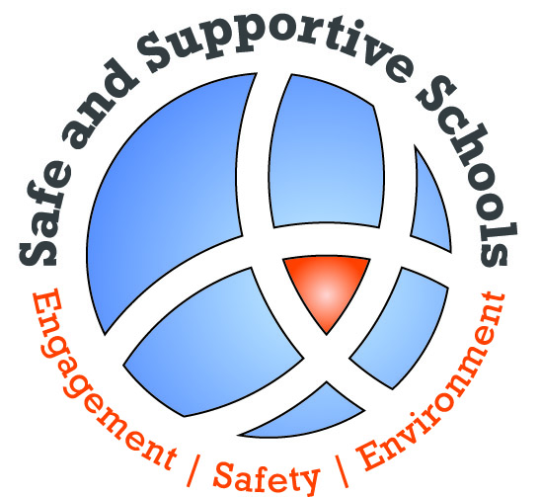
U.S Department of Education
Office of Safe and Drug-Free Schools
Safe and Supportive Schools Program

Feedback Form

(Name of the event)
(Date of the event)

- What is your current position(s) or role?
Check all that apply:
 | Project Director |  | Federal Government Staff
 | Teacher |  | State Government Staff
 | Evaluator |  | Other
 | Researcher |  | If other, list title:
 | School Counselor

2. Did the (name of the event) meet your expectations?
Exceeded my expectations
Met my expectations
Failed to meet my expectations

What was the best thing about (name of the event)?

What would you most like to change about (name of the event)?

What did you learn from (name of the event) that will help you in your work?

What topics or types of sessions would you like to see at future (name of the event)?

7. To what extent were you satisfied with the following sessions? | Very Satisfied | Satisfied | Dissatisfied | Very Dissatisfied
(Date of the event) Sessions
Session title (TBA)
Session title (TBA)
Session title (TBA)
Session title (TBA)
Session title (TBA)

 | Very Satisfied | Satisfied | Dissatisfied | Very Dissatisfied
8. To what extent were you satisfied with the hotel (location and services)?

Please provide any other comments that can assist us in making (name of the event) more useful.

Thank you for your comments and participation.

Public Burden Statement

According to the Paperwork Reduction Act of 1995, no persons are required to respond to a collection of information unless such collection displays a valid OMB control number. Public reporting burden for this collection of information is estimated to average 7 minutes per response, including time for reviewing instructions, searching existing data sources, gathering and maintaining the data needed, and completing and reviewing the collection of information. The obligation to respond to this collection is voluntary. Send comments regarding the burden estimate or any other aspect of this collection of information, including suggestions for reducing this burden, to the U.S. Department of Education, 400 Maryland Ave., SW, Washington, DC 20202-4536 or email ICDocketMgr@ed.gov and reference the OMB Control Number 1880-0542. Note: Please do not return the completed SSS TA Center Feedback Form to this address.

