White House Initiative on Asian Americans and Pacific Islanders Community Google Hangout Survey
* Required

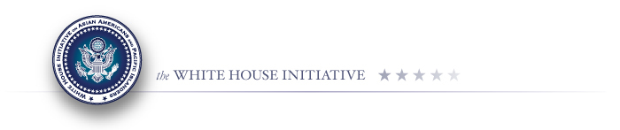
1. What topics would you have liked to go further into detail? *
Regional Interagency Working Groups
Regional Summits
Proposal Challenge
"I Am Beyond" Project Contest
Agency Plans
AANAPISIs
Affordable Care Act "Champions of Change" Contest
All of the topics were comprehensively covered.

2. How could the delivery of the Hangout be further improved? *
________________________________________________________________________________________________________________________________________________________________________________________________________________________________________________________________________________________________________________________________________________

3. What White House Initiative newsletters would you like to subscribe to? *
Weekly Highlights
AANAPISI Newsletter
Economic Zone Newsletter
IWG Newsletter
Youth Engagement Newsletter
I do not want to sign up for any newsletters.
4. What is your name?
You are only required to answer this question if you want to subscribe to a newsletter.
__________________________________________

5. What is your email address?
You are only required to answer this question if you want to subscribe to a newsletter.
__________________________________________

6. What organization are you part of?
You are only required to answer this question if you want to subscribe to a newsletter.
__________________________________________

Public Burden Statement
According to the Paperwork Reduction Act of 1995, no persons are required to respond to a collection of information unless such collection displays a valid OMB control number. Public reporting burden for this collection of information is estimated to average 10 minutes per response under 1880-0542, expiring on 7/31/2014, including time for reviewing instructions, searching existing data sources, gathering and maintaining the data needed, and completing and reviewing the collection of information. The obligation to respond to this collection is voluntary. If you have comments or concerns regarding the status of your individual submission of this survey, please contact the White House Initiative on Asian Americans and Pacific Islanders directly.

