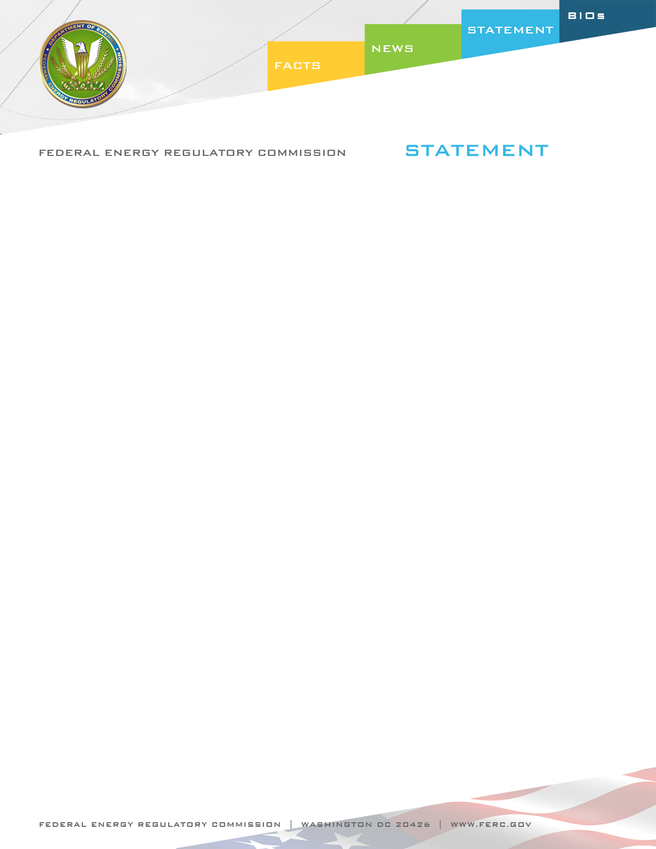

Docket Nos. RM10-23-000
Item No. E-6

July 21, 2011
Commissioner Cheryl A. LaFleur

Statement of Commissioner Cheryl A. LaFleur on
Transmission Planning and Cost Allocation

“As I have frequently observed, I believe that our nation has historically underinvested in electric transmission, particularly in high voltage interstate transmission. An important precursor to building transmission is determining what will be built, who will build it, and who will pay for it—the subjects we address today in the Final Rule.

Today, the Commission acts to ensure that transmission providers meet our nation’s transmission needs with the most efficient and cost effective solutions available. The requirements of the Final Rule are driven by our statutory mandate to ensure just, reasonable and nondiscriminatory rates, and by our judgment that changes in the electric industry require action to address deficiencies in existing rules.

New transmission is needed for at least three reasons.

First, new transmission is needed to strengthen reliability. The primary obligation of the electric industry and those who regulate it is to “keep the lights on.” The reforms adopted in this Final Rule will facilitate transmission projects that have broad reliability benefits. The Final Rule also makes clear that both incumbent and non-incumbent transmission developers must comply with mandatory reliability standards.

Second, new transmission is needed to enhance the functioning of wholesale markets and reduce customer costs. As the Final Rule notes, inadequate planning and cost allocation procedures can allow inadequate, inefficient or overlapping transmission development. These missed opportunities and inefficiencies can contribute to congestion costs and impede access to low-cost supply.

Finally, new transmission is needed to connect new resources, including those needed to satisfy state and federal public policy requirements. For example, 28 states and the District of Columbia require their utilities to purchase a sizable and growing portion of their supply from renewable resources. While these state policy choices will necessarily shape future energy supply, existing planning rules do not always allow for these policy choices to be considered as drivers of transmission needs. The reforms adopted in this Final Rule will ensure that transmission planning processes consider transmission needs driven by public policy requirements.

It is important to note that the Final Rule does not write on a blank slate. I feel honored to be part of the Commission as we build on the requirements of Orders 888 and 890 and on the hard work of transmission providers across the country. The reforms required by the Final Rule are also consistent with cost causation principles and judicial precedent, including the requirement that beneficiaries are only allocated costs that are at least roughly commensurate with benefits.

For me, one of the most difficult decisions in the Final Rule was the decision to curtail the federal right of first refusal for transmission projects. After much careful thought, I support our decision today to eliminate the right of first refusal for regional transmission projects. At a time of great expansion in the transmission grid, it is imperative that we invest in the right transmission for customers. Allowing both incumbents and nonincumbents the ability to propose transmission projects will help make that happen. I note the Final Rule opens up the planning process, but rejects the proposed structure in the proposed rule that would have guaranteed that project sponsors retain project rights for a defined period of time. This was widely viewed as unworkable by commenters.

It is important to reconcile the benefits to customers from competition in transmission construction with the need to ensure that incumbents can meet their reliability obligations to customers. The Final Rule protects an incumbent’s right to build transmission needed to meet its reliability obligations to customers in three ways.

First, the Final Rule does not eliminate any rights of first refusal for upgrades to existing transmission facilities or on existing rights of way, or for facilities that are not selected in the regional transmission plan for purposes of cost allocation.

Second, incumbents may submit projects, including projects located entirely within their retail service territory or footprint, for consideration in the regional plan for the purposes of cost allocation. The Final Rule emphasizes that in addition to arguing that their projects have regional benefits that justify cost allocation, incumbents are free to highlight their unique strengths and experience in support of their projects.

Finally, and very importantly, the Final Rule requires adoption of a “backstop” mechanism to ensure that delays in the development of a regional transmission facility will not prevent incumbents from complying with reliability needs and service obligations. Specifically, the Final Rule requires each transmission provider to amend its open access transmission tariff to require reevaluation of the regional transmission plan to determine if delays in the development of a transmission facility require evaluation of alternative solutions, including those proposed by the incumbent, to ensure that incumbents can meet reliability needs and service obligations.

There is still much work to be done on compliance. The Final Rule sets out general principles of transmission planning and cost allocation, and gives transmission providers and regional planners considerable discretion in how to satisfy them. Some transmission providers may seek to show that their existing rules already satisfy the requirements of the Final Rule. Others will recognize that elements of their existing rules will need to be changed. Additionally, each transmission provider will have to amend its tariff to set out the details of its reliability backstop. I am pleased that the Commission has directed its staff to hold informational conferences to assist entities in meeting their compliance obligations, and my staff and I will do so as well.”

