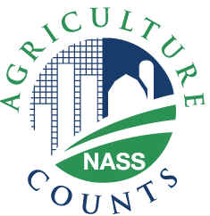
NEWS RELEASE
United States Department of Agriculture
NATIONAL AGRICULTURAL STATISTICS SERVICE
[STATE NAME] FIELD OFFICE
[ADDRESS]

FOR IMMEDIATE RELEASE | Contact: [Firstname] [Lastname]
[Month ##], 2010 | (XXX) XXX-XXXX

USDA TO CONDUCT DECEMBER HOGS AND PIGS SURVEY

[CITY, STATE] – U.S. inventory of hogs and pigs has declined in recent years. The U.S. Department of Agriculture will be looking to see if this trend continues when it conducts the quarterly Hogs and Pigs Survey in December.
During the first two weeks of the month, USDA’s National Agricultural Statistics Service (NASS) will contact nearly 12,000 pork producers, including contractors, nationwide. They will be asked to report their market hog and breeding stock inventories as well as their farrowing intentions as of December 1.
“With producer participation in these surveys, NASS can measure and report trends in the U.S. pork industry over the course of the year,” said [FIRSTNAME LASTNAME], Director of the NASS [STATE] Field Office. “The quarterly surveys enable NASS to provide timely, accurate and unbiased data that all sectors of the U.S. pork industry, depend on to help make sound business decisions,” added [LASTNAME].
[LASTNAME] noted that, as is the case with all NASS surveys, information provided by respondents is confidential by law. “NASS safeguards the privacy of all responses and publishes only state and national-level data, ensuring that no individual producer or operation can be identified,” [he/she] said.
Survey results are published in NASS’s quarterly Hogs and Pigs report, to be released December 27. NASS also publishes estimates of the number of hog operations by herd size groups and percent of inventory in the Farms, Land in Farms and Livestock Operations report in February. These and all NASS reports are available online at www.nass.usda.gov. For more information, call the NASS [STATE] Field Office at [Toll-free Number].

###

