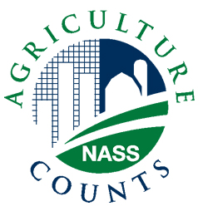
NEWS RELEASE
United States Department of Agriculture
NATIONAL AGRICULTURAL STATISTICS SERVICE
[STATE NAME] FIELD OFFICE
[ADDRESS]

FOR IMMEDIATE RELEASE | Contact: [Firstname] [Lastname]
[Month ##], [Year] | (XXX) XXX-XXXX

USDA TO SURVEY CATTLE OPERATIONS

[City, State] – The U.S. Department of Agriculture is gearing up to take a nationwide cattle inventory, with plans to contact nearly 10,000 operations during the first two weeks in July.
“The July Cattle Survey provides [State] producers the opportunity to serve as the frontline source of information on U.S. cattle production,” said [FirstName LastName], director of the NASS’s [State] Field Office. “In [State], we will contact approximately [# in your state sample] operations in order to measure trends in beef and dairy cattle inventories, calf crop and cattle operations.
“The information gathered will help producers make informed marketing decisions and plan for herd expansion or reduction,” [s/he] explained. “It also helps packers and government evaluate expected slaughter volume for future months and determine potential supplies for export,” [LastNamep] said.
To make it as easy as possible for producers to participate, NASS offers the option of responding via telephone, mail, online, or personal interview with a local NASS representative. Responses will be compiled and published in NASS’s biannual Cattle report, to be released on July 23, 2010. The report will provide national-level estimates of total inventory, beef cows, milk cows, bulls, replacement heifers, other heifers, steers, calves and number of calves born as of July 1.
As with all NASS surveys, information provided by respondents is confidential by law. NASS safeguards the privacy of all survey responses and publishes only aggregate data, ensuring that no individual operation or producer can be identified. All reports are available on the NASS web site: www.nass.usda.gov.

###

