# APPENDIX 3: Illustrative Design Comps

These sample pages are provided for context only regarding how users will enter data in SuperTracker. Please note that these pages do not necessarily include correct data or the final wording, and are provided with this memo only for the purpose of facilitating review.

## Figure : Create Profile - Users enter data to create a profile and/or register.

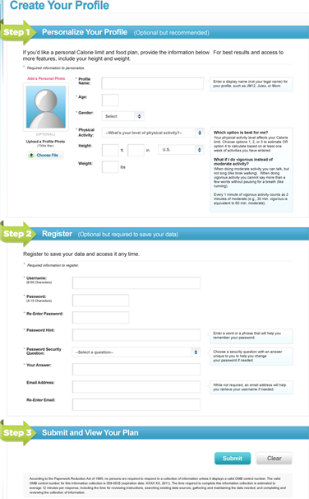**Figure 2: My Journal - Users jot down information in one of f**ive **general categories as desired.**

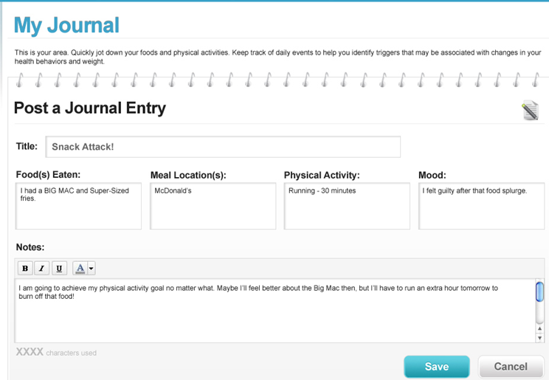

## Figure : Food Tracker - Users search and enter foods and beverages and obtain interactive feedback on how their intake compares to targets.

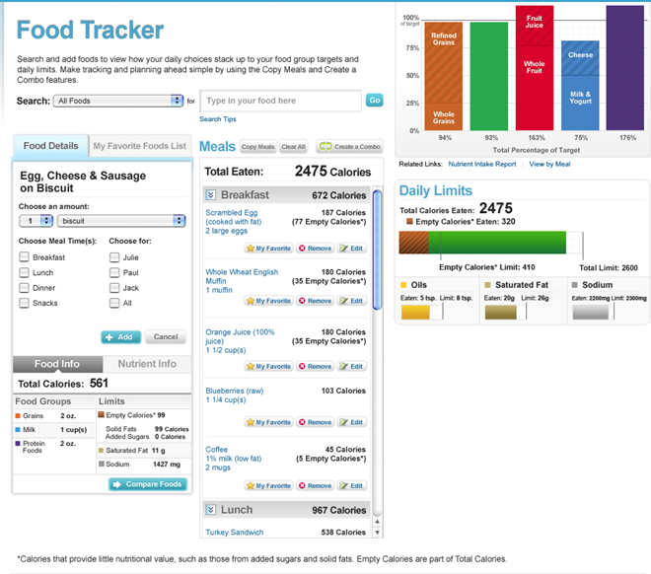

## Figure : Physical Activity Tracker - Users search and enter physical activities and obtain interactive feedback on how their physical activity compares to targets.

