United States
Department of
Agriculture

Center for
Nutrition Policy
and Promotion

3101 Park Center Drive
Room 1034
Alexandria, VA 22302

Memorandum

Date: | Original Submission May 12, 2011
To: | Julie Wise, OMB Desk Officer, Food and Nutrition Service
Through: | Rachelle Ragland Green, Food and Nutrition Service, Information Clearance Officer;  Ruth Brown, OCIO Desk Officer
From: | Robert Post, PhD, Deputy Director  USDA Center for Nutrition Policy and Promotion (CNPP)
Re: | Change Justification Request to Revise Public Burden Information for CNPP Interactive Tools under Approved OMB Clearance No. 0584 – 0535

The Center for Nutrition Policy and Promotion (CNPP) of the USDA Food, Nutrition and Consumer Services is requesting approval to update the public burden information for CNPP interactive tools under Approved OMB Clearance No. 0584-0535 (expiration 7/31/2012). This update is required as a result of CNPP’s work to combine functionality of their existing interactive tools (available at ChooseMyPlate.gov) based on user feedback, changes under the 2010 Dietary Guidelines for Americans, and the need for modern technology to streamline user experience. This combined and enhanced interactive tool is named SuperTracker.

CNPP’s interactive tools allow consumers to generate a daily food plan, analyze diet and physical activity, plan meals, and access food group and Calorie information for quick comparison. Monitoring intake has been shown to help individuals become more aware of what and how much they eat and drink – the tools allow users to explore ways to improve their food and physical activity choices.

Users have shared incredibly positive feedback about their experiences using the current interactive tools. For example, they have lost weight, decreased the need for medications, and improved their emotional health; they have attributed their successes to these tools. In addition, many have expressed appreciation for the free government tools that provide similar benefits of the many for-profit programs. SuperTracker will be the improved face of the interactive tools; overwhelmingly positive feedback is expected with the launch of this tool.

Consumers may voluntarily provide data that is stored strictly for the purpose of providing this information back to the individual for historical and trending information. This benefits consumers by allowing them to identify focus areas for implementing personal behavior changes related to their diet and physical activity. SuperTracker includes functions that consumers may use at their discretion, including a journaling feature to capture information by category (Food(s) Eaten; Meal Location; Physical Activity; Mood; Notes), with the option to post the Notes field to Facebook or Twitter. Consumers may also post system-generated congratulatory and tip messages to Facebook or Twitter using their personal social media account. Through leveraging the user’s existing social network, the user is more likely to experience positive feedback and encouragement in achieving their dietary and/or physical activity goals. Social media functionality is provided as a consumer benefit – it does not impact consumer results or reports.

Consumers will enter the same data that they enter now in the separate MyPyramid.gov interactive tools, with the added benefit of social media (Refer to Appendix 2 for a side-by-side comparison of the data entry fields for existing CNPP interactive tools and SuperTracker. Appendix 3 shows screenshots of the new user interface.) Because new technology is being used, the web application is much more streamlined and has faster processing, resulting in decreased public burden. For example, SuperTracker users log in once to gain access to all features; current registered users must log in to the Tracker and Menu Planner interactive tools separately to access the features under each. Having a single registration/login process under SuperTracker addresses a frequently cited user request, and will save users substantial time. Additional SuperTracker time savers resulting in decreased public burden include the following:

- Creating profiles for each family member rather than creating separate user names and passwords for each family member, and having to log in and log out to access each one.
- Copying meals and/or physical activities to multiple days and/or multiple profiles. Users will be able to copy family meals by clicking checkboxes. Users will no longer have to log out and then log in to the separate family account(s) and enter data manually for each day.
- Creating “combos” for commonly eaten foods consisting of multiple food items.

SuperTracker’s streamlined navigation, features that allow consumers to quickly and easily enter data for one or multiple days, and decreased processing time all contribute to the reduction of estimated time required to collect consumer data. The original burden estimate was based on data for two separate dietary assessment and physical activity tools. The revised application will be integrated into the CooseMyPlate.gov website and will not retain a separate web address. Hence all of the future usage data will be obtained through the recently launched ChooseMyPlate.gov website. These estimates are based on the number of visits to the website and average duration for these visits.

The following total annual burden estimates are based on the data obtained from current web trend tool, Google Analytics from May 29,2011 - September 10, 2011 (see Appendix 1).

- The number of annual visitors to the website is expected to be about 11.2 million.
- Approximately 30% of annual visitors will complete a one-time registration, log-in and assessment for the revised online assessment tool. This information is based on data from the MyPyramid Planner, the most frequently used dietary assessment tool (rounded up = 3.3 million).
- The average number of weekly visitors is 185,000 (rounded up = 200,000).
- 30% of the weekly visitors return each week to complete tracking activities (approximately 60,000). The amount of time spent completing entry and using expanded functionality is estimated at 45 minutes per week.

The annual public burden is estimated to decrease from 6,843,446 hours to 3,787,898, a reduction of 3,055,568 hours per annum (45% decrease). Details about the SuperTracker burden calculation are provided below.

SuperTracker Burden Estimates
Affected Public | Description of Activity | (b) Form Number | (c ) No. Annual Respondents | (d) Annual Frequency of Responses Per Respondent | (e) Est. Total Annual Responses (cxd) | (f) Hours Per Response | (g) Total Annual Burden (exf)
Reporting Burden
Individual and households | Annual Website Visitors |  | 11,200,000 | 1 | 11,200,000 | 0.05 | 560,000
Individual and households | One time Supertracker registration | N/A | 3,300,000 | 1 | 3,300,000 | 0.0167 | 55,110
Individual and households | One time Supertracker Log-in | N/A | 3,300,000 | 1 | 3,300,000 | 0.0083 | 27,390
Individual and households | Food/Physical Activity Data Entry for 1 Week | N/A | 3,300,000 | 1 | 3,300,000 | 0.25 | 825,000
Individual and households | Repeat Log-ins for 1 Year | N/A | 60,000 | 51 | 3,060,000.00 | 0.0083 | 25,398
Individual and households | Repeat Food/Physical Activity Data Entries for 1 Year | N/A | 60,000 | 51 | 3,060,000.00 | 0.75 | 2,295,000
 | Total Annual Burden Est. |  | 3,600,000 |  | 16,020,000 |  | 3,787,898

Total Respondents | 3,600,000 | (a)
Current Burden | 6,843,466
Requested Burden | 3,787,898 | ( c )
Difference | 3,055,568 | (eXf)
Reduction | 45 | %

The following information is provided for your review:

- Title of Project: SuperTracker

- Control Number: 0584-0535, expiration date: 7/31/2012

- Public affected by this Project: Individual or Households with Internet Access

- Time needed per Repeat Response: Average duration = 45 Minutes per week

- Project Methodology and Design:

In consolidating and enhancing the functionality of its existing interactive tools, CNPP has worked closely with USDA’s Food and Nutrition Service Office of Information Technology to follow software development cycle best practices. CNPP contracted with a design vendor to develop a user-friendly, best in class web application interface, and contracted with a software development vendor to develop a best in class web application.

- Federal Costs:
Total SuperTracker Contract Costs: $1,503,934.00
SuperTracker Web Application Hosting Costs: $1,025,346.00

aPPENDIX A: Web Trends USING GOOGLE ANALYTICS
2011 ChooseMyPlate.gov Usage Statistics
Week | Visitors | Visits | % New Visits | Page Views | Avg. #  Pages/Visit | Avg. Time  on Site
05/29/11 - 06/04/11 | 523,745 | 584,927 | 89.53% | 1,773,310 | 3.03 | 0:02:33
06/05/11 - 06/11/11 | 352,103 | 441,903 | 74.35% | 1,474,764 | 3.34 | 0:03:32
06/12/11 - 06/18/11 | 221,482 | 283,280 | 69.36% | 834,494 | 2.95 | 0:03:19
06/19/11 - 06/25/11 | 164,635 | 215,100 | 65.94% | 578,040 | 2.69 | 0:03:14
06/26/11 - 07/02/11 | 138,014 | 180,366 | 64.94% | 477,689 | 2.65 | 0:03:10
07/03/11 - 07/09/11 | 127,623 | 164,434 | 66.34% | 432,481 | 2.63 | 0:03:11
07/10/11 - 07/16/11 | 133,354 | 174,137 | 64.97% | 461,629 | 2.65 | 0:03:15
07/17/11 - 07/23/11 | 125,880 | 165,056 | 63.64% | 444,242 | 2.69 | 0:03:21
07/24/11 - 07/30/11 | 114,795 | 148,945 | 63.88% | 389,086 | 2.61 | 0:03:08
07/31/11 - 08/06/11 | 113,955 | 145,588 | 65.45% | 377,775 | 2.59 | 0:03:07
08/07/11 - 08/13/11 | 114,821 | 146,718 | 66.13% | 375,702 | 2.56 | 0:03:04
08/14/11 - 08/20/11 | 117,563 | 152,557 | 65.30% | 404,517 | 2.65 | 0:03:21
08/21/11 - 08/27/11 | 141,099 | 181,747 | 67.46% | 541,936 | 2.98 | 0:04:13
08/28/11 - 09/03/11 | 179,045 | 233,575 | 67.10% | 743,761 | 3.18 | 0:04:41
09/04/11 - 09/10/11 | 206,905 | 270,715 | 66.67% | 865,022 | 3.20 | 0:04:41
Total | 2,775,019 | 3,489,048 | n/a | 10,174,448 | n/a | n/a
Average | 185,001 | 232,603 | 68.07% | 678,297 | 2.83 | 0:03:27

APPENDIX 2: COMPARISON OF DATA COLLECTION

EXISTING CNPP INTERACTIVE TOOLS VS. SUPERTRACKER WEB APPLICATION

APPENDIX 3: Illustrative Design Comps

These sample pages are provided for context only regarding how users will enter data in SuperTracker. Please note that these pages do not necessarily include correct data or the final wording, and are provided with this memo only for the purpose of facilitating review.

Figure 1: Create Profile - Users enter data to create a profile and/or register.

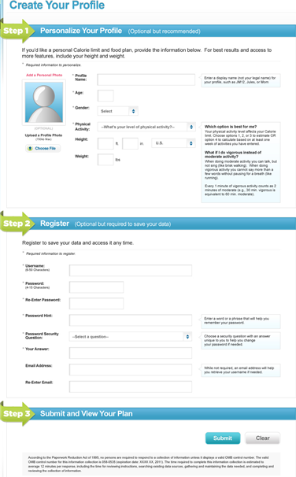
Figure 2: My Journal - Users jot down information in one of five general categories as desired.

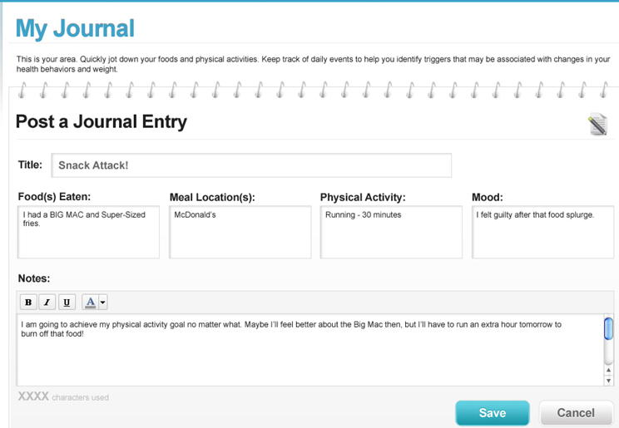

Figure 3: Food Tracker - Users search and enter foods and beverages and obtain interactive feedback on how their intake compares to targets.

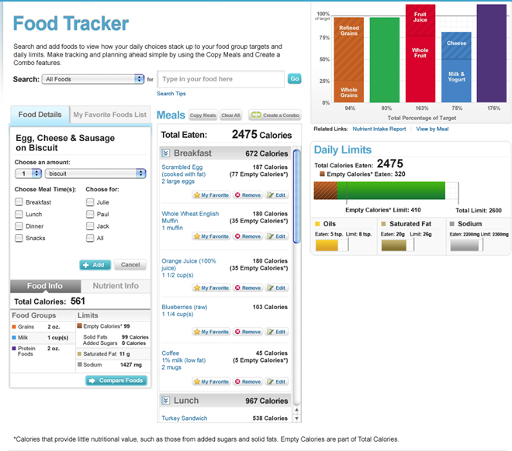

Figure 4: Physical Activity Tracker - Users search and enter physical activities and obtain interactive feedback on how their physical activity compares to targets.

