Form Approved
OMB No. 0920-XXXX
Exp.Date: xx/xx/20xx

Attachment H-4:

Self-reported general work environment and health questionnaire (28 items)

This questionnaire will be completed by all participating employees at the start of the study and once every year for 2 years.

Today's Date: MONTH/ DAY /YEAR;

SECTION A. GENERAL INFORMATION

1. Age in years______
2. Gender: Male; Female;
3. Your Height: FEET; INCHES;
4. Your Weight: POUNDS;
5. In the past year, on average, how much total time did you spend in a vehicle each day? Less than 1 hour per day; 1 hour to less than 2 hours per day; 2 hours to less than 3 hours per day; 3 hours to less than 5 hours per day ; More than 5 hours per day;

SECTION B. WORK INFORMATION

6. How long have you worked at this company? Less than 3 months; 3 months to less than 1 year; 1 year to less than 3 years; years to less than 5 years; 5 years to less than 10 years; 10 years or more;

7. How long have you worked in your current job? Less than 3 months; 3 months to less than 1 year; 1 year to less than 3 years; 3 years to less than 5 years; 5 years to less than 10 years; 10 years or more;

8. On your job at this company, do you usually work: Regular daytime shift (first shift); Regular evening shift (second shift); Regular night shift (third shift);

9. Do you work overtime at this company? No; a. How many overtime HOURS PER WEEK do you USUALLY work? Less than 5 hours per week; 5 to 10 hours per week; 11 to 20 hours per week; More than 20 hours per week;

10a. Do you work at a second job (for a different employer)? No; Yes; If you checked no, please go to SECTION C;

10b. If yes, does the second job involve LIFTING, PUSHING, PULLING, or CARRYING: 1) MODERATE weight objects? No; Sometimes; Often; 2) HEAVY weight objects? No; Sometimes; Often;

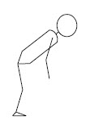
10c. Does this second job involve bending your back at least as far forward as shown in the picture? Never or rarely; Less than half of the time; Half the time or more

Public reporting burden for this collection of information is estimated to average 10 minutes per response, including the time for reviewing instructions, searching existing data sources, gathering and maintaining the data needed, and completing and reviewing the collection of information. An agency may not conduct or sponsor, and a person is not required to respond to a collection of information unless it displays a currently valid OMB control number. Send comments regarding this burden estimate or any other aspect of this collection of information, including suggestions for reducing the burden estimate to CDC/ASTDR Reports Clearance Officer, 1600 Clifton Road, NE, MS D-74, Atlanta, Georgia 30333; ATTN: PRA (0920-xxxx).

SECTION C. PHYSICAL ACTIVITIES OUTSIDE OF WORK

Please think for a moment about all the different PHYSICAL activities you do when you are not at work. These activities might include, but are not limited to: Housework, Dependent Care, Sports, Grocery Shopping, Hobbies, Auto and Home Repair. Although you may not do the same activities every week, tell us how much time you spend on average or in a typical week on physical activities outside of work.
NOT including your time at this company (Questions 11 -12):

11. How many hours do you use your hands with moderate to heavy effort? (such as scrubbing, using a hammer, gripping a bowling ball, weight lifting, etc.): Less than 5 hours a week; 5 to less than 10 hours a week; 10 to less than 20 hours a week; 20 or more hours a week;

12. How many hours on average do you spend on activities in which…
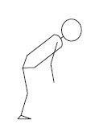
a. you twist your back or bend forward at least as much as shown in this picture? (such as raking, working under the hood of a car, bathing a child, etc.) Less than 5 hours a week; 5 to less than 10 hours a week; 10 to less than 20 hours a week; 20 or more hours a week;

b. you lift, push, pull or carry moderate to heavy weights? (such as children or groceries, moving furniture, shoveling, backpacking, etc.) Less than 5 hours a week; 5 to less than 10 hours a week; 10 to less than 20 hours a week; 20 or more hours a week;

SECTION D. HEALTH INFORMATION

13. How would you rate your health compared to other persons your age? Poor; Fair; Good; Very Good; Excellent;

SECTION E. SYMPTOMS

The FOLLOWING SECTIONS ask if you have had symptoms such as pain, aching, stiffness, burning, numbness, or tingling in any of the body parts listed below:

E1. NECK
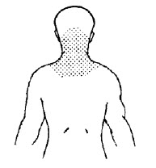
The following questions ask about symptoms in the shaded area in this picture (the NECK). There are separate questions on shoulder symptoms.

14. In the past 12 months, have you had NECK symptoms (pain, aching, stiffness, spasm, unable to move your head, burning, numbness or tingling) more than 3 times OR lasting a week (7 days) or longer? No; If you checked no, please go to SECTION E2.SHOULDERS;

15. In the past 12 months, how would you rate your level of NECK pain AT ITS WORST? No pain; Mild pain; Moderate pain; Severe pain; Very severe pain;

E2. SHOULDERS
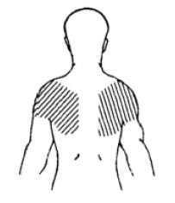
The following questions ask about symptoms in the shaded area in this picture (the SHOULDERS).

16. In the past 12 months, have you had SHOULDER symptoms (pain, aching, stiffness, spasm, unable to raise your arms, burning, numbness or tingling) more than 3 times OR lasting a week (7 days) or longer? Yes; No; If you checked no, please go to E3. ELBOWS/FOREARMS;

17. In the past 12 months, how would you rate your level of SHOULDER pain AT ITS WORST? For both Left and Right shoulder: Left Shoulder: No pain; Mild Pain; Moderate Pain; Severe Pain; Very severe pain; Right Shoulder: No pain; Mild Pain; Moderate Pain; Severe Pain; Very severe pain;

E3. ELBOWS/FOREARMS
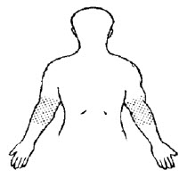
The following questions ask about symptoms in the shaded area in this picture (the ELBOWS/FOREARMS).

18. In the past 12 months, have you had ELBOW/FOREARM symptoms (pain, aching, stiffness, burning, numbness or tingling) more than 3 times OR lasting a week (7 days) or longer? Yes; No; If you checked no, please go to E4. HANDS/WRISTS;

19. In the past 12 months, how would you rate your level of ELBOW/FOREARM pain AT ITS WORST? For both Left and Right elbow/forearm: Left Elbow/Forearm: No pain; Mild Pain; Moderate Pain; Severe Pain; Very severe pain; Right Elbow/Forearm: No pain; Mild Pain; Moderate Pain; Severe Pain; Very severe pain;

E4. HANDS/WRISTS
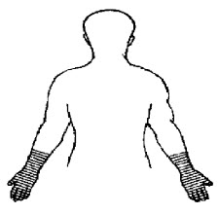
The following questions ask about symptoms in the shaded area in this picture (the HANDS/WRISTS).

20. In the past 12 months, have you had HAND/WRIST symptoms (pain, aching, stiffness, burning, numbness or tingling) more than 3 times OR lasting a week (7 days) or longer? Yes; No; If you checked no, please go to E5. BACK;

21. In the past 12 months, how would you rate your level of HAND/WRIST pain AT ITS WORST? For both Left and Right hand/wrist: Left Hand/Wrist: No pain; Mild Pain; Moderate Pain; Severe Pain; Very severe pain; Right Hand/Wrist: No pain; Mild Pain; Moderate Pain; Severe Pain; Very severe pain;

E5. BACK
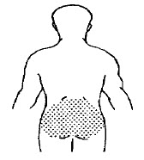
The following questions ask about symptoms in the low back as shown in the shaded area in this picture (the BACK).

22. In the past 12 months, have you had BACK pain every day for a week (7 days) or more? Yes; No; If you checked no, the survey is complete.

23. a) In the past 12 months, ON AVERAGE, how intense was your back pain rated on a 0-10 scale where 0 is 'no pain' and 10 is 'pain as bad as could be'? (That is, your usual pain at times you were experiencing pain.) 0 1 2 3 4 5 6 7 8 9 10;

b) In the past 12 months, how intense was your WORST back pain rated on a 0-10 scale where 0 is 'no pain' and 10 is 'pain as bad as could be'? 0 1 2 3 4 5 6 7 8 9 10;

c) How would you rate your back pain AT THE PRESENT TIME on a 0-10 scale, where 0 is "no pain" and 10 is "pain as bad as could be"? 0 1 2 3 4 5 6 7 8 9 10;

SURVEY COMPLETED- THANK YOU!

