Attachment L-1:

Details of Interventions

Powered Hand Truck:  The Powered Hand Truck (PHT) intervention is a powered stair-climbing hand truck designed to move large products (such as appliances up to l,500 lbs.) up/down stairs, on/off delivery vehicles, loading docks, and in/ out of buildings. Photos courtesy of Power Mate. | 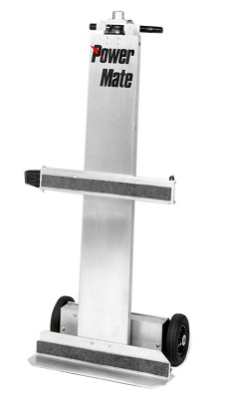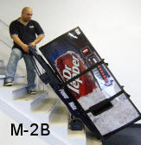
Truck Lift Gate:  The Truck Lift Gate (TLG) intervention is a powered platform that attaches to the rear of a delivery truck. The powered platform raises/lowers large products (such as appliances etc.) on/off delivery vehicles. Photo courtesy of Tommy Gate. | 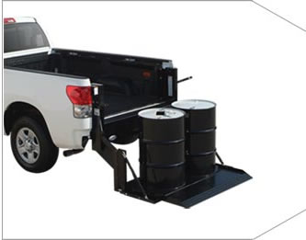
Note: As part of the Safety Grants process, OBWC will utilize a bid process to select a small range of intervention brands and vendors that meet a range of specifications for the PHT and TLG interventions. Within each matching pair of participating companies, both companies will receive the same brand of intervention though models may vary slightly (e.g. different lifting capacities).

