Attachment 4
Simulations for Drug Related Science Education (NIDA)
Submission date 7/20/11

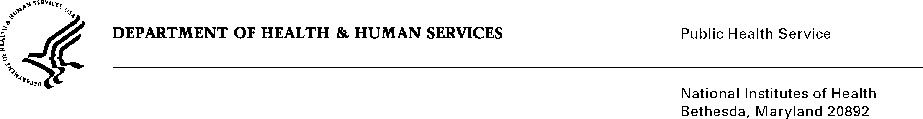

DATE: December 11, 2009

TO: Cathrine Sasek, Ph.D.
Project Officer
Office of Science Policy & Communications, NIDA

FROM: NIH Privacy Act Officer

SUBJECT: Applicability of the Privacy Act: Simulations for Drug Related Science Education

I have reviewed the NIDA submission to OMB entitled “Simulations for Drug Related Science Education” and determined that the Privacy Act will apply to this data collection.

Students will be asked to provide personally identifiable information (e.g., date of birth, gender, race/ethnicity, personal opinions). Although the system will not ask for the student’s name, a home phone number or locker number (as an alternative) will be requested in order to gather and match student responses to pre- and post- intervention questionnaires completed during school hours.

The data collection is covered by NIH Privacy Act Systems of Record 09-25-0156, “Records of Participants in Programs and Respondents in Surveys Used to Evaluate Programs of the Public Health Service, HHS/PHS/NIH/OD.”

If you have any questions, please contact my office at (301) 496-2832.

Karen M. Plá

