Attachment 22B: Follow-Up Survey in English

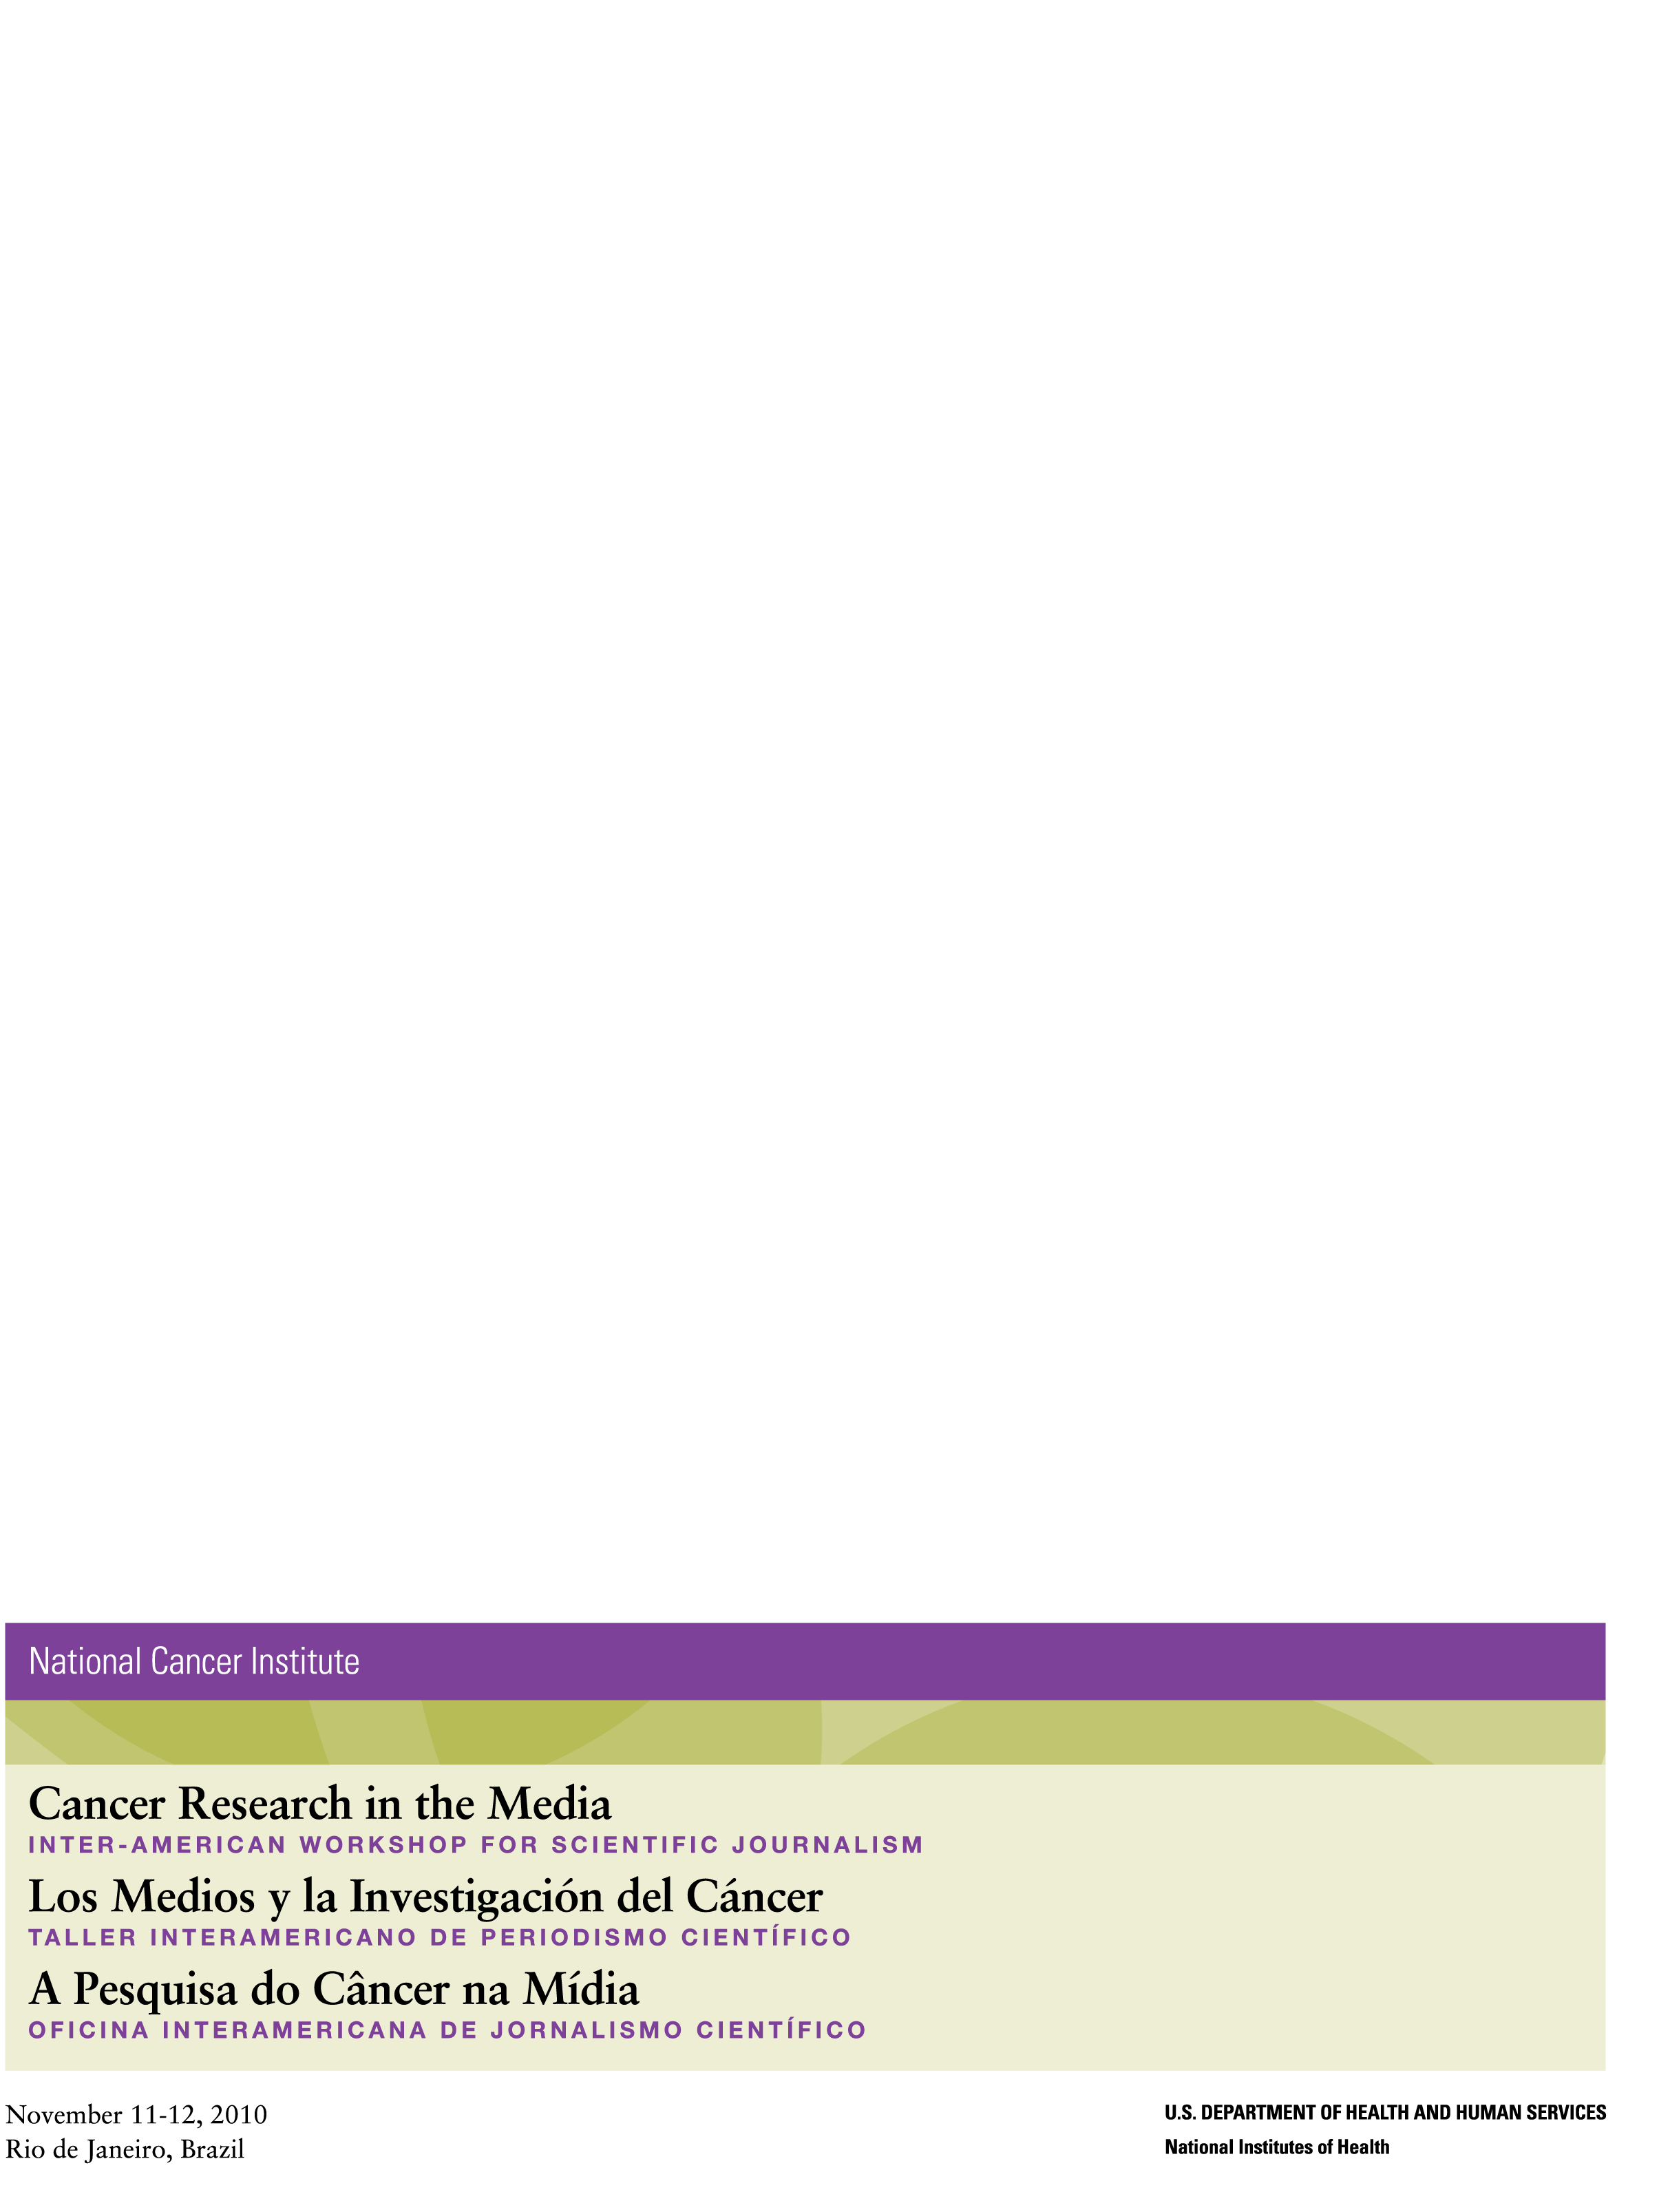

OMB No.: 0925-0642

Expiration Date: 9/30/2014

Public reporting burden for this collection of information is estimated to average 15 minutes per response, including the time for reviewing instructions, searching existing data sources, gathering and maintaining the data needed, and completing and reviewing the collection of information. **An agency may not conduct or sponsor, and a person is not required to respond to, a collection of information unless it displays a currently valid OMB control number.** Send comments regarding this burden estimate or any other aspect of this collection of information, including suggestions for reducing this burden to: NIH, Project Clearance Branch, 6705 Rockledge Drive, MSC 7974, Bethesda, MD 20892-7974, ATTN: PRA (0925-0642). Do not return the completed form to this address.

**The Online Survey Questions:**

1. Country in which you work: ___________________________
2. Type of media outlet: (select all that apply)

❑ Newspaper

❑ Magazine  
❑ Radio

❑ TV

❑ Other: _______________________

1. Job description: (select all that apply)

❑ Journalist/writer

❑ Editor

❑ Producer

❑Presenter

❑Other: ______________________________

| How well did Cancer Research in the Media 2010 Workshop prepare you to perform the following tasks? | **Very Poor** | **Poor** | **Acceptable** | **Well** | **Very Well** |
| --- | --- | --- | --- | --- | --- |
| 1. Understand the results of cancer research studies | ❑ | ❑ | ❑ | ❑ | ❑ |
| 1. Interpret research results for the public | ❑ | ❑ | ❑ | ❑ | ❑ |
| 1. Identify appropriate resources for accurate and current cancer research | ❑ | ❑ | ❑ | ❑ | ❑ |
| 1. Determine the credibility of a research finding | ❑ | ❑ | ❑ | ❑ | ❑ |
| 1. Understand - clinical trials | ❑ | ❑ | ❑ | ❑ | ❑ |

1. Since you participated in “Cancer Research in the Media 2010 Workshop”:
   1. How many **health** news stories have you written/created/edited? ______

❑ Number: ______ (you may give an approximate number)   
❑ I have not been able to write/create/edit any **health** news story

❑ I do not remember

* 1. How many **health research** news stories have you written/created/edited? ______

❑ Number: ______ (you may give an approximate number)   
❑ I have not been able to write/create/edit any **health research** news story

❑ I do not remember

* 1. How many **cancer** news stories have you written/created/edited? ______

❑ Number: ______ (you may give an approximate number)   
❑ I have not been able to write/create/edit any **cancer** news story

❑ I do not remember

* 1. How many **cancer research** news stories have you written/created/edited?

❑ Number: ______ (you may give an approximate number)   
❑ I have not been able to write/create/edit any **cancer research** news story

*[If NO Stories have been written for a-d, SKIP TO #20)*.

❑ I do not remember

| Since “Cancer Research in the Media 2010 Workshop”, have you included the following HealthNewsReview.org criteria in the news stories on **cancer research** you have written/created/edited how? | **Never** | **Rarely** | **Sometimes** | **Most of the time** | **Always** |
| --- | --- | --- | --- | --- | --- |
| 1. Discussed the **availability** of the treatment, screening test, product or procedure covered in the story. | ❑ | ❑ | ❑ | ❑ | ❑ |
| 1. Discussed of the **costs** of the treatment, screening test, product or procedure covered in the story. | ❑ | ❑ | ❑ | ❑ | ❑ |
| 1. Discussed **potential harms** from using the treatment, screening test, product or procedure covered in the story. | ❑ | ❑ | ❑ | ❑ | ❑ |
| 1. Discussed **potential benefits** of the treatment, screening test, product or procedure covered in the story. | ❑ | ❑ | ❑ | ❑ | ❑ |
| 1. Promoted the **gravity** of a particular disease or risk factor in the story. | ❑ | ❑ | ❑ | ❑ | ❑ |
| 1. Evaluated the **quality of the evidence** of the research being covered. | ❑ | ❑ | ❑ | ❑ | ❑ |
| 1. Discussed whether the treatment, screening test, product or procedure covered in the story is a **true novelty**. | ❑ | ❑ | ❑ | ❑ | ❑ |
| 1. Used a **press release** exclusively to write the new story.* | ❑ | ❑ | ❑ | ❑ | ❑ |
| 1. Discussed **alternative options** for the treatment, screening test, product or procedure covered in the story. | ❑ | ❑ | ❑ | ❑ | ❑ |
| 1. Apply the HealthNewsReview.org to other health research issues NOT related to cancer. | ❑ | ❑ | ❑ | ❑ | ❑ |

*Denote reverse-phrased items. /Scoring must be reversed prior to analysis.

1. Thinking back to “Cancer Research in the Media 2010 Workshop” what is one thing that has been most helpful in developing high quality cancer research stories? ______________________________________________________________________________ ______________________________________________________________________________
2. Since you participated in “Cancer Research in the Media 2010 Workshop” what have been the main challenges you have faced in covering **cancer research** news? __________________________________________________________________________  
   __________________________________________________________________________
3. Is there anything about “Cancer Research in the Media 2010 Workshop” that could have been done differently to make it more useful to you?

______________________________________________________________________________ ______________________________________________________________________________

1. What other topics would you like to see offered in future trainings by the National Cancer Institute?

______________________________________________________________________________ ______________________________________________________________________________