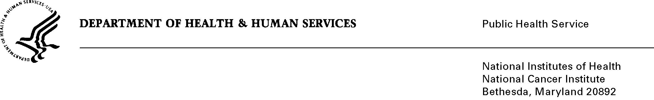

Date: April 24, 2013

To: Office of Management and Budget (OMB)

Through: Keith Tucker, Report Clearance Officer, HHS
Seleda Perryman, Reports Clearance Officer, NIH

From: Vivian Horovitch-Kelley, PRA/OMB Project Clearance Liaison, NCI
National Cancer Institute (NCI)/NIH

Subject: Generic Sub-Study OMB No.: 0925-0642-25 (CCT)

Based on OMB’s comments, corrections to generic sub-study titled, “Center for Cancer Training (CCT) Web Site Usability Testing” has been made.

In summary, OMB questioned: 1) whether the Federal employees were counted in the burden totals, 2) the amount of the proposed incentive, and 3) which respondents will receive the incentive.

To make these corrections, the following revisions were made:

- Fast Track Request – Since Federal employees are being asked to participate because of their position and knowledge related to their job - and they will be responding as part of their official duties and while on the job - they are not counted in the burden totals because PRA does not apply.

- Fast Track Request – The incentive for non-Federal respondents was decreased to $25 to match the previously approved sub-study in equity and consistency. Federal employees will not be offered an incentive since then it would be considered dual compensation because it is anticipated they will be responding while on the job. It is felt that these incentives are necessary and at the lowest amount possible to be effective.

- Attachments 1 and 4 – Revised the incentive amount to $25.

We appreciate your feedback and request that this submission be re-reviewed. Thanks.

