Attachment 2B: Survey Screenshots for CPTAC Listserv

CPTAC - Listerv Survey Page 1

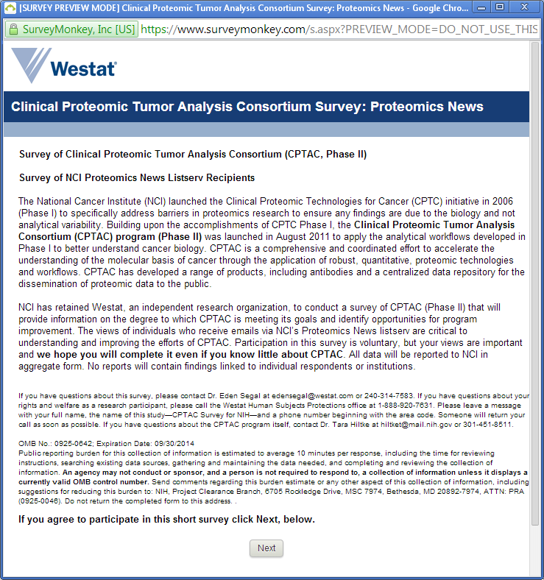

CPTAC - Listserv Survey Page 2

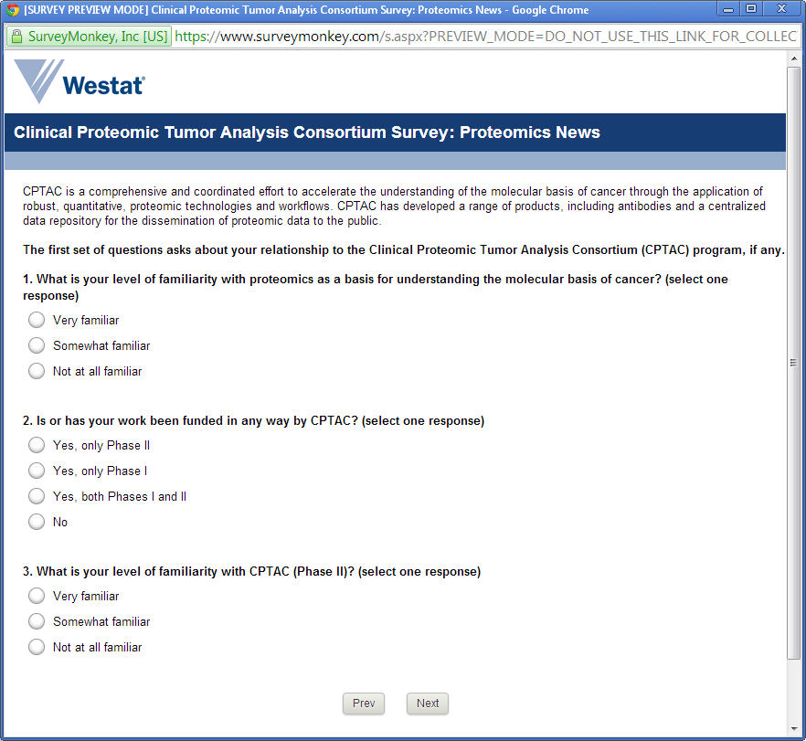

[Q3 Not at all familiar skips to survey Page 7]

CPTAC - Listserv Survey Page 3

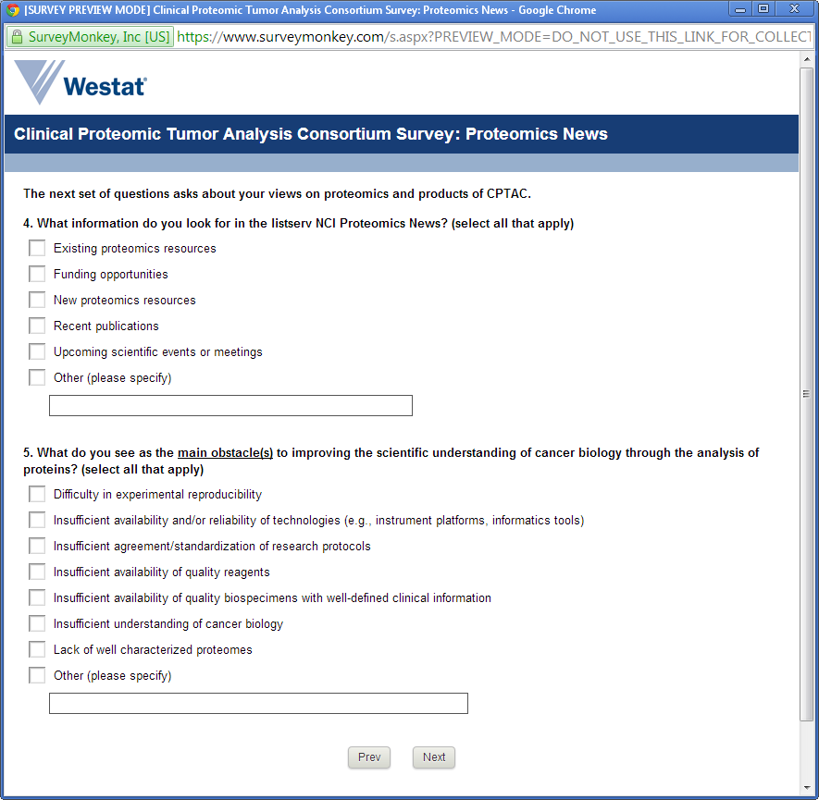

CPTAC - Listserv Survey Page 4

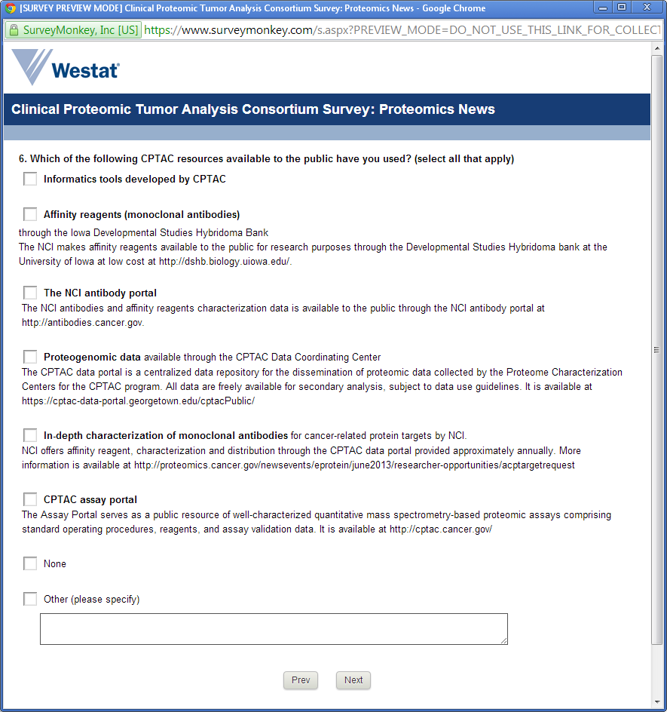

CPTAC - Listserv Survey Page 5

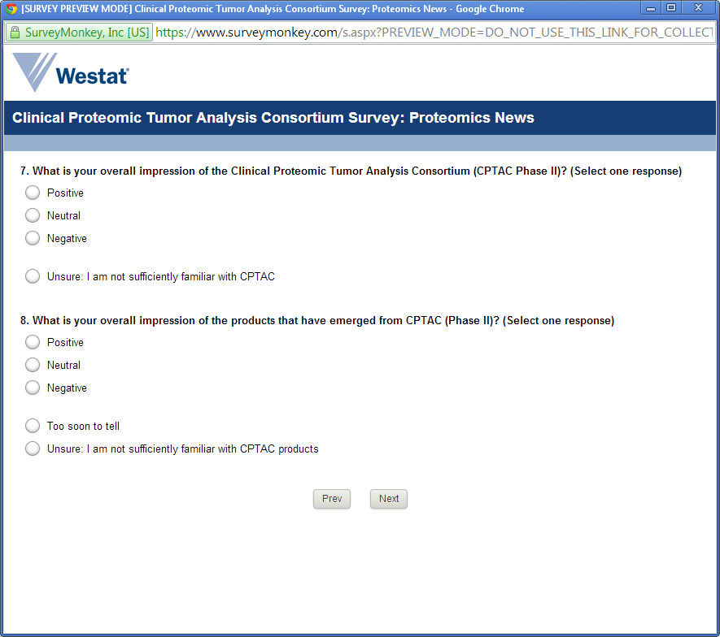

CPTAC - Listserv Survey Page 6

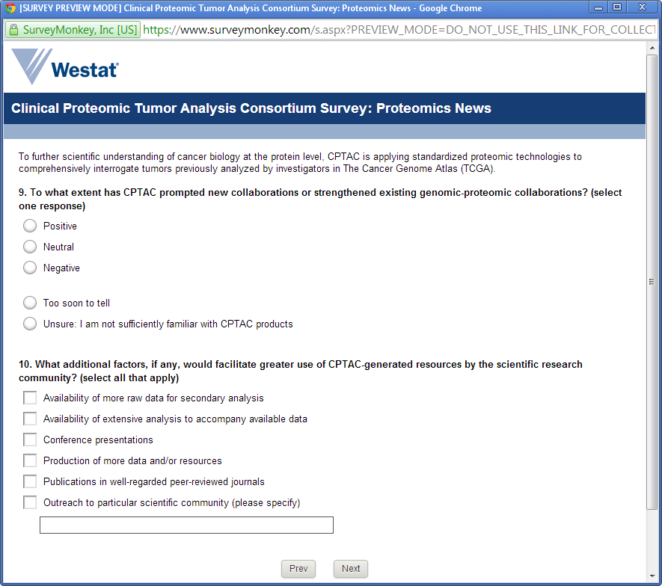

CPTAC - Listserv Survey Page 7

