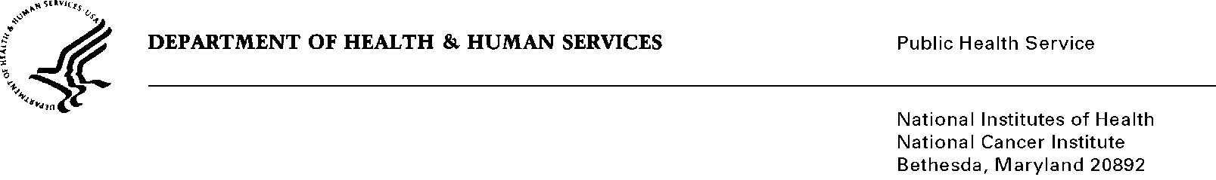
Date: April 20, 2012

To: Office of Management and Budget (OMB)

Through: Keith Tucker, Report Clearance Officer, HHS
Seleda Perryman, Program Officer, Project Clearance Branch, OPERA, NIH

From: Vivian Horovitch-Kelley, PRA OMB Project Clearance Liaison
National Cancer Institute/NIH

Subject: Bundled Generic Sub-Study Packages for 0925-0642-11 and 12

Both sub-studies are web-site based customer satisfaction surveys.

Files and attachments are labeled with their sub-study number and short title, e.g., #11 CRIM, #12 TCRB.

Sub-study #11: Title: “Follow-up Survey of 2010 Workshop: Cancer Research in Media”
Short Title: CRIM
- Fast Track Request #11
- Attachment 11A – Email Invitation
- Attachment 11B – Screenshots in English
- Attachment 11C – Screenshots in Portuguese
- Attachment 11D – Screenshots in Spanish

Sub-study #12: Title: “Online User Survey for Smokefree.gov”
Short Title: TCRB
- Fast Track Request #12
- Attachment 1A and 1B – NCI Smokefree.gov User Screenshots

Estimate of Burden Hours for Sub-Studies #11 and #12
Category of Respondents | Number of Respondents | Participation Time  (minutes/hour) | Burden Hours
Sub-study #11 - Individuals | 25 | 15/60 | 6
Sub-study #12 - Individuals | 3000 | 5/60 | 250
Total | 3025 |  | 256

