Attachment 2B: Survey Screenshots for CPTAC Listserv

CPTAC - Listerv Survey Page 1
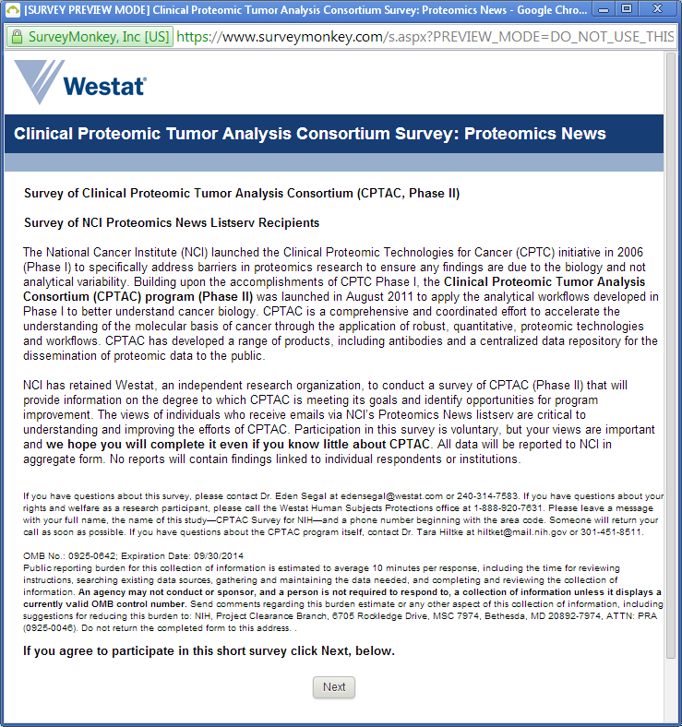

CPTAC - Listserv Survey Page 2
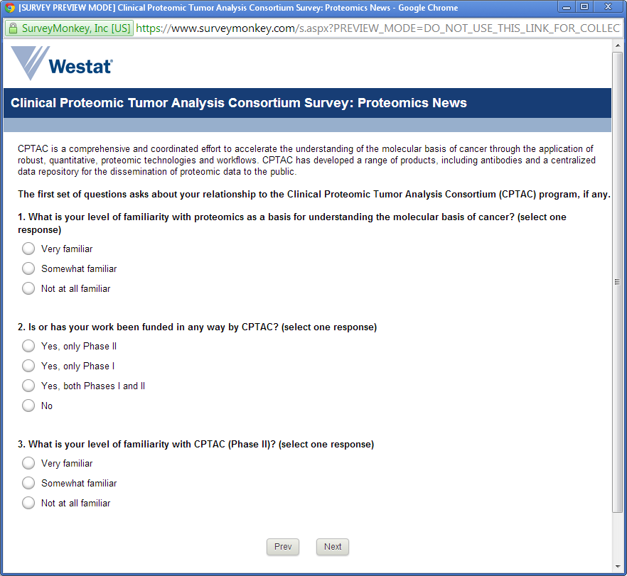

[Q3 Not at all familiar skips to survey Page 7]

CPTAC - Listserv Survey Page 3
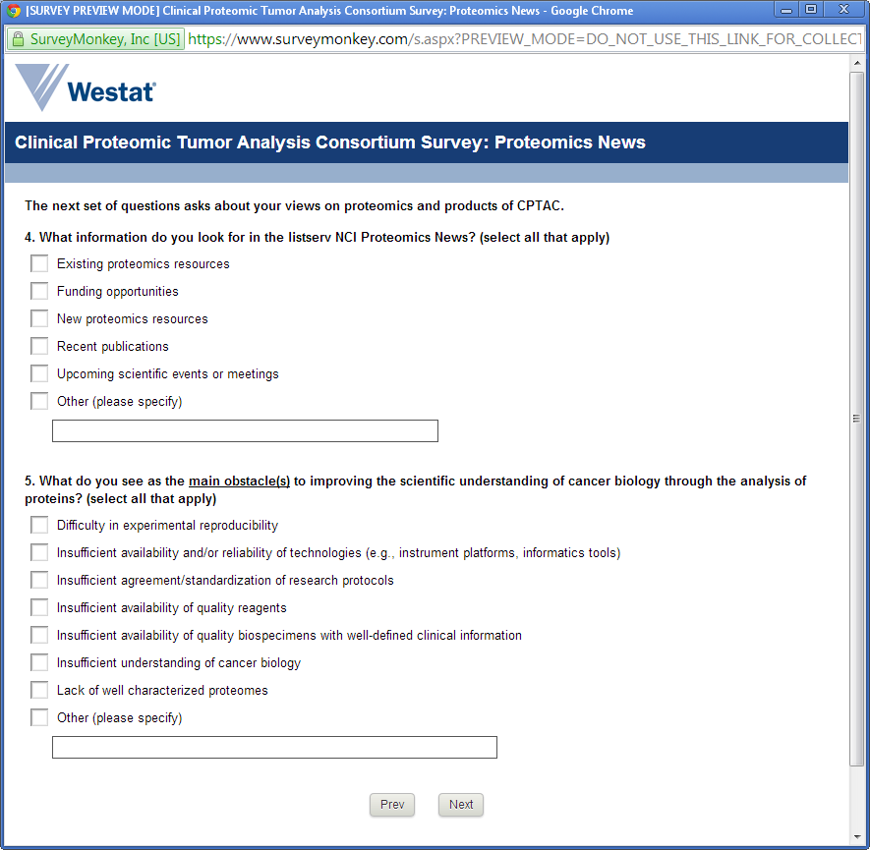

CPTAC - Listserv Survey Page 4

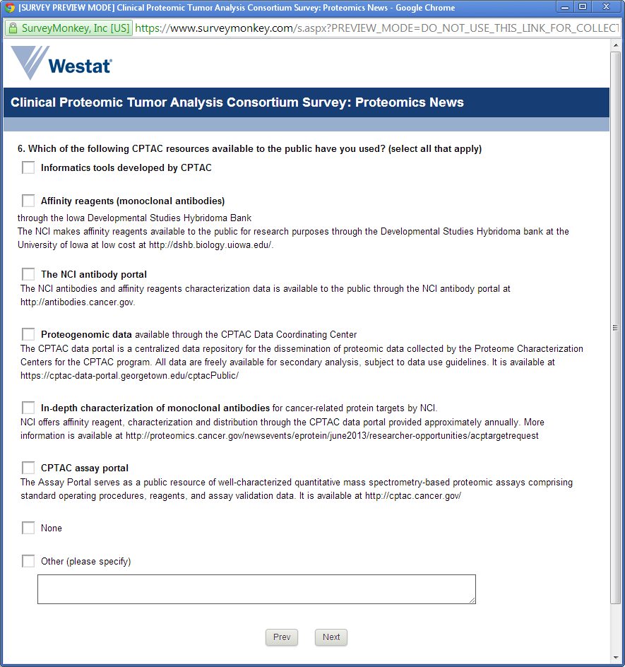
CPTAC - Listserv Survey Page 5

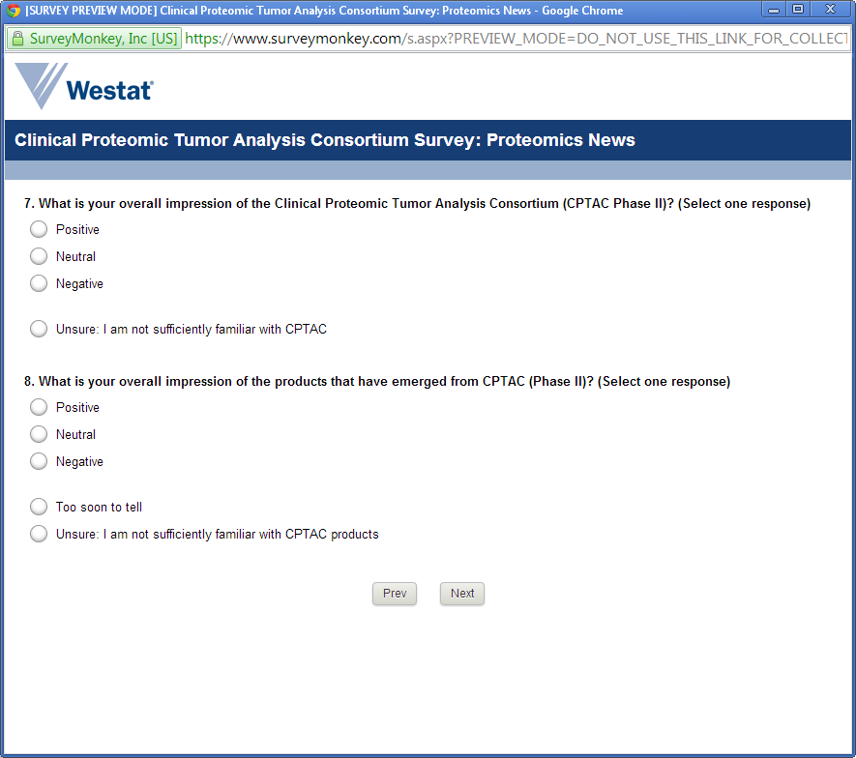
CPTAC - Listserv Survey Page 6

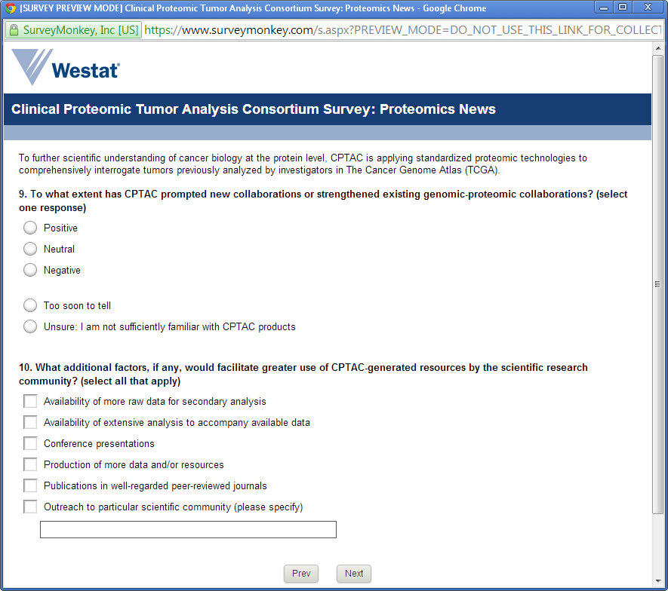

CPTAC - Listserv Survey Page 7

