Assisted Living Collaborative

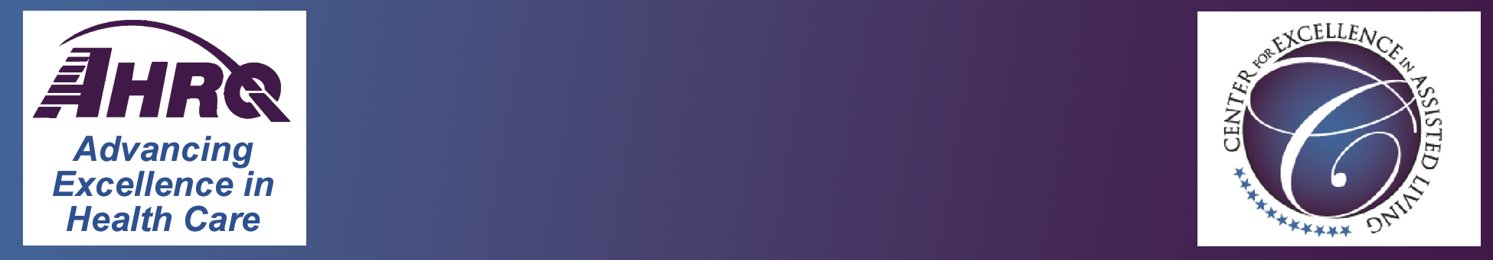

**Organizational Participants**

Don Redfoot, Topic Workgroup Chair

AARP Public Policy Institute

Kathy Cameron

Consumer Consortium on Assisted Living

Mike Splaine

Alzheimer’s Association

Beverley Laubert

State LTC Ombudsman  
Ohio Department of Aging

Jessica Sayers Barker

National Association of State Units on Aging

Chris Herman

National Association of Social Workers

Cathy Lieblich

Pioneer Network

Paula Carder

Gerontological Society of America

Assisted Living Special Interest Group

Susan Ganson

CARF-CCAC

Sharon K. Colling, CNHA, CALA, FACHCA

American College of Health Care Administrators

Candace Baldwin

NCB Capital Impact

Steve Maag

American Association of Homes and

Services for the Aging

Maribeth Bersani

Assisted Living Federation of America

Rachelle Bernstecker

American Seniors Housing Association

Monika White

National Association of Professional

Geriatric Managers

Dave Kyllo

National Center for Assisted Living

D.E.B. Potter, MS

Agency for Healthcare Research & Quality

William Spector, PhD

Agency for Healthcare Research & Quality

**Ex-Officio (Non-Voting) Collaborative Participants**

Donna Folkemer

National Conference of State Legislatures

Gavin Kennedy and Emily Rosenoff

Office of Disability, Aging, and Long-Term Care Policy

U.S. HHS, Office of the Secretary, ASPE

Lauren Harris-Kojetin, PhD

Chief, Long-Term Care Statistics Branch

National Center for Health Statistics

U.S. Centers for Disease Control and Prevention

Bob Hornyak

U.S. Administration on Aging

Greg B. Case

U.S. Administration on Aging

Barbara Miltenberger

American Health Lawyers Association

**Key Non-Voting Collaborative Participants**

Doug Pace

American Association of Homes and

Services for the Aging

Karen Love

Center for Excellence in Assisted Living

Penny Mallet

Center for Excellence in Assisted Living

Shelley Sabo

National Center for Assisted Living

Rhona Limcangco, PhD

Agency for Healthcare Research and Quality

Judith A. Sangl, Sc.D.

Agency for Healthcare Research and Quality

**Abt/UNC Contractor Support Team**

Allison J. Muma, MHA

Abt Associates Inc.

Sheryl Zimmerman, PhD

University of North Carolina at Chapel Hill  
  
Philip Sloane, MD, MPH

University of North Carolina at Chapel Hill  
  
Madeline Mitchell, MURP

University of North Carolina at Chapel Hill

Joan Hyde, Ph.D.

CEO Ivy Hall Senior Living

University of Massachusetts