OMB No. 1117-
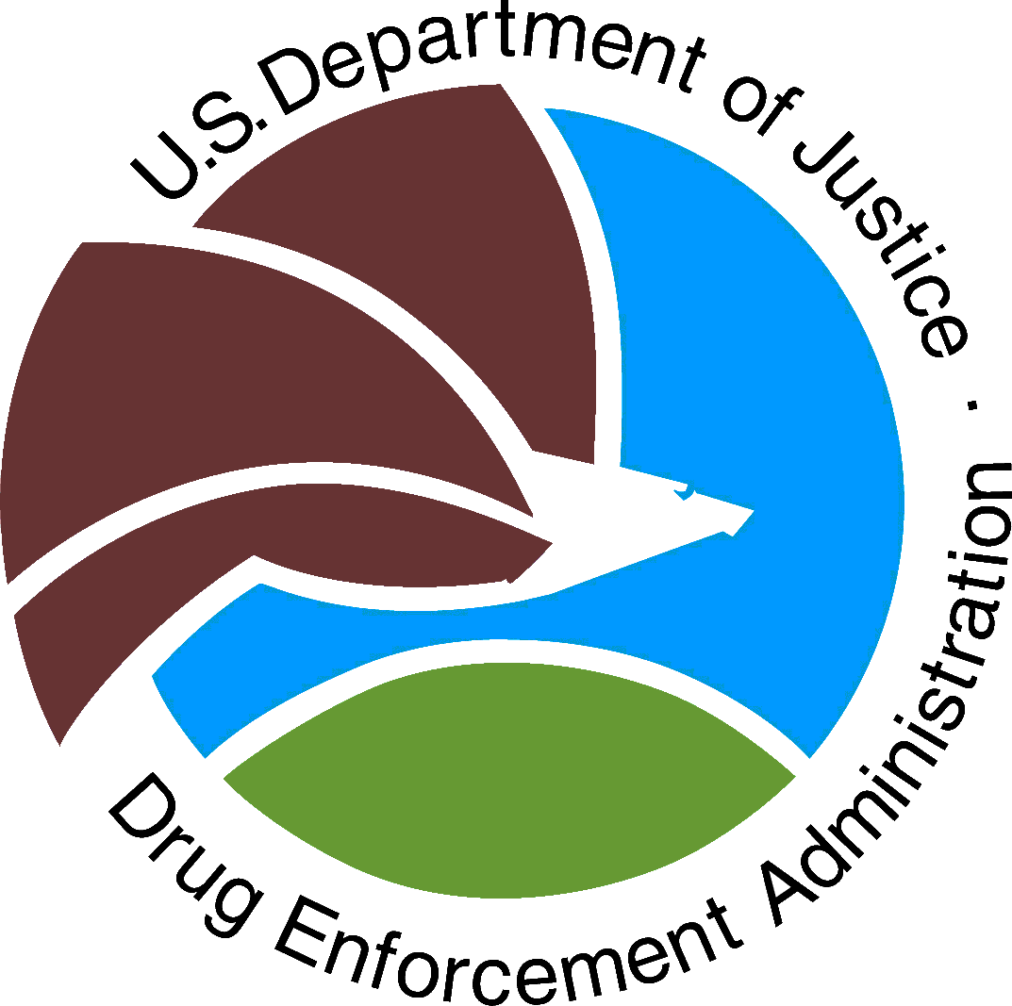 | US Department of Justice  Drug Enforcement Administration  Red Ribbon Week Patch  Activity Report | 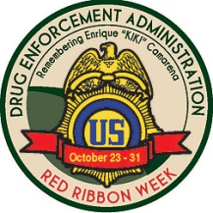
EXP DATE:
This form certifies your completion of all program requirements and MUST be completed to receive your
DEA Red Ribbon Week Patches.
Scout unit or troop number: _________ Council Name: _____________________________________

Troop’s mailing address (print): ________________________________________________________

City: _________________________________ State: ________________________ Zip Code _______

Troop’s e-mail address (Print): _________________________________________________________

Number of Boy Scouts or Girl Scouts that attended the anti-drug prevention session: ______________
Number of Boy Scouts or Girl Scouts that took the drug free pledge: ___________________________
Number of patches requested for your troop or unit: ________________________________________

Please describe the Red Ribbon Week activity/event your troop or unit sponsored:

Approximately how many participants attended your Red Ribbon Week activity? _________________
Did you partner with anyone? Yes ____ No ____
If so, please mark all that apply:
Please mark as appropriate:
________Business/Corporation ________Civic organization/non-profit
________School ________Faith-based organization
________Government Agency ________Coalition
(city, county, state, or federal) ________Other ___________________

Please describe the anti-drug prevention education session attended by the scouts (i.e. discussion, lecture, etc):

Are you planning to participate in next year’s Red Ribbon Week? Yes ____ No ____
Is there anything that you recommend to improve DEA’s Red Ribbon Week Patch program for next year?

DEA-316A

