May 13, 2009

NOTE TO THE  REVIEWER OF: | OMB CLEARANCE #1220-0141  “Cognitive and Psychological Research”
FROM: | William Mockovak  Research Psychologist  Office of Survey Methods Research
SUBJECT: | Submission of materials for focus groups with potential users of the Occupational Outlook Handbook

Please accept the enclosed materials for approval under the OMB clearance package #1220-0141 “Cognitive and Psychological Research.”

In accordance with our agreement with OMB, I am submitting a brief description of one in a series of proposed focus groups with potential users of the Occupational Outlook Handbook. We estimate 25 burden hours will be required for this initial study.

We are attaching the protocol and related forms for this study. Future requests will reference this memorandum and provide protocols (and related forms) relevant to the group being studied.

If there are any questions regarding this project, please contact Bill Mockovak at (202) 691-7414 or Mockovak_W@bls.gov.

- Introduction and Purpose
In previous research, the Office of Survey Methods Research (OSMR) completed a variety of qualitative research to provide the Office of Employment Projections (OEP) with information for their strategic planning initiative. This prior research involved focus groups with 30 career counselors from Fairfax County high schools, five career counselors from American University, and nine career counselors from George Mason University. In addition, usability testing of the OOH website was conducted with 20 high school students, ages 13-17, and individual interviews were conducted with four technical users of the Occupational Outlook Handbook (OOH).

The redesign of the OOH is entering a new phase. A Reinvention Team has been formed to: “Develop a new and improved Occupational Outlook Handbook by embracing new technology and incorporating stakeholder feedback.” The team’s task is to concentrate on conceptualizing and designing a new online Occupational Outlook Handbook that better serves its customers. The actual implementation and rollout of the new Internet product will be carried out by future teams.

There are three phases to the entire project: research, design, and testing. The current request deals with the research phase. The team has decided that with the exception of a Web survey, which provided general feedback from visitors to the OOH website, they currently have second-hand information about what many potential users (for example, high school and college students, current job holders, etc.) want or expect from job/career resource materials and how they would react to the specific content of the OOH. Therefore, we would like to run some additional focus groups with the following groups:

- High school students who plan to attend college
- College students
- Current job holders (planning a change in their careers)
- High school students – whose college plans are uncertain
- High school students – who don’t plan to attend college
- Unemployed
- High school dropouts
- High school students interested in vocational training in or beyond high school
- Parents
- Non-permanent residents
- Military
- Middle-school students
- College dropouts

Although we are asking for approval to conduct focus groups with representatives from each of these groups, at the present time we have only made tentative arrangements to meet with female middle school students.

2. Participants
The participants will be 25 middle school students in Grades 7-8. They will be recruited through a local Girl Scout troop that meets at Whitman Intermediate School in Fairfax, County, Virginia.

Contact has already been made with the leader of the Girl Scout troop, who has given her approval for this research. Parental approval will be obtained separately (see attachments C and D). Consent forms will be obtained from the parents or guardians of all participating students. In addition, the students will be asked to sign a consent form before the study is started (see Attachment B). As a token of appreciation for securing the cooperation of their girls and handling all the logistics for the focus groups, an incentive of $125 will be give to each of the two co-leaders of the Girl Scout troop.

3. Research Design
A focus group will be used to determine what types of questions middle-school students have about potential future jobs or careers (see protocol in Attachment A), and also how they react to the home page of the existing website.

4. Burden Hours
We anticipate that 25 students will each participate in a one-hour focus group, for a total of 25 burden hours. These focus groups (we plan to hold two separate, concurrent groups) will be held at Whitman Intermediate School in Fairfax County, Virginia.

5. Data Confidentiality
Participants will be informed as to the voluntary nature of the study. Participants will also be informed that the study will be used to help staff of the Occupational Outlook Handbook better decide what information is of interest to middle-school students and how it might be presented effectively. Information related to this study will not be released to the public in any way that would allow identification of individuals except as prescribed under the conditions of the Privacy Act Notice.

6. Attachments

A. Protocol
B. Student consent form
C. Parental consent form
D. Description of study (for parents)
E. Screen shots of OOH home page
Appendix A: Protocol for Focus Group
FOCUS GROUP PROTOCOL: Middle-School Students

STUDY PURPOSE: To determine what types of questions middle-school students have about potential future jobs or careers, and what their initial reactions are to the existing home page.

AGENDA FOR PLANNED DISCUSSIONS:
Category of Information to be Covered | Approx. Time Duration
Introduction/Ground Rules/Welcome/Consent Form | 10 minutes
Issue A: Questions about job information | 25 minutes
Issue B: General reactions to the home page | 15 minutes
Closure | 10 minutes
Total Time Allotted | 60 minutes

INTRODUCTIONS

My name is __________, and I’m a researcher at the Bureau of Labor Statistics. The Bureau of Labor Statistics is a government agency within the Department of Labor. Our primary role is to collect and publish statistics or information about our economy, but we also publish information about jobs in America, and we have a website that is dedicated to this purpose. In general, that’s what we will be talking about today. So thank you for agreeing to participate in this discussion.

I hope you’ll find the discussion that we’re going to have fun, and that you learn something from it. By the way, the type of discussion we are going to have is called a focus group, because it focuses on a specific topic. The topic we are going to talk about today deals with the kinds of questions you might have about potential future jobs or careers, and also what type of information we should provide to answer those questions.

The type of discussion we are going to have has certain ground rules that I want you to follow so that the discussion flows smoothly and everyone gets the chance to participate. Here are the rules that I want you to follow:

- Please talk one at a time.
- If someone is talking, please allow that person to finish a point before you start.
- Please talk as loudly as possible so everyone can hear.
- Please don’t get into side conversations with your neighbor.
- I would like to hear from everyone. However, you don’t have to answer every question.
- Work for equal air time so no one talks too much or too little.
- Allow for different points of view; there are no right or wrong answers to the questions that I’m going to ask.
- Say what you believe, whether or not anyone agrees with you.
- With your permission, I will be tape recording this conversation for my own note-taking purposes.

Are there any questions about what I have just covered? (If there are no other questions, then let's begin.)

A. What questions do students of this age want answered about jobs?
Please introduce yourself, tell me what your favorite hobby is, if any, and if you have any idea what you would like to be when you become an adult and have to get a job.

- When you think about different types of jobs, what comes to mind? What types of things would you like to know about different jobs?

- Let’s assume you had the chance to talk to someone who was actually working in a job that you were interested in. If you could ask that person only one question about the job, what would that question be? (If necessary) What are some of the most important things you would want to know about a job?)

- The organization that I work for, the Bureau of Labor Statistics, may produce videos about how a person in a job spends a typical day. If we were to do this, what types of things would you like to see covered in this video?

B. How do students react to the existing home page for the OOH? (Attachment E)

- Now I’m going to show you what the home page of our website looks like. The first page is the top half, and the second page is the bottom half.

a. What are your general reactions to this?

b. Is there anything about this page that is confusing to you? For example, are there
abbreviations or words that you don’t understand?

c. Please look in the left-hand column. The column that has OOH Home at the top.
What does ‘OOH Home’ mean to you?

d. Now look at the words underneath OOH Home. Can you briefly tell me what
each word means to you?

e. Now please look at the tabs across the top of the screen. There are two rows of
them One row starts with Home, then Subject Areas, Databases & Tables,
Publications, and Economic Releases. Can you briefly tell me what each of these
titles means to you?

f. If you were interested in finding out general information about a job, let’s say
being a school teacher. What would you probably do first?

C. WRAP-UP
Appendix B: Student Consent Form

Consent Form

The Bureau of Labor Statistics (BLS) is conducting research to improve the quality of materials presented on one of its websites: the Occupational Outlook Handbook.

The BLS, its employees, agents, and partner statistical agencies, will use the information you provide for statistical purposes only and will hold the information in confidence to the full extent permitted by law. In accordance with the Confidential Information Protection and Statistical Efficiency Act of 2002 (Title 5 of Public Law 107-347) and other applicable Federal laws, your responses will not be disclosed in identifiable form without your informed consent. The Privacy Act notice on the back of this form describes the conditions under which information related to this study will be used by BLS employees and agents.

During this research you may be audio taped, and you will be observed by researchers from BLS.

We estimate the focus group will last about an hour. Your participation in this research project is voluntary, and you have the right to stop at any time. If you agree to participate, please sign below.

Persons are not required to respond to the collection of information unless it displays a currently valid OMB control number. The OMB control number is 1220-0141 and expires February 29, 2012.

------------------------------------------------------------------------------------------------------------
I have read and understand the statements above. I consent to participate in this study.

___________________________________ ___________________________
Participant's signature Date

___________________________________
Participant's printed name

___________________________________
Researcher's signature

OMB Control Number: 1220-0141
Expiration Date: February 29, 2012
PRIVACY ACT STATEMENT

In accordance with the Privacy Act of 1974, as amended (5 U.S.C. 552a), you are hereby notified that this study is sponsored by the U.S. Department of Labor, Bureau of Labor Statistics (BLS), under authority of 29 U.S.C. 2. Your voluntary participation is important to the success of this study and will enable the BLS to better understand the behavioral and psychological processes of individuals, as they reflect on the accuracy of BLS information collections. The BLS, its employees, agents, and partner statistical agencies, will use the information you provide for statistical purposes only and will hold the information in confidence to the full extent permitted by law. In accordance with the Confidential Information Protection and Statistical Efficiency Act of 2002 (Title 5 of Public Law 107-347) and other applicable Federal laws, your responses will not be disclosed in identifiable form without your informed consent.

Appendix C: Parental Consent Form
Parental Consent Form
The Bureau of Labor Statistics (BLS) is conducting research to improve the quality of its printed and web-based materials. This study is intended to identify improvements to the Occupational Outlook Handbook, and related publications (for example, the Career Guide to Industries). These publications are designed to provide career information to a wide variety of people, including students and adults.

In this study, we are interested in the types of questions middle-school students might ask about potential future jobs and careers. In addition, we are interested in finding out how they react to some existing materials that were developed for the World Wide Web. Therefore, we are asking your permission to have your child participate in a focus group, which will be conducted at Whitman Intermediate School. A focus group is essentially a structured discussion in which a moderator asks a series of open-ended questions about specific topics.

During this research your child will be observed by a BLS researcher and the conversation will be recorded. Your child’s participation in this research project is voluntary, and he or she has the right to stop at any time. The focus group will last no longer than an hour. If you agree to allow your child to participate, please sign below. If you would like to talk with a researcher before giving your permission, please see the contact information below.

The BLS, its employees, agents, and partner statistical agencies will use the information your child provides for statistical purposes only and will hold the information in confidence to the full extent permitted by law. In accordance with the Confidential Information Protection and Statistical Efficiency Act of 2002 (Title 5 of Public Law 107-347) and other applicable Federal laws, your child’s responses will not be disclosed in identifiable form without your informed consent. The Privacy Act notice on the next page of this form describes the conditions under which information related to this study will be used by BLS employees and agents.

------------------------------------------------------------------------------------------------------------
I have read and understand the statements above, and I give my consent for my child to participate in this study.

___________________________________ ___________________________
Parent’s or Guardian’s signature Date

___________________________________ Contact Information for BLS researcher:
Parent’s or Guardian’s printed name Dr. Bill Mockovak, 202-691-7414

Note:
Persons are not required to respond to the collection of information unless it displays a currently valid OMB control number. The OMB control number is 1220-0141 and it expires February 29, 2012.

PRIVACY ACT STATEMENT
In accordance with the Privacy Act of 1974, as amended (5 U.S.C. 552a), you are hereby notified that this study is sponsored by the U.S. Department of Labor, Bureau of Labor Statistics (BLS), under authority of 29 U.S.C. 2. Your voluntary participation is important to the success of this study and will enable the BLS to better understand the behavioral and psychological processes of individuals, as they reflect on the accuracy of BLS information collections. The BLS, its employees, agents, and partner statistical agencies, will use the information you provide for statistical purposes only and will hold the information in confidence to the full extent permitted by law. In accordance with the Confidential Information Protection and Statistical Efficiency Act of 2002 (Title 5 of Public Law 107-347) and other applicable Federal laws, your responses will not be disclosed in identifiable form without your informed consent.

Appendix D: Description of Study (for parents)

Why is your child being asked to participate in this study? | The Bureau of Labor Statistics (BLS) distributes a variety of information about jobs and careers. One of the key sources is the website for the Occupational Outlook Handbook (http://www.bls.gov/oco/).  This website is being redesigned, and BLS wants to ensure that it meets the needs of as diverse an audience as possible, including students in middle school.
What exactly will my child do? | Your child will participate in a structured discussion, called a focus group. This discussion will probably last between 50-60 minutes.
What types of questions will be asked? | Your child will be asked if she has ever thought about future jobs or careers. If so, what questions does she have about those jobs, or what types of information would she like to be provided with about those jobs? She will also be shown a picture of the home page of the website and asked for her reactions.
Is this voluntary? | Participation is completely voluntary. However, you must sign a consent form in order for your child to participate.
Are there any benefits to my child’s participation? | Your child will learn about a free website that provides detailed information about thousands of jobs.
If I have any questions, whom can I contact? | You can contact Bill Mockovak:  Work: 202-691-7414  Home: 703-360-9792  E-mail: Mockovak_W@BLS.gov

Attachment E: Screen shots of OOH home page

Occupational Outlook Handbook

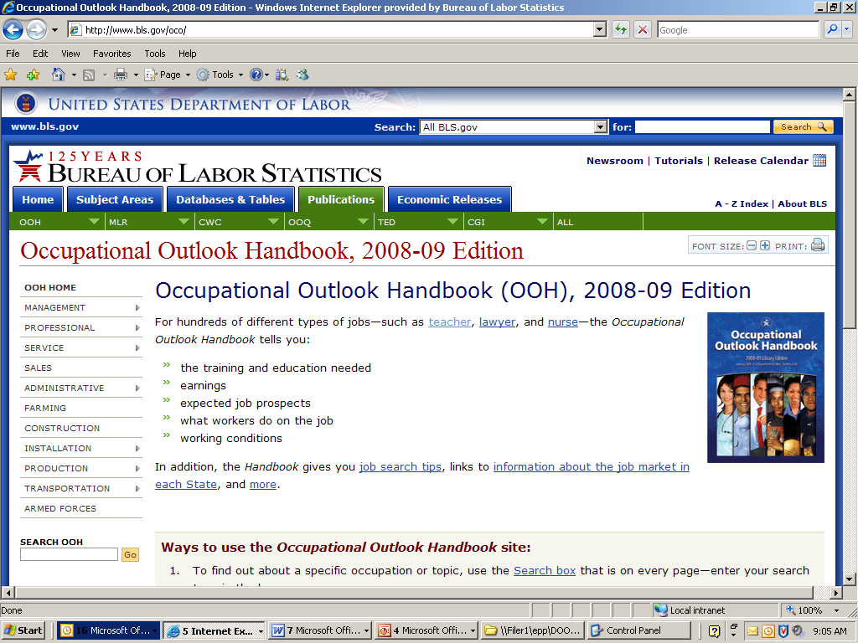
Bottom Half of Home Page

