**Attachment I**

**Recruitment Materials**

Sample Recruitment Flyer

**Did you graduate from college in 2008?**

**You may be eligible to help us review a 90-minute EDUCATION SURVEY and RECEIVE $40 for your time!**

General

We are interested in talking to individuals who completed the requirements for a **bachelor’s degree** (B.A. or B.S. only) **between July 1, 2007 and June 30, 2008**.

Teachers

We are interested in talking to individuals who completed the requirements for a **bachelor’s degree** (B.A. or B.S. only) **between July 1, 2007 and June 30, 2008 who are currently teaching in an elementary or secondary school**.

STEM

We are interested in talking to individuals who completed the requirements for a **bachelor’s degree** (B.A. or B.S. only) in science, technology, engineering or mathematics **between July 1, 2007 and June 30, 2008**.

Enrolled

We are interested in talking to individuals who completed the requirements for a **bachelor’s degree** (B.A. or B.S. only) **between July 1, 2007 and June 30, 2008, who are currently enrolled in college or graduate school**.

RTI International is conducting this study for the National Center for Education Statistics (NCES) of the U.S. Department of Education. Your responses will be used to refine survey questions.

Flexible appointment openings, including weekends and evenings to meet your scheduling needs.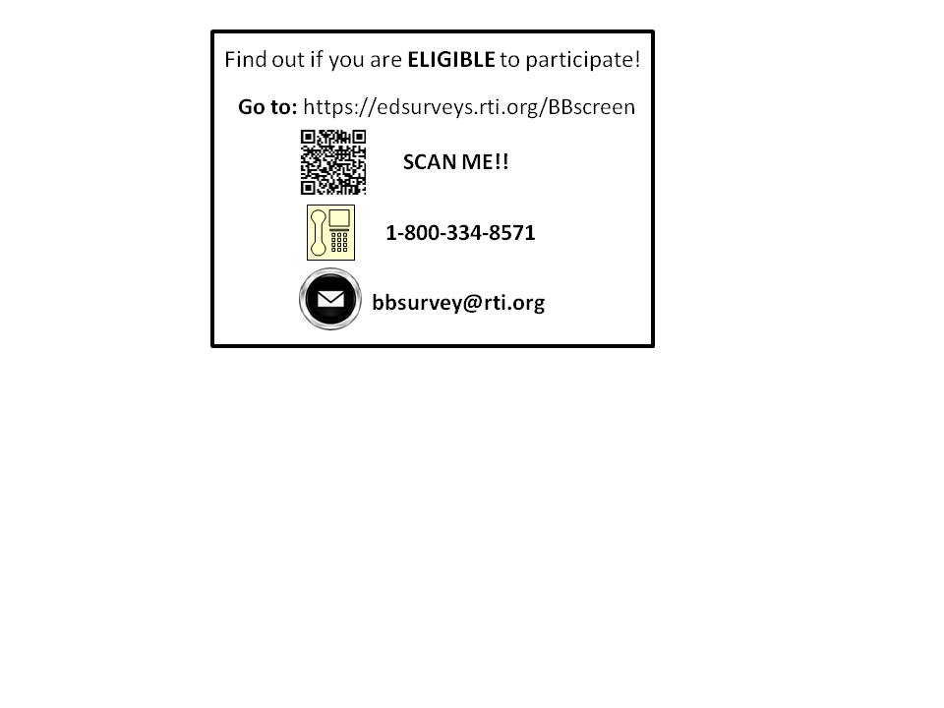

RTI International is a non-profit research firm located in Research Triangle Park near Cornwallis Road and Davis Drive, with easy access to and from I-40./CHICAGO FLYER: RTI International is a non-profit research firm located in the Loop in Downtown Chicago.

Sample Recruitment Online Ad

2008 COLLEGE GRADUATES: RECEIVE $40 FOR A SURVEY

IF YOU ...

Completed the requirements for a bachelor’s degree (B.S., B.A.) between July 1, 2007 and June 30, 2008

FOR SPECIAL INTEREST GROUPS – WE WILL HAVE SEPARATE ADS FOR EACH GROUP

* *and you have enrolled in college or graduate school since earning your bachelor’s degree…*
* *and you majored in science, technology, engineering or mathematics…*
* *and you are a teacher in an elementary or secondary school…*

WE NEED YOU TO...

Answer a few questions about your experiences since college, with a focus on additional education and employment after receiving your bachelor’s degree

You may be eligible to help us pretest a college survey and RECEIVE $40 for your time!



Our appointment schedule is flexible, with weekend and evening sessions.

Your responses will be used to refine survey questions.

RTI International is conducting this survey for the National Center for Education Statistics located within the U.S. Department of Education.

RTI is a non-profit research firm located in Research Triangle Park near Cornwallis Road and Davis Drive, with easy access to and from 1-40. /CHICAGO FLYER: RTI International is a non-profit research firm located in the Loop in Downtown Chicago.

On average, these sessions take about 90 minutes.

**Attachment II**

**Baccalaureate and Beyond**

**Eligibility Screening Questions[1]**

**Intro:** *Thank you for inquiring about this study. I need to ask you a few questions to determine if you are eligible to participate in the study. The screening is expected to take approximately 3-5 minutes.*

1. Were you enrolled for a bachelor’s degree at a postsecondary institution at any time between July 1, 2007 and June 30, 2008?

1- Yes

0- No *(Not eligible, Go to question 11)*

1. When did you complete the requirements for a bachelor’s degree?

1- Before January 1, 2007

2- January 1, 2007 to June 30, 2007

3- July 1, 2007 to June 30, 2008

4- July 1, 2008 to Dec. 31, 2008

5- After January 1, 2009

**if answer 1, 2, 4, or 5 *(Not eligible, Go to question 11)*

1. In what month and year were you awarded your bachelor’s degree?

1- July 1, 2007 to June 30, 2008

2- July 1, 2008 to December 31, 2008

3- January 2, 2009 to June 30, 2009

4- After July 1, 2009 *(Not eligible, Go to question 11)*

1. What is your age?

0- Under 18 *(Not eligible, Go to question 11)*

1- 18 to 21

2- 22 to 24

3- 25 to 30

4- 31 to 35

5- 36 to 40

6- Over 40

1. What is your sex?

1- Male

0- Female

1. What was your major or field of study for your bachelor's degree?

______________________________________________________________

**7.** Have you enrolled in any school for an additional degree or certificate (including enrollment for any graduate or additional undergraduate degree or certificate programs) since earning your bachelor's degree?

1- Yes

0- No

**8.** Since graduating, have you worked as a teacher at the K-12 level?

1- Yes (*skip to question 11)*

0- No

**9.** Have you done anything to prepare for a teaching career at the K-12 level?

1- Yes (*skip to question 11)*

0- No

**10.** Are you currently considering a career in teaching at the K-12 level?

1- Yes

0- No

**11.** What is your name?

______________________________________________________________

**12.** What is the best telephone number to reach you?

______________________________________________________________

**13.** What is your e-mail address?

______________________________________________________________

**14.** What days of the week and times of day would you be available to participate in an interview?

______________________________________________________________

**If eligible:** *Thank you for answering our questions. You are eligible to participate in this study. We will contact you soon to schedule an interview time and answer any questions you have about the study.  
  
Participation will involve answering questions and reviewing a survey for an upcoming study that will be used to learn about people’s experiences after graduation. During the interview, we will ask you to complete a survey and give us your thoughts on the questions you are being asked. In addition, we will ask you questions as you go in order to measure your understanding and interpretation of the questions in the survey.   
  
Each full interview is expected to last approximately 90 minutes. The interviews will be recorded so that we can review your ideas and comments. We will prepare a report that does not single out any one person, but will summarize what we heard from the group as a whole. We will keep the recording only until our report is finished. No names will be mentioned in the report.  
  
After your interview has been scheduled, you will receive a follow-up message to confirm the date, time, and location. At that point, you****must****RSVP to the invitation to guarantee an interview time. Upon completion of the interview you will receive $40.*

**If ineligible:** *Thank you for inquiring about this study. If you are eligible to participate, we will contact you at a later date.*

**STEM MAJORS FOR REFERENCE**

* Computer and Information Sciences
* Artificial Intelligence and Robotics
* Information Technology
* Computer Programming/Programmer
* Computer Programming
* Data Processing and Data Processing Technology
* Information Science/Studies
* Computer Systems Analysis/Analyst
* Computer Science
* Web Page, Digital/Multimedia and Information Resources Design
* Data Modeling/Warehousing and Database Administration
* Computer Graphics
* Computer Systems Networking and Telecommunications
* System Administration/Administrator
* System, Networking, and LAN/WAN Management
* Computer and Information Systems Security
* Web/Multimedia Management and Webmaster
* Engineering
* Aerospace, Aeronautical and Astronautical Engineering
* Agricultural/Biological Engineering and Bioengineering
* Architectural Engineering
* Biomedical/Medical Engineering
* Ceramic Sciences and Engineering
* Chemical Engineering
* Civil Engineering
* Geotechnical Engineering
* Structural Engineering
* Transportation and Highway Engineering
* Water Resources Engineering
* Computer Engineering
* Computer Hardware Engineering
* Computer Software Engineering
* Electrical, Electronics and Communications Engineering
* Engineering Mechanics
* Engineering Physics
* Engineering Science
* Environmental/Environmental Health Engineering
* Materials Engineering
* Mechanical Engineering
* Metallurgical Engineering
* Mining and Mineral Engineering
* Naval Architecture and Marine Engineering
* Nuclear Engineering
* Ocean Engineering
* Petroleum Engineering
* Systems Engineering
* Textile Sciences and Engineering
* Materials Science
* Polymer/Plastics Engineering
* Construction Engineering
* Forest Engineering
* Industrial Engineering
* Manufacturing Engineering
* Operations Research
* Surveying Engineering
* Geological/Geophysical Engineering
* Engineering Technology
* Architectural Engineering Technology
* Civil Engineering Technology
* Electrical, Electronic and Communications Engineering Technology
* Laser and Optical Technology
* Telecommunications Technology
* Biomedical Technology
* Electromechanical Technology/Electromechanical Engineering Technology
* Instrumentation Technology
* Robotics Technology
* Heating, Air Conditioning and Refrigeration Technology
* Energy Management and Systems Technology
* Solar Energy Technology
* Water Quality and Wastewater Treatment Management and Recycling Technology
* Environmental Engineering Technology/Environmental Technology
* Hazardous Materials Management and Waste Technology
* Plastics Engineering Technology
* Metallurgical Technology
* Industrial Technology
* Manufacturing Technology
* Occupational Safety and Health Technology
* Quality Control Technology
* Industrial Safety Technology
* Hazardous Materials Information Systems Technology
* Aeronautical/Aerospace Engineering Technology
* Automotive Engineering Technology
* Mechanical Engineering/Mechanical Technology
* Mining Technology
* Petroleum Technology
* Construction Engineering Technology
* Surveying Technology/Surveying
* Hydraulics and Fluid Power Technology
* Computer Engineering Technology
* Computer Technology/Computer Systems Technology
* Computer Hardware Technology
* Computer Software Technology
* Drafting and Design Technology
* CAD/CADD Drafting and/or Design Technology
* Architectural Drafting and Architectural CAD/CADD
* Civil Drafting and Civil Engineering CAD/CADD
* Electrical/Electronics Drafting and Electrical/Electronics CAD/CADD
* Mechanical Drafting and Mechanical Drafting CAD/CADD
* Nuclear Engineering Technology
* Engineering/Industrial Management
* Biology/Biological Sciences
* Biomedical Sciences
* Biochemistry
* Biophysics
* Molecular Biology
* Molecular Biochemistry
* Molecular Biophysics
* Structural Biology
* Photobiology
* Radiation Biology/Radiobiology
* Biochemistry/Biophysics and Molecular Biology
* Botany/Plant Biology
* Plant Pathology/Phytopathology
* Plant Physiology
* Plant Molecular Biology
* Cellular Biology and Histology
* Anatomy
* Developmental Biology and Embryology
* Neuroanatomy
* Cellular and Molecular Biology
* Cell Biology and Anatomy
* Microbiology
* Medical Microbiology and Bacteriology
* Virology
* Parasitology
* Mycology
* Immunology
* Zoology/Animal Biology
* Entomology
* Animal Physiology
* Animal Behavior and Ethology
* Wildlife Biology
* Genetics
* Molecular Genetics
* Microbial and Eukaryotic Genetics
* Animal Genetics
* Plant Genetics
* Human/Medical Genetics
* Physiology
* Molecular Physiology
* Cell Physiology
* Endocrinology
* Reproductive Biology
* Neurobiology and Neurophysiology
* Cardiovascular Science
* Exercise Physiology
* Vision Science/Physiological Optics
* Pathology/Experimental Pathology
* Oncology and Cancer Biology
* Pharmacology
* Molecular Pharmacology
* Neuropharmacology
* Toxicology
* Molecular Toxicology
* Environmental Toxicology
* Pharmacology and Toxicology
* Biometry
* Biostatistics
* Bioinformatics
* Biotechnology
* Ecology
* Marine Biology and Biological Oceanography
* Evolutionary Biology
* Aquatic Biology/Limnology
* Environmental Biology
* Population Biology
* Conservation Biology
* Systematic Biology
* Epidemiology
* Mathematics
* Algebra and Number Theory
* Analysis and Functional Analysis
* Geometry
* Topology and Foundations
* Applied Mathematics
* Computational Mathematics
* Statistics
* Mathematical Statistics and Probability
* Military Technologies
* Physical Sciences
* Astronomy
* Astrophysics
* Planetary Astronomy and Science
* Atmospheric Sciences and Meteorology
* Atmospheric Chemistry and Climatology
* Atmospheric Physics and Dynamics
* Meteorology
* Chemistry
* Analytical Chemistry
* Inorganic Chemistry
* Organic Chemistry
* Physical and Theoretical Chemistry
* Polymer Chemistry
* Chemical Physics
* Geology
* Geochemistry
* Geophysics and Seismology
* Paleontology
* Hydrology and Water Resources Science
* Geochemistry and Petrology
* Oceanography, Chemical and Physical
* Physics
* Atomic/Molecular Physics
* Elementary Particle Physics
* Plasma and High-Temperature Physics
* Nuclear Physics
* Optical Sciences
* Solid State and Low-Temperature Physics
* Acoustics
* Theoretical and Mathematical Physics
* Biology Technician
* Industrial Radiologic Technology
* Nuclear Power Technology
* Chemical Technology
* Medical Scientist (MS, PhD)
* Actuarial Science

**Attachment III**

**Sample Consent Form**



**Consent to Participate in Research**

**Title of Research**: **2008-12 Baccalaureate and Beyond Longitudinal Study**

## Introduction

You are being asked to participate in a cognitive interview which is part of a larger research study sponsored by the National Center for Education Statistics (NCES) of the U.S. Department of Education. The study is designed to examine the decisions and experiences of individuals four years after completing a baccalaureate degree. Before you decide if you want to take part in this study, you need to read this Informed Consent form so that you understand what the interview is about and what you will be asked to do. This form also tells you who can participate in the interviews, the risks and benefits of participating, how we will protect your information, and who you can call if you have questions. Please ask the researcher to explain anything you don’t understand before you make your decision.

## Purpose

The interview is being conducted by RTI International, a research organization located in Research Triangle Park, North Carolina.

Participation will involve answering questions and reviewing a survey for an upcoming study that will be used to learn about individuals’ experiences after college graduation. During the interview, we will ask you to complete a web or telephone survey and give us your thoughts on the questions you are being asked. In addition, we will ask you questions as you go in order to measure your understanding and interpretation of the questions in the survey. The information from the interviews will help us finalize development of the questions for a large study that will be conducted early next year.

## Procedures

You are one of approximately 30 individuals participating in these cognitive interviews.

The interview will be audio recorded to make sure we don’t miss anything that you say and to help us write a report summarizing the results of the interviews. Upon completion of the written report, the recording will be destroyed. Your name will never be used in the report that we write.

## Study Duration

Your participation in the cognitive interview will take about 90 minutes.

## Possible Risks or Discomforts

We do not anticipate that any of the discussion topics will make you uncomfortable or upset. However you may refuse to answer any question or take a break at any time.

## Benefits

## Your Benefits There are no direct benefits to you from participating in this study.

**Benefits for Other People**  We hope that these interviews will help us develop and improve questions for a national survey that will help us understand individuals’ experiences after completing their baccalaureate degree.

**Payment for Participation**  You will be paid $40 upon completion of the interview.

## Confidentiality

RTI International is conducting this study for the National Center for Education Statistics (NCES) of the U.S. Department of Education. This study is authorized by law under the Education Sciences Reform Act (20 U.S.C., § 9543). Your participation is voluntary. Your responses may only be used for statistical purposes and may not be disclosed, or used, in identifiable form for any other purpose except as required by law (20 U.S.C., § 9573).

## Future Contacts

We will not contact you in the future.

## Your Rights

Your decision to take part in this research study is completely voluntary. You can refuse to answer any question and you can stop participating at any time.

***Your Questions***

If you have any questions about the study, you may call Melissa Cominole at RTI International (919-990-8456). If you have any questions about your rights as a study participant, you may call RTI’s Office of Research Protection at 1-866-214-2043 (a toll-free number).

**YOU WILL BE GIVEN A COPY OF THIS CONSENT FORM TO KEEP.**

Your signature below indicates that you have read the information provided above, have received answers to your questions, and have freely decided to participate in this research. By agreeing to participate in this research, you are not giving up any of your legal rights.

|  |  |  |
| --- | --- | --- |
|  |  |  |
| Signature of Participant |  | Date |
|  |  |  |
| Printed Name of Participant |  |  |

I certify that the nature and purpose, the potential benefits, and possible risks associated with participating in this research have been explained to the above-named individual.

|  |  |  |
| --- | --- | --- |
|  |  |  |
| Signature of Person Obtaining Consent |  | Date |
|  |  |  |
| Printed Name of Person Obtaining Consent |  |  |

1. Eligibility screening will be conducted by telephone and website.